**CTR 5:**

**“For God so loved the world, that he gave his only begotten Son…”**

**CTR 6:**

**“…that whosoever believeth in him should not perish, but have everlasting life” (John 3:16).**

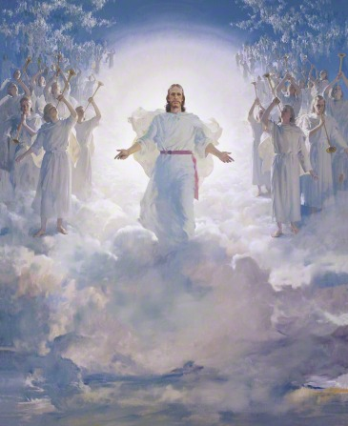

**He**

**Sent**

**His**

**Son**

**Baptism**

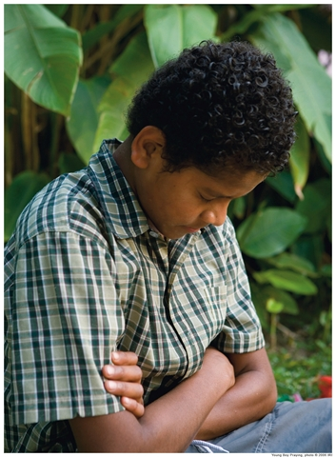

**The**

**Holy**

**Ghost**

**Search, Ponder, and Pray**

**Keep**

**the Commandments**

**Repentance**

**The Miracle**

**I’ll**

**Walk With You**

**CTR 7:**

***“…*charity is the pure love of Christ” (Moroni 7:47).**

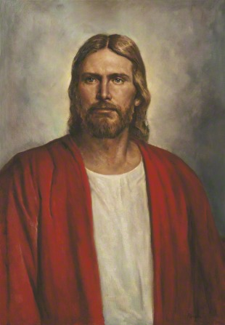

**I Feel My Savior’s Love**

**Come, Follow Me**