As a Child of God Flipchart
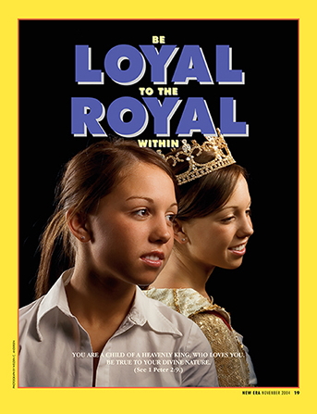

Words & Music by Janice Kapp Perry

Flipchart adapted by Cherice Montgomery from an idea by Cara Webber
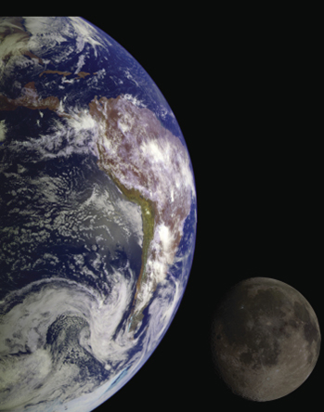

I
came to

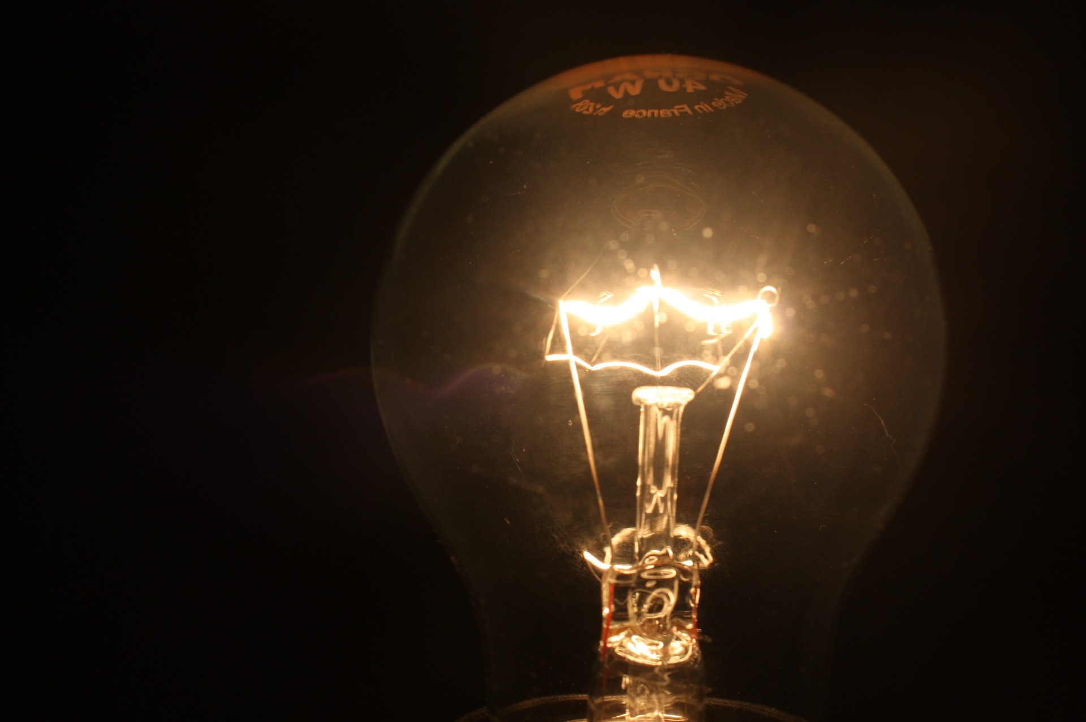

with

to choose.
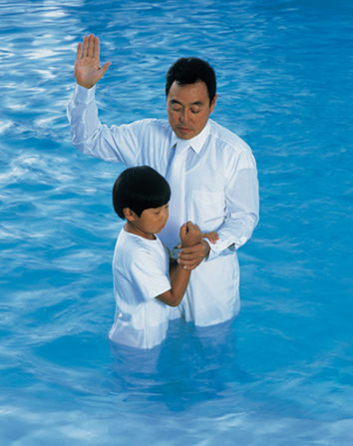

Good
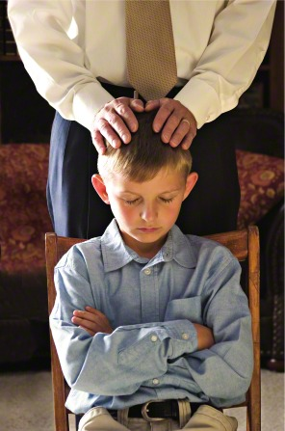

me
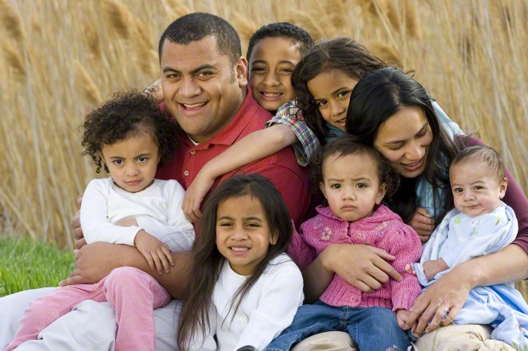
too.

and my

As a

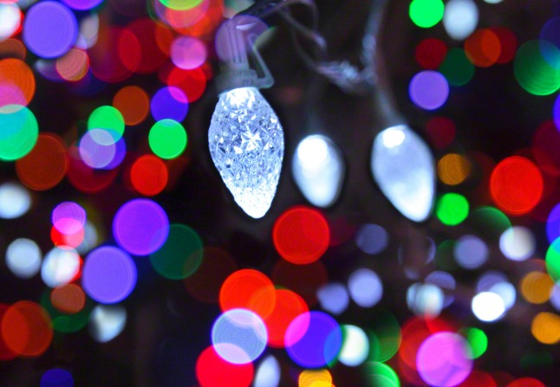

I receive
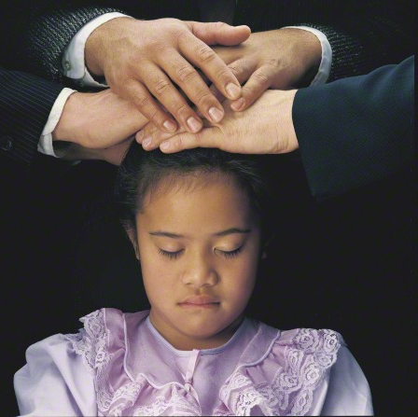

helps
me


to
know
what is
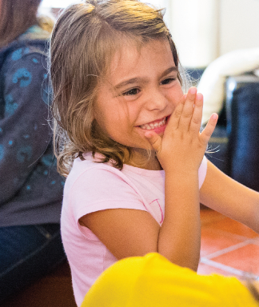
because

I feel so
safe and

Such feelings of peace come from

As a

I receive

helps
me

to
know
what is

In my own

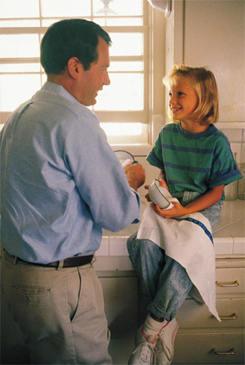

I’ll happily

I’ll strengthen my


by
my
good

As a

I receive

helps
me

to
know
what is
Image Credits

Earth: https://www.lds.org/media-library/images/earth-321127?lang=eng

Light Bulb Light Lighting Pear Pixabay 1784496:
https://pixabay.com/en/light-bulb-light-lighting-pear-1784496/

Baptism Boy Asians: https://www.lds.org/media-library/images/baptism-boy-asians-37810?lang=eng

Father Blessing Son: https://www.lds.org/media-library/images/father-blessing-son-243817?lang=eng

Family: https://www.lds.org/media-library/images/family-396160?lang=eng

Mormonad Loyal Royal: https://www.lds.org/media-library/images/mormonad-loyal-royal-1118364?lang=eng

Christmas Lights: https://www.lds.org/media-library/images/christmas-lights-853472?lang=eng

Priesthood Blessing: https://www.lds.org/media-library/images/priesthood-blessing-37771?lang=eng

LDS Primary Clipart Lens: http://www.clipartkid.com/lds-primary-clipart-lens19051292-89472d5f90e8e749b285b5dec24d47a8-jpg-ryePD8-clipart/

Meme Mckay Happiness: https://www.lds.org/media-library/images/meme-mckay-happiness-1486072?lang=eng

As Family On Couch: https://www.lds.org/media-library/images/aa-family-on-couch-208901?lang=eng

Father Daughter Doing Dishes: https://www.lds.org/media-library/images/father-daughter-doing-dishes-167194?lang=eng

Teenager Snow Shovel: https://www.lds.org/media-library/images/teenager-snow-shovel-695640?lang=eng

