Instructions:
1) Print leaves.
2) Laminate and cut out leaves.
3) Write a song on the back of each leaf.
4) Hang leaves from a dead tree branch.
5) Use as a song choosing game.
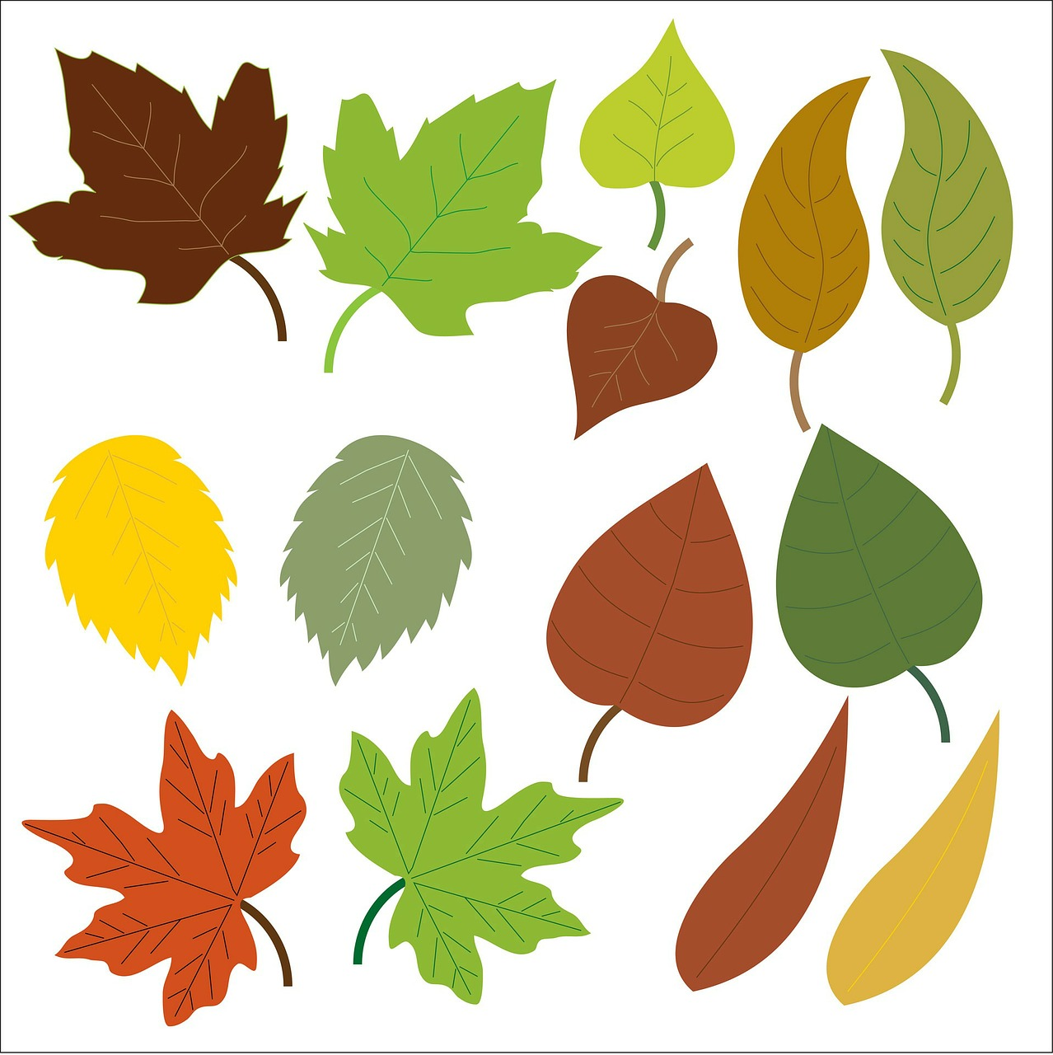
Image source: https://pixabay.com/en/leaf-leaves-oak-maple-green-brown-163609/

