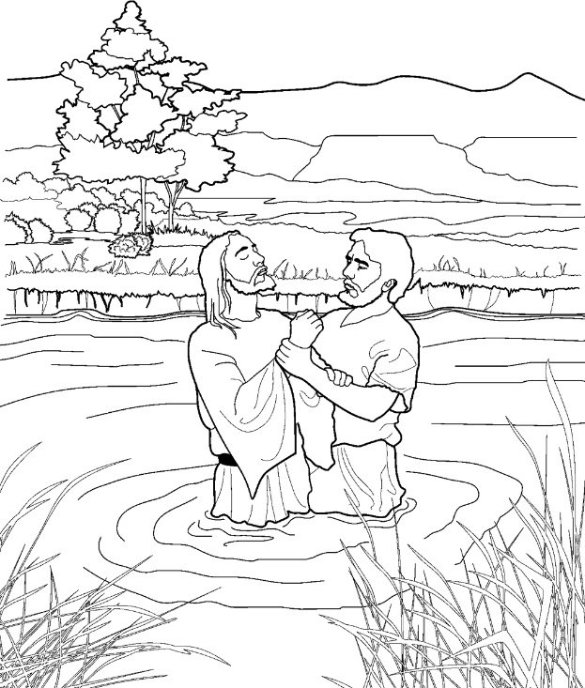
Baptism, p. 100
Words: Mabel Jones Gabbott
Music: Crawford Gates
Baptism Sing-a-Story
Compiled by
Cherice Montgomery

Materials Needed:
- Jesus – Plastic spoon with picture of Jesus taped to it
- John the Baptist – Plastic spoon with picture of John the Baptist taped to it
- Picture of Judea
- Picture of River Jordan

Story: Baptism, p. 100 (Verses 1 & 2)

Jesus came to John the Baptist | Move Jesus spoon toward John spoon
In Judea long ago | Walk both spoons in front of picture of Judea
And was baptized by immersion | Lay Jesus spoon down, then back up in front of river picture
In the river Jordan’s flow | Point to the river
“To fulfill the law,” said Jesus | Have the Jesus spoon “talk” to the John spoon
When the Baptist questioned, “Why?” | Have the John spoon “talk” to the Jesus spoon
And to enter with my Father | Move the Jesus spoon to a picture of Heavenly Father
In His kingdom up on high | Move the Jesus spoon above your head

Instructions:

Set-up: Distribute to each child:
- A Jesus spoon
- A John spoon
- A Judea picture
- A river picture

Note: If you don’t have time to print the pictures, just give each child 2 plastic spoons and have them pretend that one is Jesus and one is John. Tell them their knees are Judea and the space between them is the River Jordan.

First Time: Model the story as you sing the song the first time (children listen).

Second Time: Have children act out the song with you as you sing it together

Third Time: Pair children. One child sings while the other moves the spoons, then switch.
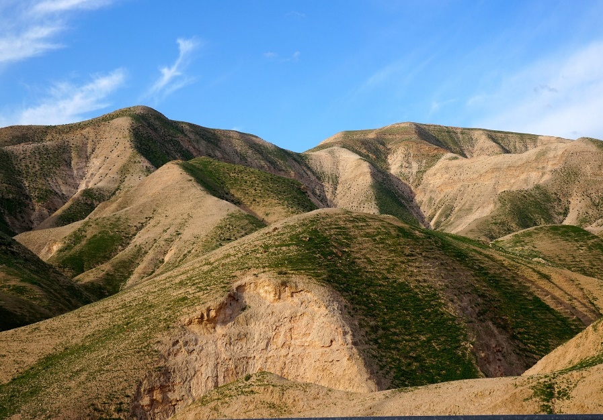
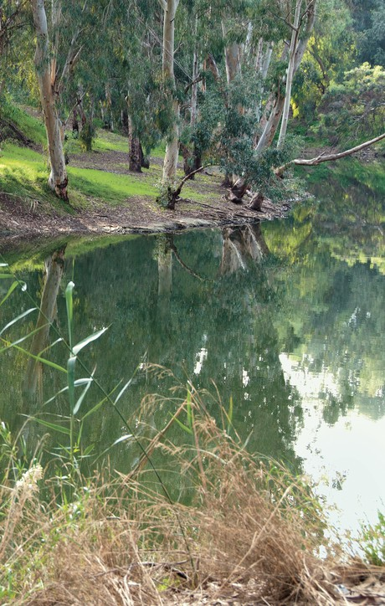
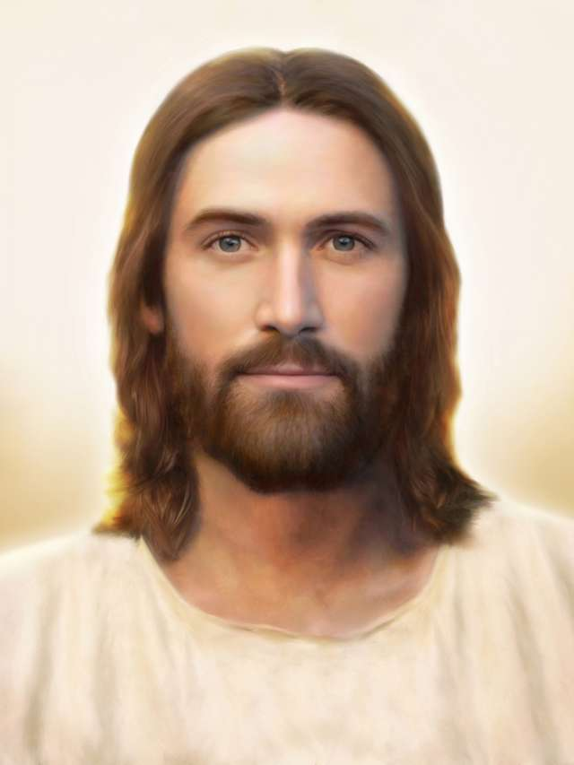
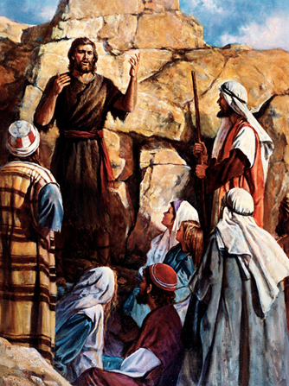

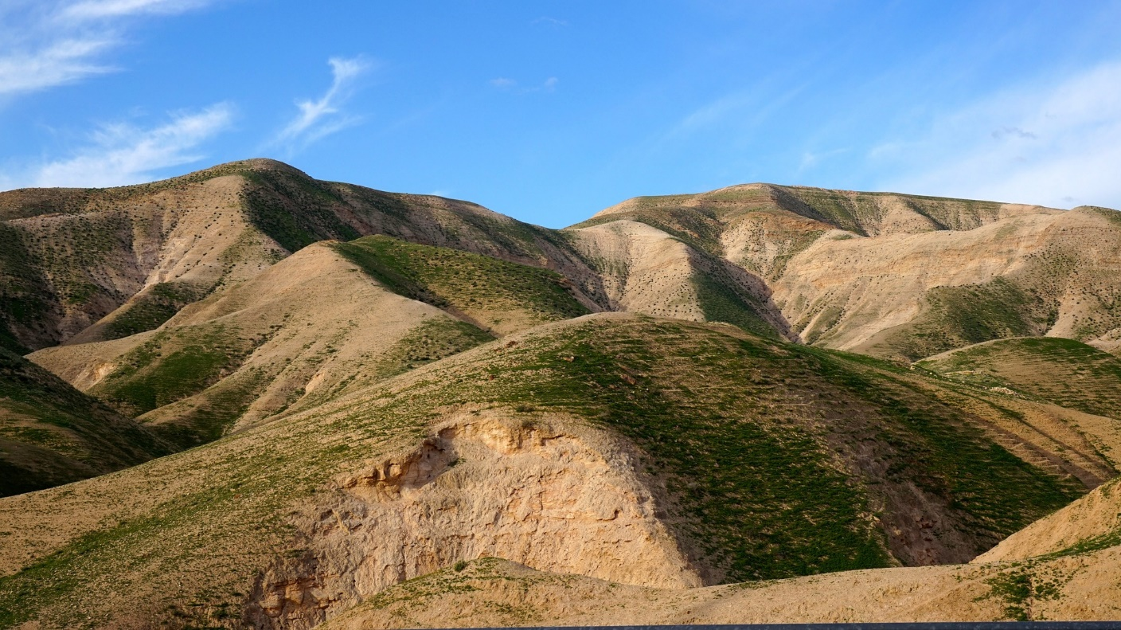
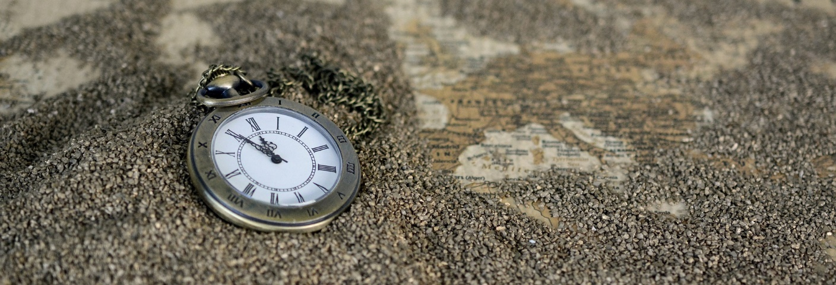

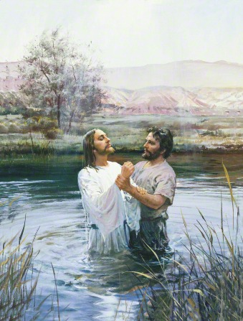
To fulfill the law
Why?

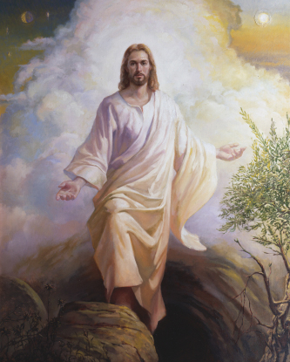
Credits:
Annca. (2016, Sept. 2). Pocket watch time of sand. Pixabay. Retrieved February 2, 2019, from https://pixabay.com/en/pocket-watch-time-of-sand-1637396/ Used under a Pixabay License. Free for commercial use. No attribution required.

Borup, Brent. Light of the World. LDS Media Library. Retrieved February 3, 2019, from https://www.lds.org/media-library/images/light-of-the-world-jesus-christ-1301483?lang=eng

John baptizes Christ. LDS Media Library. Retrieved February 3, 2019, from https://www.lds.org/media-library/images/john-baptizes-christ-39544?lang=eng

John the Baptist by Del Parson. LDS Media Library. Retrieved February 3, 2019, from https://www.lds.org/media-library/images/john-baptist-lds-art-parson-39541?lang=eng

Anderson, Harry. John baptizing Jesus. LDS Media Library. Retrieved February 3, 2019, from https://www.lds.org/media-library/images/john-baptizing-jesus-377623?lang=eng

Moore67. (2016, Jun. 9). Israel Judea desert hills. Pixabay. Retrieved February 2, 2019, from https://pixabay.com/en/israel-judea-desert-hills-1444843/ Used under a Pixabay License. Free for commercial use. No attribution required.

Ong, Wilson J. The Resurrected Christ. LDS Media Library. Retrieved February 3, 2019, from https://www.lds.org/media-library/images/resurrected-christ-wilson-ong-212048?lang=eng&_r=1

Jordan River. LDS.org Bible Photos. Retrieved February 3, 2019, from https://www.lds.org/scriptures/bible-photos/photo-25?lang=eng

