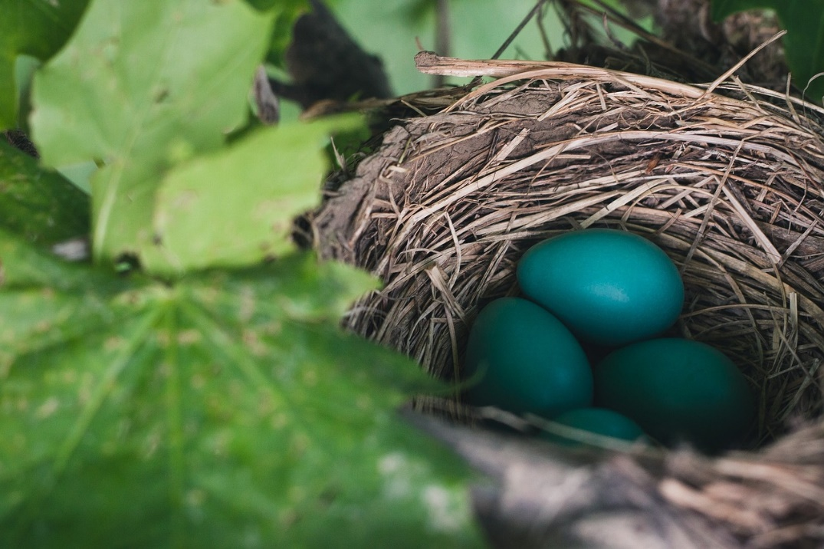
Birds in the Tree

Children’s Songbook, 1977, p. 241
Words: Glenna Tate Holbrook
Music: Marjorie Castleton Kjar
Flipchart by Cherice Montgomery
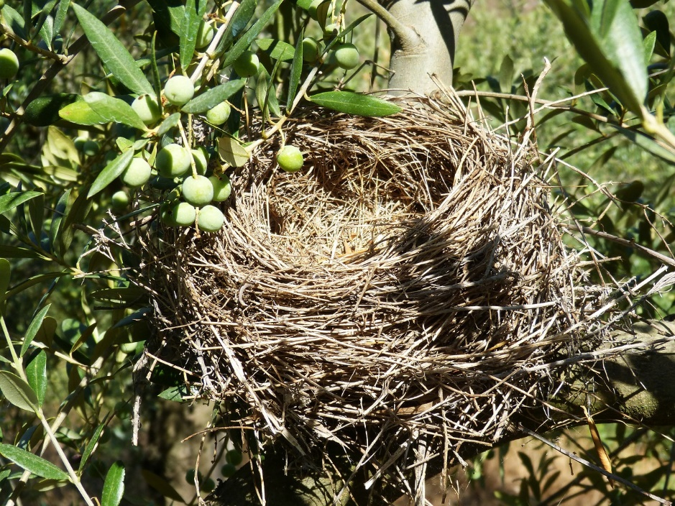
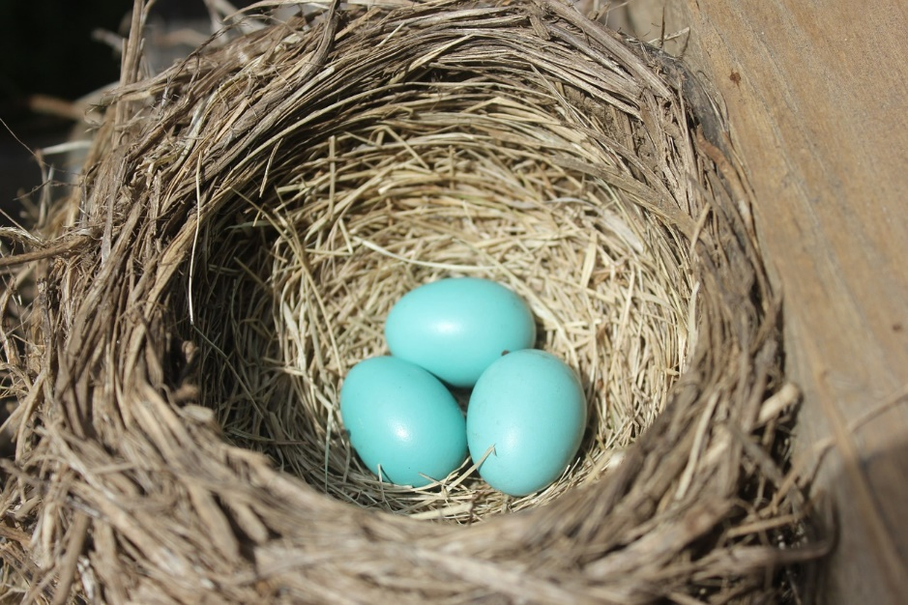
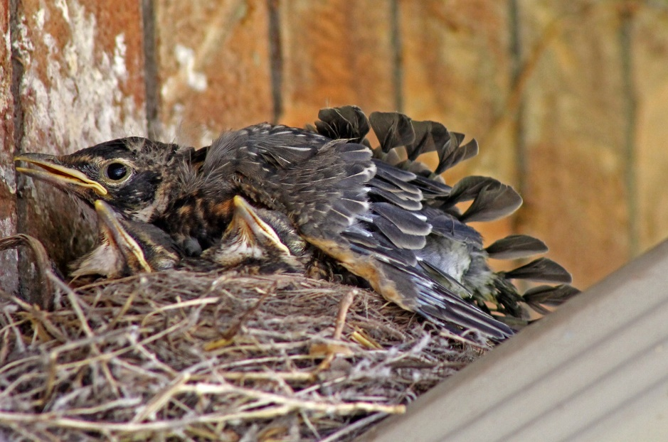
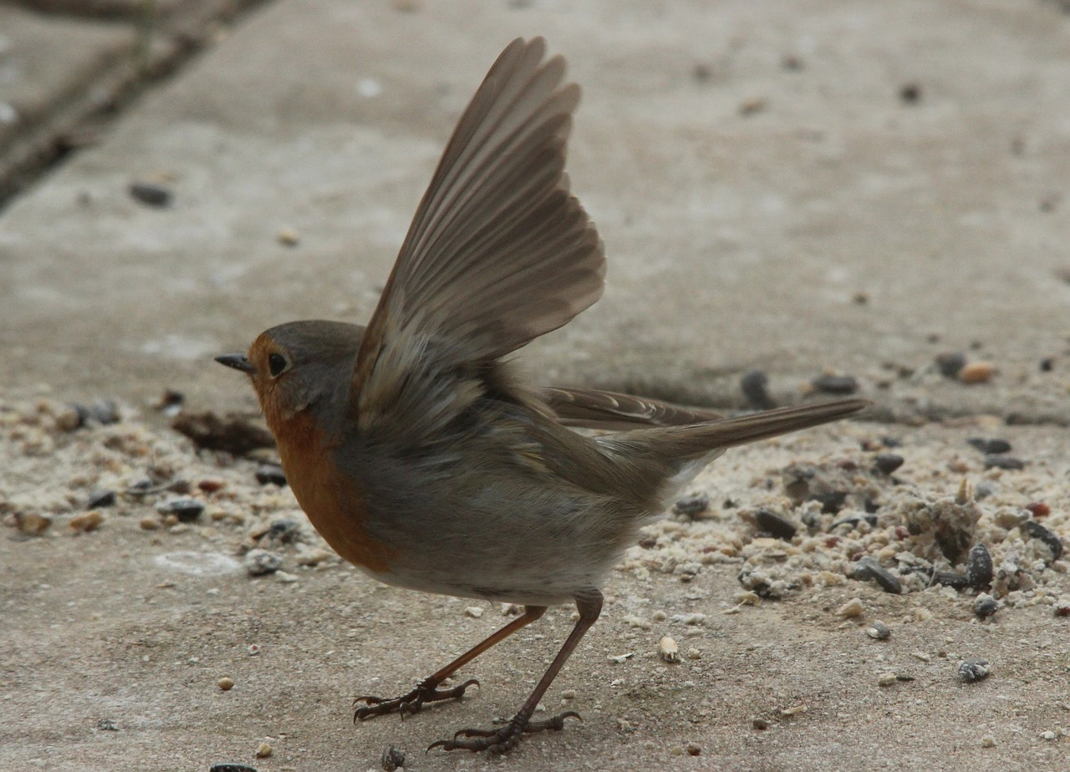
Image Credits:

Unsplash. (2015, July 16). Nest eggs nest egg nature birds 843231. Pixabay. Retrieved from https://pixabay.com/en/nest-eggs-nest-egg-nature-birds-843231/ Used under a CCO Public Domain License. Free for commercial use. No attribution required.

Makamukio. (2014, December 12). Nest olive birds 1715459. Pixabay. Retrieved from https://pixabay.com/en/nest-olive-birds-1715459/ Used under a CCO Public Domain License. Free for commercial use. No attribution required.

Nikle5. (2016, May 14). Robin bird’s nest nest eggs 1443211. Pixabay. Retrieved from https://pixabay.com/en/robin-bird-s-nest-nest-eggs-1443211/ Used under a CCO Public Domain License. Free for commercial use. No attribution required.

Virtual Artist. (2016, May 22). Robin baby robins birds wildlife 1978325. Pixabay. Retrieved from https://pixabay.com/en/robin-baby-robins-birds-wildlife-1978325/ Used under a CCO Public Domain License. Free for commercial use. No attribution required.

Spirit1995. (2013, April 2). Departure robin bird animals 98061. Pixabay. Retrieved from https://pixabay.com/en/departure-robin-bird-animals-98061/ Used under a CCO Public Domain License. Free for commercial use. No attribution required.

