God’s Love
Children’s Songbook, p. 97

Words: Elizabeth Cushing Taylor
Music: Grace Wilbur Conant
Flipchart: Cherice Montgomery

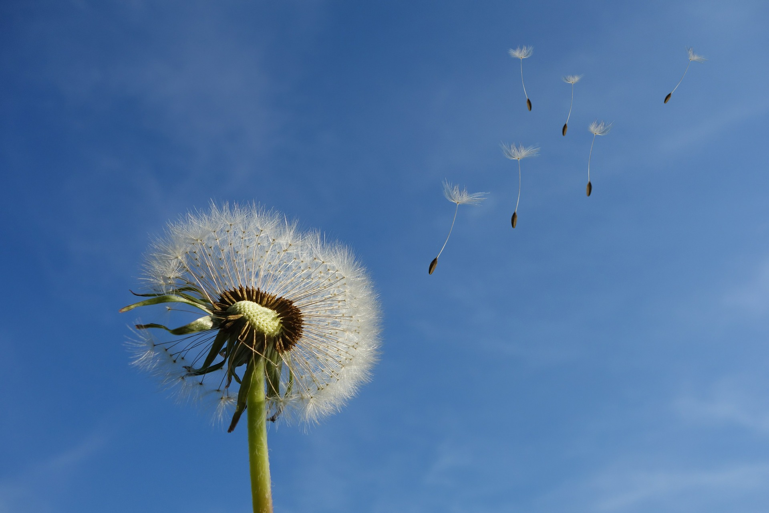
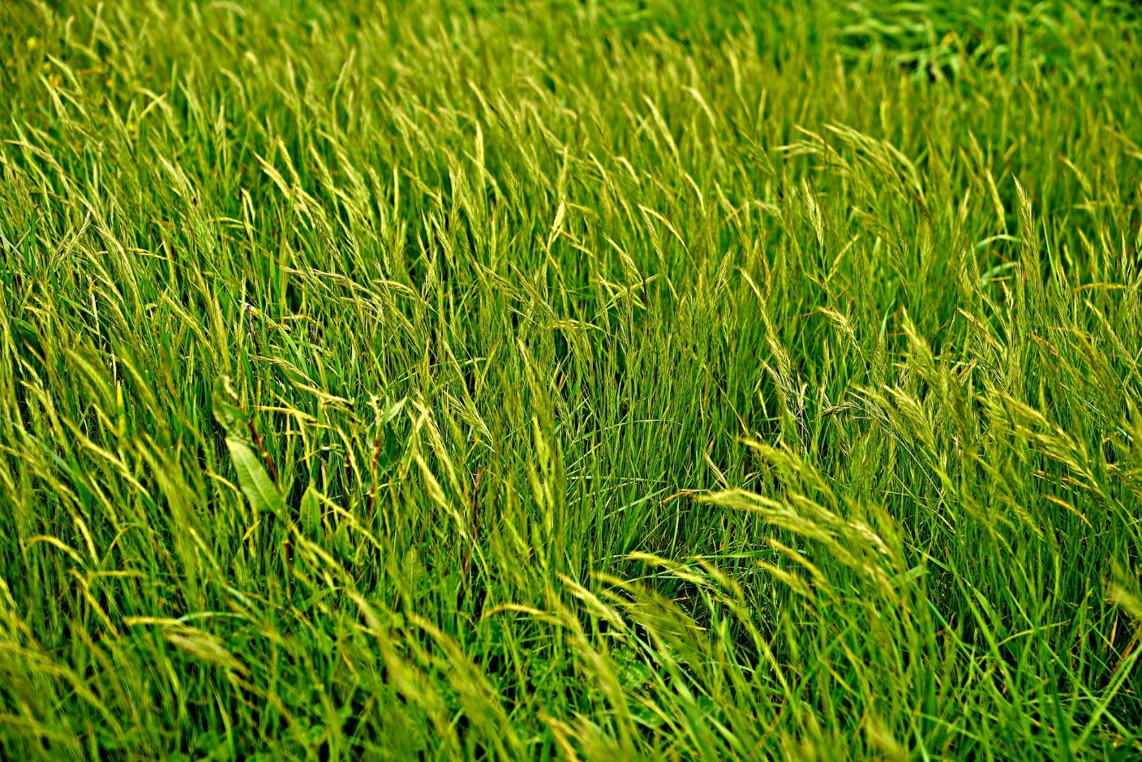

Credits
Dandelion: https://pixabay.com/en/dandelion-sky-flower-nature-seeds-463928/
Flag: https://pixabay.com/en/american-flag-flag-flying-378142/
Footsteps : https://pixabay.com/en/footsteps-sand-traces-barefoot-390516/
Kite: https://pixabay.com/en/kite-sky-clouds-fun-summer-fly-2667477/
Red sand: https://www.lds.org/media-library/images/sand-960963?lang=eng
Motion windy grass land: https://pixabay.com/en/motion-windy-grass-land-2825836/
See the world: https://www.freeimages.com/photo/see-the-world-1-1359033

