Have a Very Happy Birthday!
284b
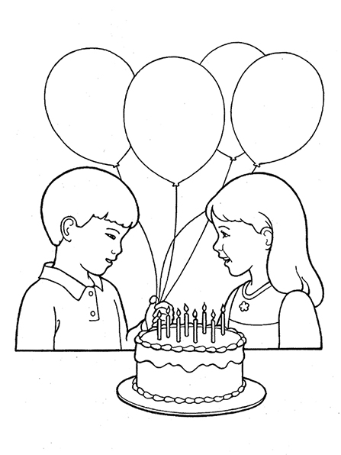

Words: Mabel Jones Gabbott
Music: Michael Finlinson Moody
Flipchart compiled by Cherice Montgomery
Have a very happy birthday

Filled with sunshine ev’rywhere!
May the year bring
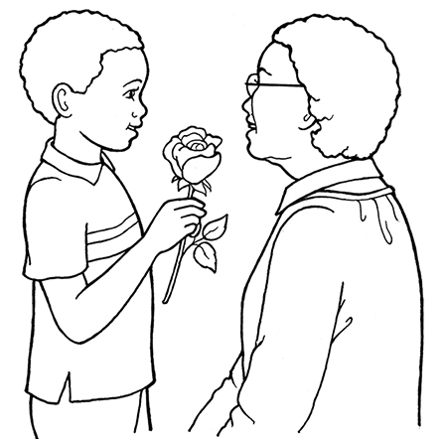
joy & gladness
And the love of friends
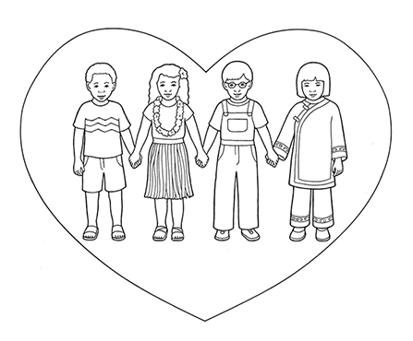
who care.
Have a most exciting birthday!

Share a smile with someone new.
Say a
kind word to your neighbor;

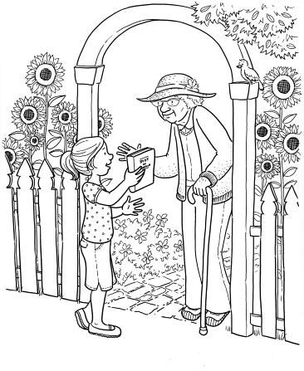

Let him know
a happy you.

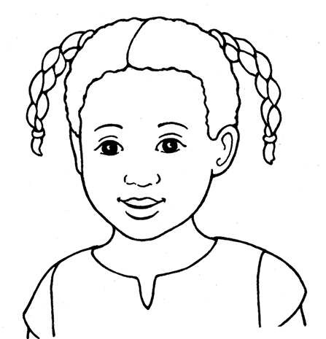

Have a very special birthday!

Add a candle,
blow it out,

Share your cake, and
share your friendship;
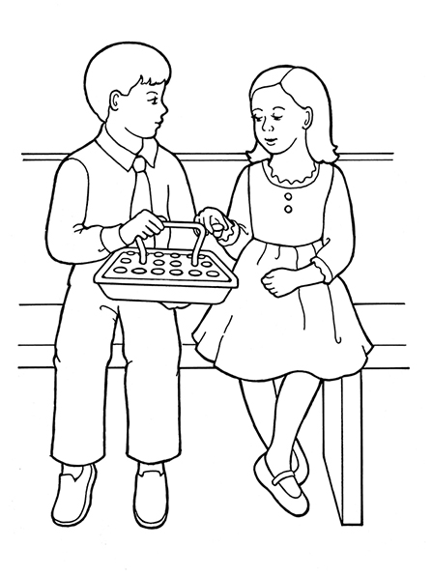

That’s what
birthdays
are about.

Image Credits:

Children Birthday Party: https://www.lds.org/media-library/images/children-birthday-party-1232928?lang=eng

Sun Whitaker: https://www.lds.org/media-library/images/sun-whitaker-368213?lang=eng

Boy Rose Mother: https://www.lds.org/media-library/images/boy-rose-mother-1238170?lang=eng

Children Love: https://www.lds.org/media-library/images/children-love-1238924?lang=eng

Primary Art Children Faces: https://www.lds.org/media-library/images/primary-art-children-faces-1156218?lang=eng

Girl Man Coloring Page: https://www.lds.org/media-library/images/girl-man-coloring-page-stott-496728?lang=eng

Girl Child: https://www.lds.org/media-library/images/girl-child-1232936?lang=eng

Boy Girl Sacrament Nursery Manual: https://www.lds.org/media-library/images/boy-girl-sacrament-nursery-manual-402192?lang=eng

Girl Eighth Birthday: https://www.lds.org/media-library/images/girl-eighth-birthday-624259?lang=eng

