Hello, Friends!
By Wilma Boyle Bunker
p. 254a

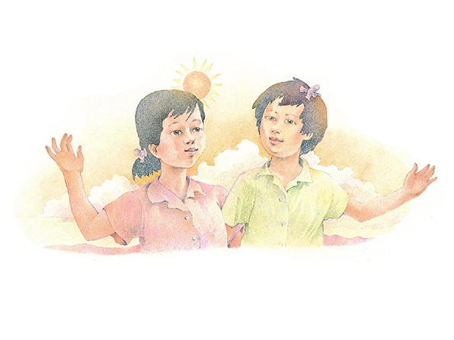
Flipchart compiled by Cherice Montgomery

Hello, friends!

It's nice to be

here with you

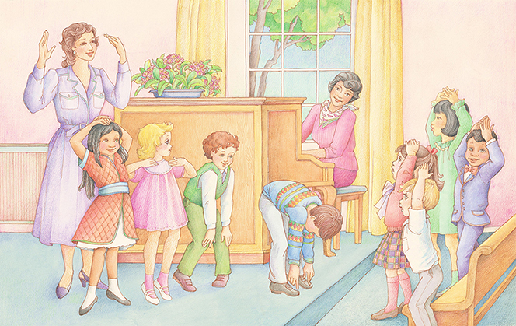
in Primary.

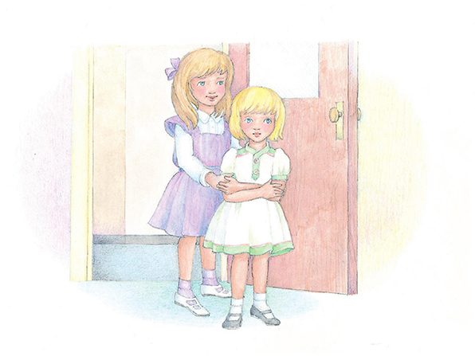
I'll help you, and
you'll help me.

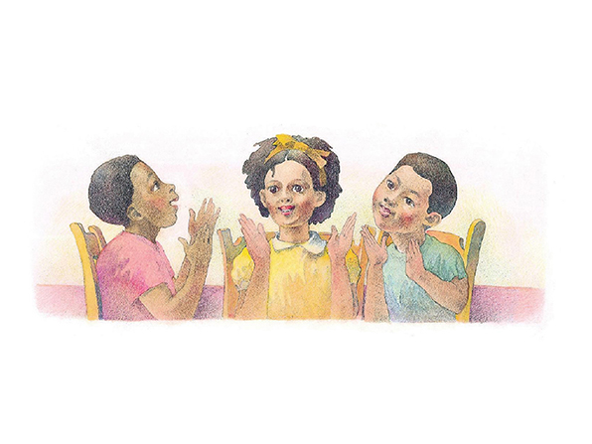
We'll be happy
as can be.
Image Credits

Friends in Sunshine: https://www.lds.org/media-library/images/children-songbook-art-153062?lang=eng&_r=1

LDS Primary Children Singing Activity: https://www.lds.org/media-library/images/lds-primary-children-singing-activity-358193?lang=eng

Girls Walking into Primary: https://www.lds.org/media-library/images/children-songbook-art-153026?lang=eng

Clapping & Singing: https://www.lds.org/media-library/images/children-songbook-art-153066?lang=eng

