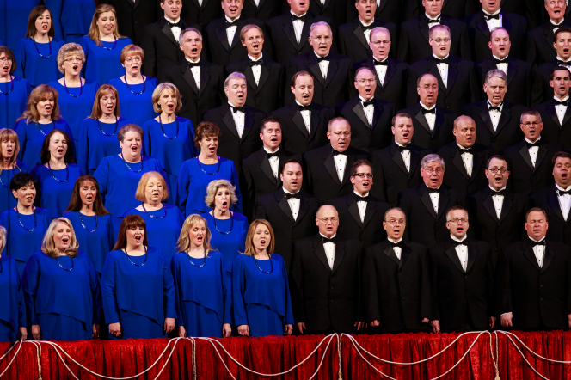

Let’s sing like the Mormon Tabernacle Choir!

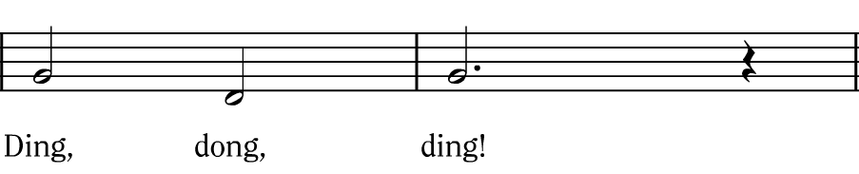

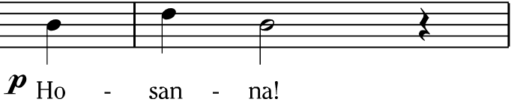

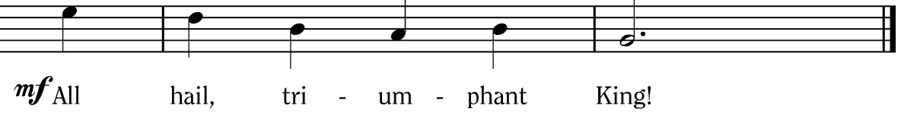

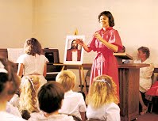
Hosanna! Let our
voices
ring!

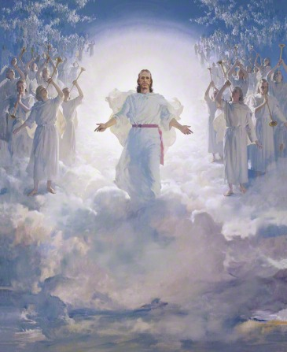
With praises to our heav’nly
King;
Let ev’ry
living
creature
sing
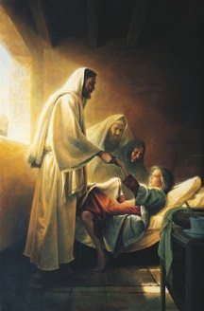
To Him
who life
did bring!

Image Credits:
Singing at Church 3-65: https://sites.google.com/site/ldsmeetinghouselibrarypicsgia/_/rsrc/1236209903846/Home/Singing%20at%20Church.3-65.jpg?height=153&width=200

Mormon Tabernacle Choir Christmas Concert 2013 1189120: https://www.lds.org/media-library/images/mormon-tabernacle-choir-christmas-concert-2013-1189120?lang=eng

The Second Coming 39618: https://www.lds.org/media-library/images/the-second-coming-39618?lang=eng&_r=1

Singing 658557: https://www.lds.org/media-library/images/singing-658557?lang=eng

Jesus Raising Jarisus’s Daughter 39561: https://www.lds.org/media-library/images/jesus-raising-jairuss-daughter-39561?lang=eng

