JR. OPENING EXERCISES: 10:10 – 10:15 AM
JR. SINGING TIME: 10:15 - 10:35 AM
SR. OPENING EXERCISES: 10:40 – 10:45 AM
SR. SINGING TIME: 10:45 – 11:00 AM
- I can be happy by LIVING THE WAY JESUS TAUGHT (i.e., the gospel). [JR: 5 min., SR: 2 min.]

SING: I’m Trying to Be Like Jesus – 78 (I Spy)

SAY: What are some things the song says Jesus taught us to do? [Be kind, give, love, serve (“to serve” means to help other people)]

JR ONLY: ACTIVITY 1: I Spy Pass out a toilet paper roll covered in wrapping paper to each child.

- We’re going to sing it again slowly.
- As you sing, find a picture of Jesus.
[Sing: I’m trying to be like Jesus Ask: Nod if you are looking at a picture of Jesus?]
- Next, find someone doing the same thing Jesus did. Here we go.
[Sing: I’m following in His ways Ask: Did everyone find a match?]
- Now find a new picture of Jesus. Here we go. Sing with me!
[Sing: I’m trying to love as He did Ask: Does everyone have a new picture of Jesus?]
- Now look for its match.
[Sing: In all that I do and say Say: Look at me through your binoculars if you found a match]

JR & SR: ACTIVITY 2: Stop & Go

SAY: Now let’s see how well you know the chorus.

- I’m going to point to a class.
- Sing until I hold up the stop sign.
- Then I’ll point to another class.
- They will sing until I say stop.
- Bro./Sis. _____ will help me show you how this works. (Pick a teacher to model it with you)

Love one another…as Jesus loves you
Try to show kindness…in all that you do
Be gentle and loving…in deed and in thought
For these are the things…Jesus taught

- I can be happier by LOVING others. [3 minutes]

ASK: What are some things people do to show you they love you? (Give presents, hugs, kind words, kisses, service, spend time with you, tell you they love you)

SAY: If we want people to love us, we need to love them!

ACTIVITY: Kissy Face

- These are people who need our love. (Post pictures of teachers, ward
leaders, & parents)
- You are going to sing.
- I’m going to watch for super singers.
- Super singers will choose love to give them. (Let them choose from pictures with
magnets, or distribute stickers of presents, speech bubbles, kisses, and clocks)
- Let’s cover them in love before the song ends!

SING: Jesus Said Love Everyone – 61 (Actions) OR A Happy Family – 198 (Kissy face game)

[Repeat the game, singing one or both songs multiple times until time to move on]

SAY: We get to choose how we show love to others, and sometimes, the small ways are the best. For example, we don’t have to give big expensive presents to all of our friends to prove that we love them, and we don’t have to kiss someone we don’t know, etc.

- I can be happier by BEING KIND to others. [5 minutes]

SAY: It can be easy to love people who are like us or those we enjoy spending time with, but Jesus said we should love EVERYONE.

I’m going to sing you a story about that, then you get to try it.

SING: I’ll Walk With You – 140 (with spoon story) OR A Special Gift is Kindness – 145a (with flipchart) [if pressed for time]

ACTIVITY: Sing-a-Story with Spoons – Now you try it with me.

SAY: This week, I am going to try to be nice to ALL the people around me. I hope you’ll try that too and then tell me how it goes next week!

- I can be happier by SERVING others. [3 minutes]

SAY: Another thing Jesus did was to help the people around Him.

JUNIOR

ACTIVITY 1: Popcorn with Gs

- What sound does a G make? [Yes, [g] like “give”]
- Every time you hear a G, stand up.
- If you are already standing up, sit down.
- Let’s try it! [Model it by standing and sitting with the children up until you get to the phrase: “as it hurried down the hill”]

ACTIVITY 2: Popcorn with Ss

- What sound does an S make?
- That’s right: S like “said” or “stream” or “small”
- Okay, let’s try the rest of the song with Ss.

JUNIOR SING: “Give,” Said the Little Stream – 244 (Stand on Gs, sit on Ss) OR
When We’re Helping – 198b [If pressed for time]

SAY: Have you ever noticed that all around a stream (which is like a little river), the grass is green and lots of flowers, plants, and trees grow? We want to be so kind to the people around us that after we leave, they perk up because they feel happier, just like plants perk up after they get watered.

SENIOR:

SAY: Jesus taught us that when they ask us for help, we should do even more than they ask. That’s called “going the second mile.”

SENIOR SING: Teach Go the Second Mile – 167

ACTIVITY: I Sing, You Sing

- Post the phrases “do it with a smile,” “go the second mile,” and “try it for awhile.”
- Sing each phrase to the piano and have children echo you.
- Say: Those are your parts for today.
- Say: I’m going to sing my part, then point to one of your parts
- Say: Your job is to remember how to sing that part.
- I can be happier by CHOOSING THE RIGHT. [JR: 4 minutes, SR: 2 minutes]

SING: Choose the Right Way – 160 (Chorus only) OR Choose the Right - #239

TESTIFY: The scriptures tell us that “…men are that they might have joy” (2 Nephi 2:25). This means that the whole reason we are alive is so we can be happy.

But the scriptures also tell us that “…wickedness never was happiness” (Alma 41:10). This means that when we try to make ourselves happy by doing things we know we shouldn’t, it might seem fun for a little while, but it won’t make us happy in a way that lasts.

That’s because happiness doesn’t come from what we get. It comes from what we give. “For that which ye do send out shall return unto you again, and be restored….” (Alma 41:14).

I know that when we live the way Jesus taught, we will show love to others. That will make people around us happy and that will make us happy.

Transition Time Songs
Notes | Page | Songs | Activities
 | 261 | Here We Are Together | Name Game
 | 266 | If You’re Happy | Freeze like this….(with yoga cards)
 | 267a | Smiles  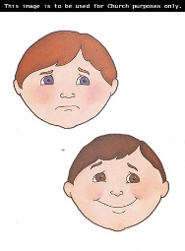 | If you…frown - Frown  Do not… – Wag finger  Quickly – Hop facing backwards  Turn it - Hop forwards  Upside down – Flip head down between legs  Smile that frown away – Sit up and smile
 | 267b | A Smile is Like the Sunshine | Smile – Smile  Sunshine – Hands over head in a circle  Brightens – Move circle to left and right  Day – ASL  Eye – Point to eye  Twinkle – Flash hands  Chases – Run in place
SENIOR | 18 | I Need My Heavenly Father | Echo Singing
Opening Song: | 163 | I Am Like a Star | I – Point to self  Star – ASL  Shining brightly – Flash hands  Shining…world – Circle arms in front of self and then spin  I can do & say – Run in place then point to mouth  Happy things – Smile & nod head  Each day – Hop 2x  For I know – Point to head  Heavenly Father – Hand up  Loves me – Hug self

Scripture | Page | Singing Time Songs | Activities
“Blessed are the meek: for they shall inherit the earth” (Matthew 5:5).  “Therefore, what manner of men ought ye to be? Verily I say unto you, even as I am” (3 Nephi 27:27).  “Be ye therefore perfect, even as your Father which is in heaven is perfect” (Matthew 5:48). | 78 | I’m Trying to Be Like Jesus | 1: I Spy Game  2: Stop & Go Game
“Blessed are the peacemakers: for they shall be called the children of God” (Matthew 5:9). | 61  198a | Jesus Said Love Everyone OR  A Happy Family | Kissy Face Game
“But I say unto you, Love your enemies, bless them that curse you, do good to them that hate you, and pray for them which despitefully use you, and persecute you;” (Matthew 5:44). | 140  145a | I’ll Walk With You OR  A Special Gift is Kindness | Sing-a-Story with Spoons  Posters
“Give to him that asketh thee, and from him that would borrow of thee turn not thou away” (Mathew 5:42).  “And whosoever shall compel thee to go a mile, go with him twain” (Matthew 5:41). | 244  198b  167 | JR: “Give,” Said the Little Stream OR  When We’re Helping  SR: Go the Second Mile | Stand on Gs, sit on Ss  I Sing, You Sing Game
“And moreover, I would desire that ye should consider on the blessed and happy state of those that keep the commandments of God. For behold, they are blessed in all things, both temporal and spiritual;…” (Mosiah 2:41) | 160  #239 | Choose the Right Way OR  Choose the Right | Chorus only
“If ye know these things, happy are ye if ye do them” (John 13:17).  Postlude | 18 | I Need My Heavenly Father | Play and sing as they dismiss to classes

Pictures for matching what Jesus did with what we do.

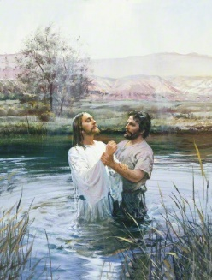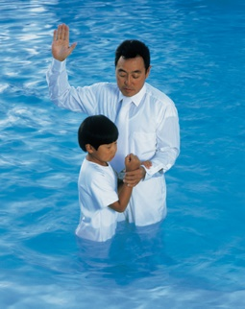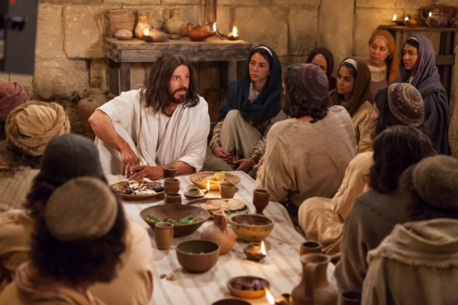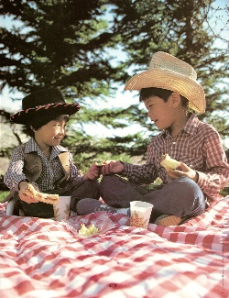

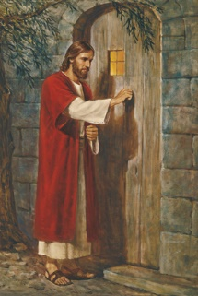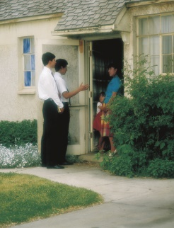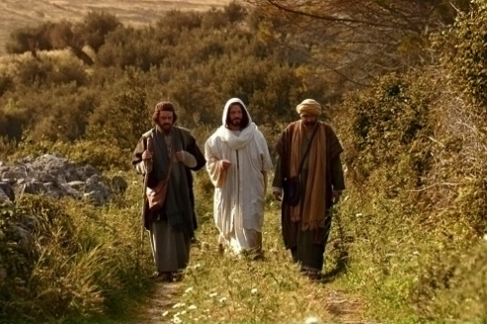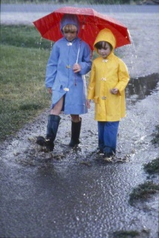

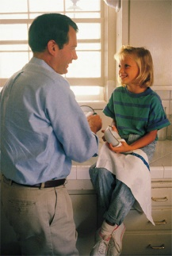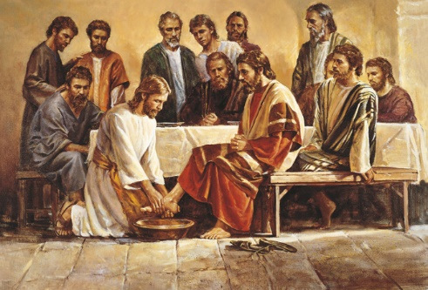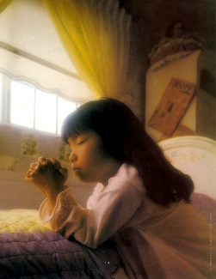

ALTERNATE IDEA FOR SINGING TIME

I can be happy by LIVING THE WAY JESUS TAUGHT (i.e., the gospel). [15-20 minutes]

- Choose an object.
- Read the scripture.
- Sing the related song.
- Ask: So how does (insert the name of the gospel principle) help us to feel happy?

SING: I’m Trying to Be Like Jesus – 78 OR I Need My Heavenly Father – 18

SAY: What are some things that Jesus taught us to do? (Look at the pictures for help.)

- SOAP - I can keep my thoughts, words, and actions clean.
“And blessed are all the pure in heart, for they shall see God” (3 Nephi 12:8) OR “But I say unto you, Swear not at all…” (Matthew 5:34).
(The Lord Gave Me a Temple – 153)

- LIGHT - I can set a good example.
“Let your light so shine before men, that they may see your good works, and glorify your Father which is in heaven” (Matthew 5:16).
(Shine On – 144)

- SALT – I can be kind and forgiving.
“But I say unto you, Love your enemies, bless them that curse you, do good to them that hate you, and pray for them which despitefully use you, and persecute you” (Matthew 5:44).
(Kindness Begins with Me – 145b)

- MIRROR or MAGNIFYING GLASS – I can show love to other people.
“A new commandment I give unto you, That ye love one another;….By this shall all men know that ye are my disciples, if ye have love one to another” (John 13:34-35). (Love One Another – 136)

- BLANKET - I can be a peacemaker.
“Blessed are the peacemakers: for they shall be called the children of God” (Matthew 5:9).
(Jesus Said Love Everyone – 61)

- PUPPY – I can humbly and willingly listen to my parents, teachers, church leaders, and the Holy Ghost so they can teach me.
“Blessed are the meek: for they shall inherit the earth” (Matthew 5:5).
(Teach Me to Walk in the Light – 177)

