Instructions: Match the picture in the 1st column with the correct phrase in the 2nd column.
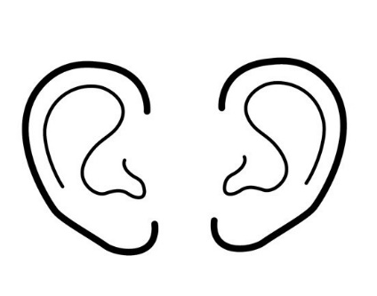 |  | 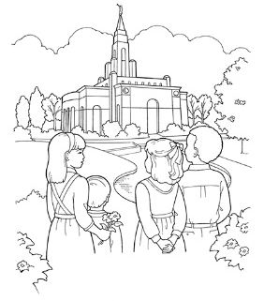  PLACES WHERE THEY SHOULD
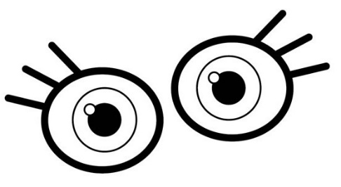 |  | 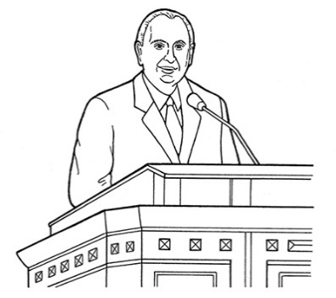  THE TRUTH
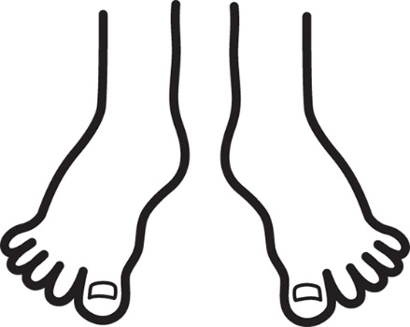 |  | 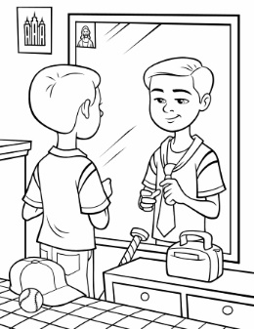  ME THIS WAY
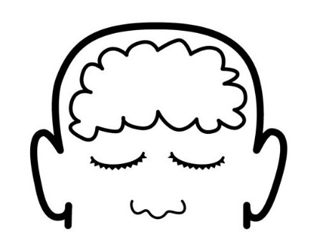  WISELY |  | 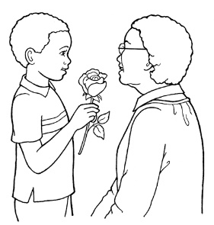  THE GOOD
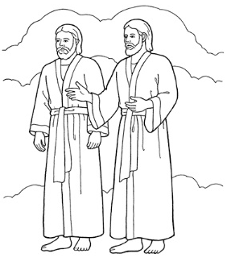  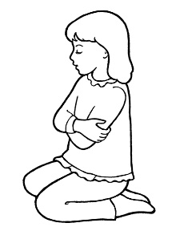 |  | 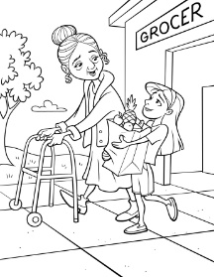  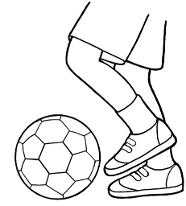  WORK & PLAY
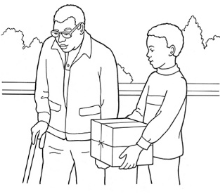

WORK FOR ME
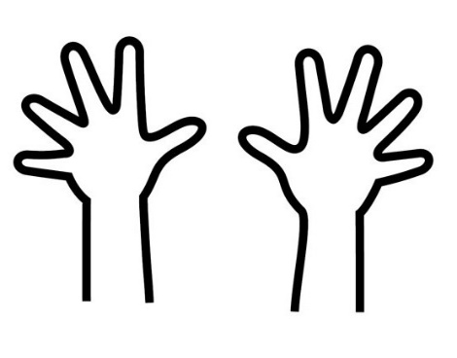 |  | 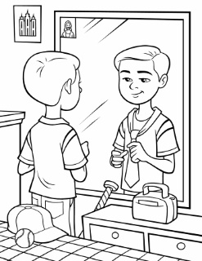  ME THIS WAY
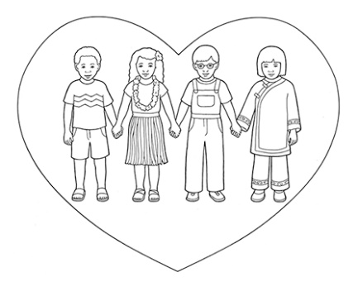 |  | 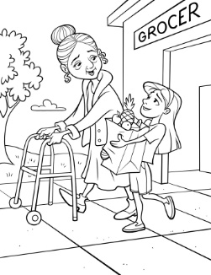  WORK & PLAY
WISELY |  | HEAVENLY FATHER GAVE TO ME
 |  | KIND WORDS
Credits

Boy Giving Flowers to an Older Woman: https://www.lds.org/media-library/images/boy-rose-mother-1238170?lang=eng&_r=1

Boy Helping Man: https://www.lds.org/media-library/images/boy-helping-man-694950?lang=eng&_r=1

Boy Mirror Tying Tie: https://www.lds.org/media-library/images/boy-mirror-tying-tie-1020755?lang=eng

Brain: https://www.lds.org/media-library/images/choose-right-2012-outline-sharing-time-heart-brain-814134?lang=eng

Children at the Temple: https://www.lds.org/media-library/images/line-art-children-temple-835109?lang=eng&_r=1

Children Holding Hands in a Heart: https://www.lds.org/media-library/images/children-love-1238924?lang=eng&_r=1

Ears: https://www.lds.org/media-library/images/choose-right-2012-outline-sharing-time-ears-814115?lang=eng

Eyes: https://www.lds.org/media-library/images/choose-right-2012-outline-sharing-time-eyes-814117?lang=eng&_r=1

Feet: https://www.lds.org/media-library/images/choose-right-2012-outline-sharing-time-feet-814119?lang=eng

Foot Kicking Soccer Ball: https://www.lds.org/media-library/images/child-kicking-soccer-ball-whitaker-387239?lang=eng&_r=1

Girl Helping: https://www.lds.org/media-library/images/girl-elderly-woman-groceries-helping-959416?lang=eng&_r=1

Godhead: https://www.lds.org/media-library/images/primary-men-1264764?lang=eng

Hands: https://www.lds.org/media-library/images/choose-right-2012-outline-sharing-time-hands-814123?lang=eng

Heart: https://www.lds.org/media-library/images/heart-1232299?lang=eng

Mouth: https://www.lds.org/media-library/images/choose-right-2012-outline-sharing-time-heart-mouth-814136?lang=eng

President Monson Speaking at General Conference: https://www.lds.org/media-library/images/general-conference-activity-packet-children-694943?lang=eng&_r=1

Small Girl Kneeling: https://www.lds.org/media-library/images/girl-praying-beth-whitaker-368209?lang=eng&_r=1

Washing Hands: https://www.lds.org/media-library/images/washing-hands-whitaker-387241?lang=eng&_r=1

