I Have Two Ears
From The Children’s Songbook, p. 269

Words by Georgia Maeser
Music by A. Laurence Lyon

Picture Only Flipchart for Verses 1 & 2 compiled by Cherice Montgomery
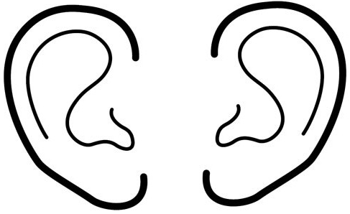
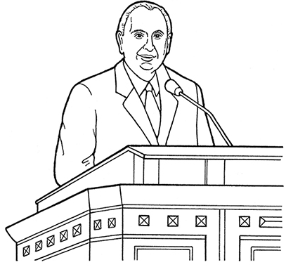

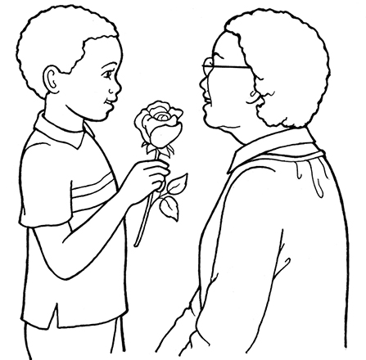
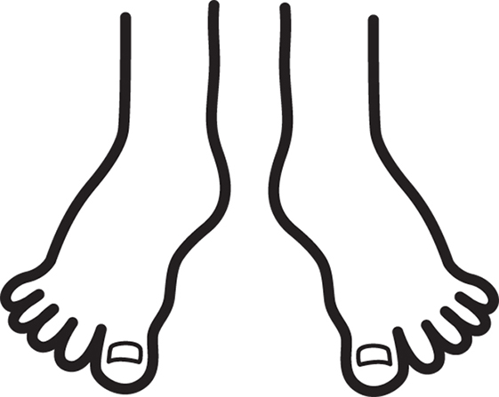
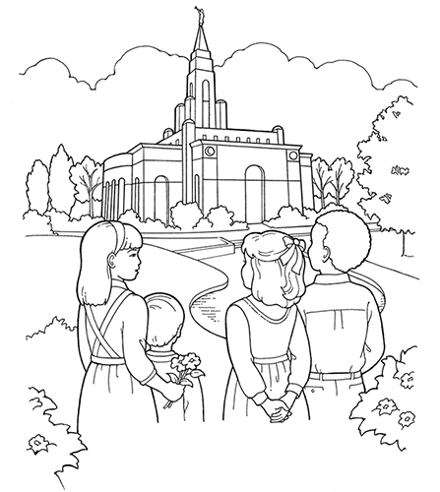
WISELY
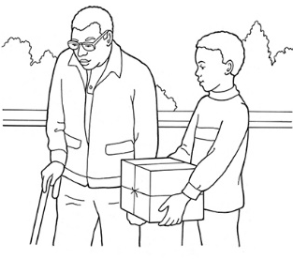

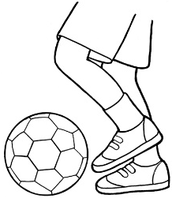

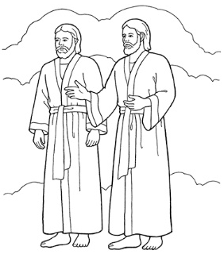

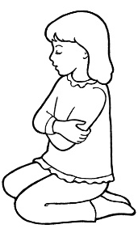

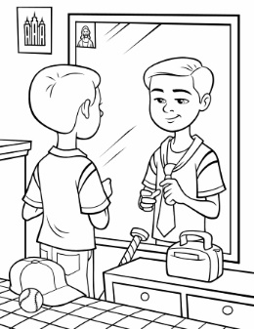

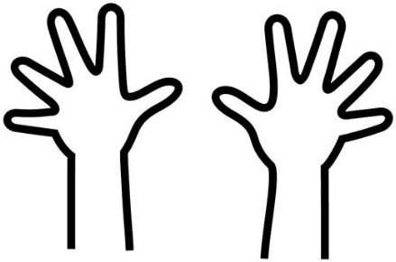
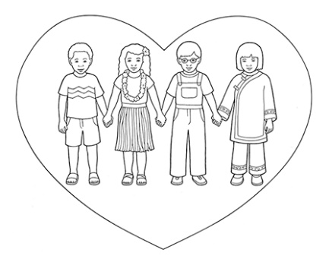
WISELY

Credits
Boy Giving Flowers to an Older Woman: https://www.lds.org/media-library/images/boy-rose-mother-1238170?lang=eng&_r=1
Boy Helping Man: https://www.lds.org/media-library/images/boy-helping-man-694950?lang=eng&_r=1
Boy Mirror Tying Tie: https://www.lds.org/media-library/images/boy-mirror-tying-tie-1020755?lang=eng
Brain: https://www.lds.org/media-library/images/choose-right-2012-outline-sharing-time-heart-brain-814134?lang=eng
Children at the Temple: https://www.lds.org/media-library/images/line-art-children-temple-835109?lang=eng&_r=1
Children Holding Hands in a Heart: https://www.lds.org/media-library/images/children-love-1238924?lang=eng&_r=1
Ears: https://www.lds.org/media-library/images/choose-right-2012-outline-sharing-time-ears-814115?lang=eng
Eyes: https://www.lds.org/media-library/images/choose-right-2012-outline-sharing-time-eyes-814117?lang=eng&_r=1
Feet: https://www.lds.org/media-library/images/choose-right-2012-outline-sharing-time-feet-814119?lang=eng
Foot Kicking Soccer Ball: https://www.lds.org/media-library/images/child-kicking-soccer-ball-whitaker-387239?lang=eng&_r=1
Girl Helping: https://www.lds.org/media-library/images/girl-elderly-woman-groceries-helping-959416?lang=eng&_r=1
Godhead: https://www.lds.org/media-library/images/primary-men-1264764?lang=eng
Hands: https://www.lds.org/media-library/images/choose-right-2012-outline-sharing-time-hands-814123?lang=eng
Heart: https://www.lds.org/media-library/images/heart-1232299?lang=eng
Mouth: https://www.lds.org/media-library/images/choose-right-2012-outline-sharing-time-heart-mouth-814136?lang=eng
President Monson Speaking at General Conference: https://www.lds.org/media-library/images/general-conference-activity-packet-children-694943?lang=eng&_r=1
Small Girl Kneeling: https://www.lds.org/media-library/images/girl-praying-beth-whitaker-368209?lang=eng&_r=1
Washing Hands: https://www.lds.org/media-library/images/washing-hands-whitaker-387241?lang=eng&_r=1

