**It’s what you bring to the pot!**

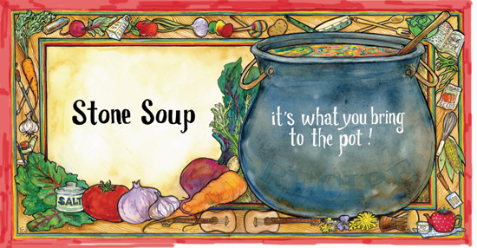

**Stone Soup**



**It’s what you bring to the pot!**

**PL 2nd Gratitude Dinner**

**Wed., Nov. 19, 2014**

**7:00 p.m. to 8:30 p.m.**

**In the Cultural Hall**

**3145 W. Mayflower Ave.**

**Nursery Provided**

**It’s what you bring to the pot!**