**Little Purple Pansies, p. 244**

**Words: Anon.**

**Music: Joseph Ballantyne**

**All images are from the**

**LDS Media Library**

**Flipchart compiled by**

**Cherice Montgomery**

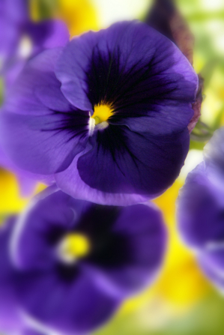

corner

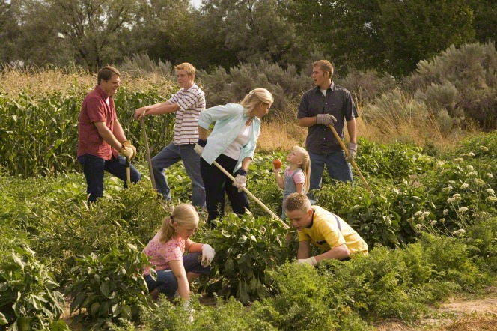

very tiny

but must

TRY, TRY, TRY

