Pictures for teaching the 2nd verse of My Heavenly Father Loves Me compiled by Cherice Montgomery based on an idea by Sharla Dance: http://teachingprimarymusic.com/my-heavenly-father-loves-me-sights-and-sounds-2nd-verse/

Instructions:

1) Show the picture (i.e., eyes).
2) Sing the targeted phrase (i.e., “He gave me my eyes, that I might see the color of butterfly wings.”)
3) Show the mystery picture (for eyes and for life/mind/heart) or play the mystery sound (for ears).
4) Let children guess.
5) Sing the targeted phrase again as you hold up the picture that shows the correct answer.

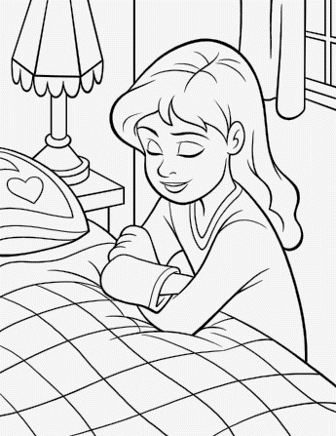

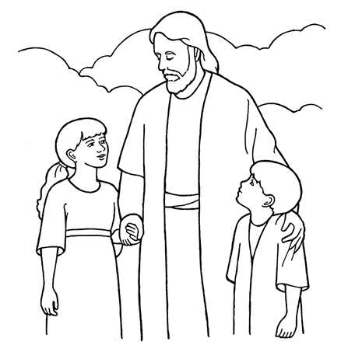

Credits
Ears: https://www.lds.org/media-library/images/choose-right-2012-outline-sharing-time-ears-814115?category=primary/line-art&&lang=eng
Eyes: https://www.lds.org/media-library/images/choose-right-2012-outline-sharing-time-eyes-814117?category=primary/line-art&&lang=eng
Feet: https://www.lds.org/media-library/images/choose-right-2012-outline-sharing-time-feet-814119?category=primary/line-art&&lang=eng
Girl Praying: https://www.lds.org/media-library/images/line-art-girl-praying-998955?lang=eng&_r=1
Hands: https://www.lds.org/media-library/images/choose-right-2012-outline-sharing-time-hands-814123?category=primary/line-art&&lang=eng
Heart: https://www.lds.org/media-library/images/choose-right-2012-outline-sharing-time-heart-814132?category=primary/line-art&&lang=eng
Mind: https://www.lds.org/media-library/images/choose-right-2012-outline-sharing-time-heart-brain-814134?category=primary/line-art&&lang=eng
Mouth: https://www.lds.org/media-library/images/choose-right-2012-outline-sharing-time-heart-mouth-814136?category=primary/line-art&&lang=eng

