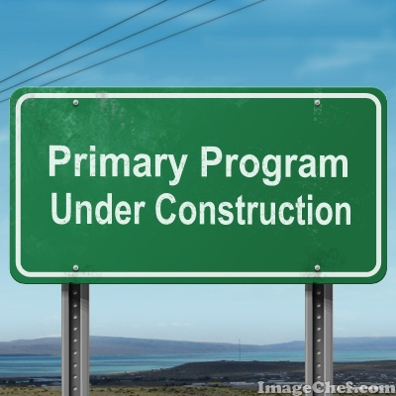

http://www.imagechef.com/t/vn4s/Freeway-Sign-Green

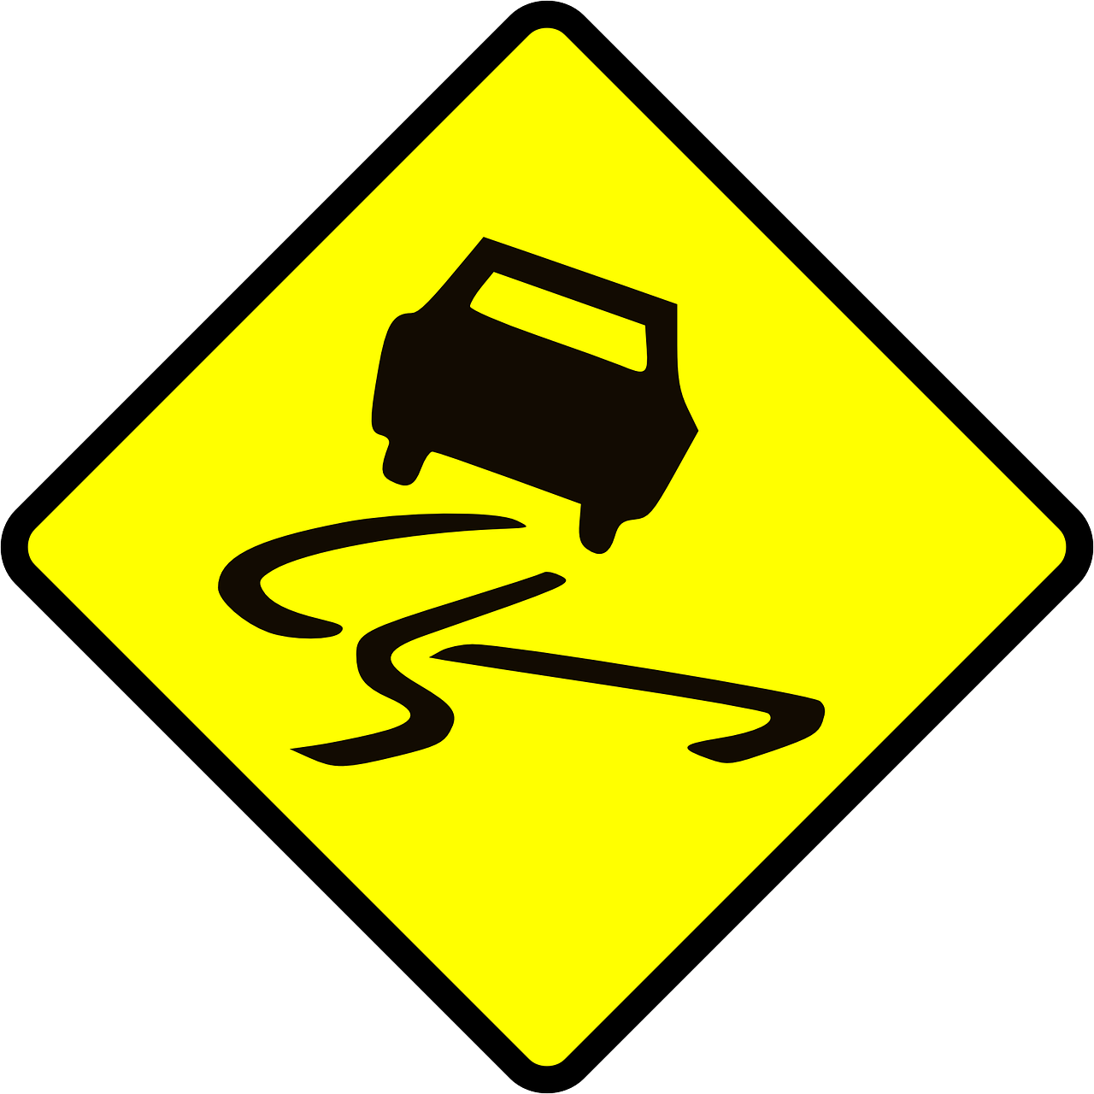
Activity: When chorister sprays water in the air, slide around on chairs as you sing

Image: https://pixabay.com/en/sign-road-sign-slippery-caution-32622/

Activity: Sing the song forwards and then backwards (i.e., last line first, then 3rd line, then 2nd line, etc.)

Image: https://pixabay.com/en/two-way-traffic-two-way-road-148887/

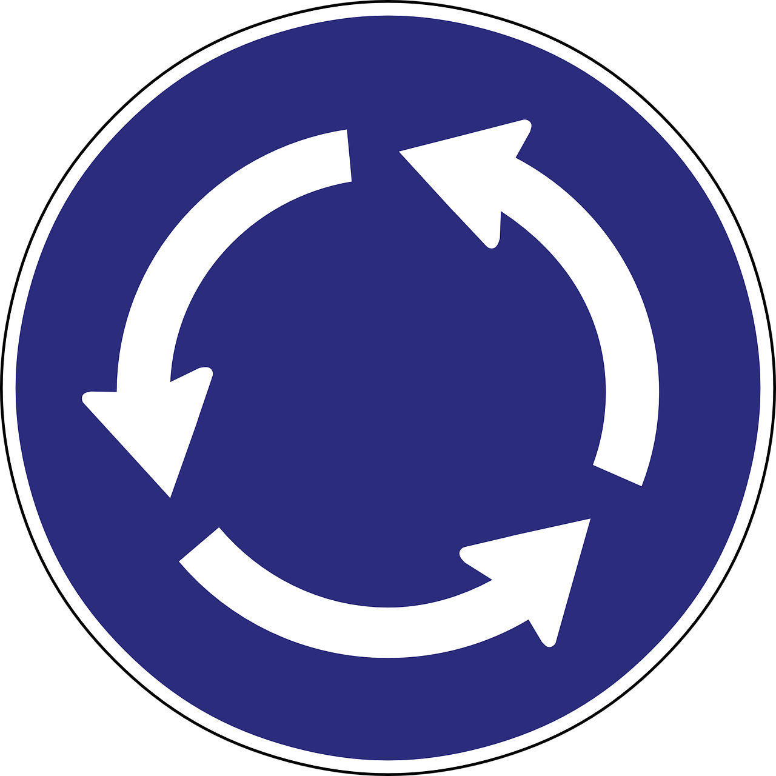
Possible Activities:
1) Sing song as a round.
2) One class sings the first line, the
next class the second, etc.

3) Sing the song three times in a row.

Image: https://pixabay.com/en/roundabout-arrow-direction-910043/
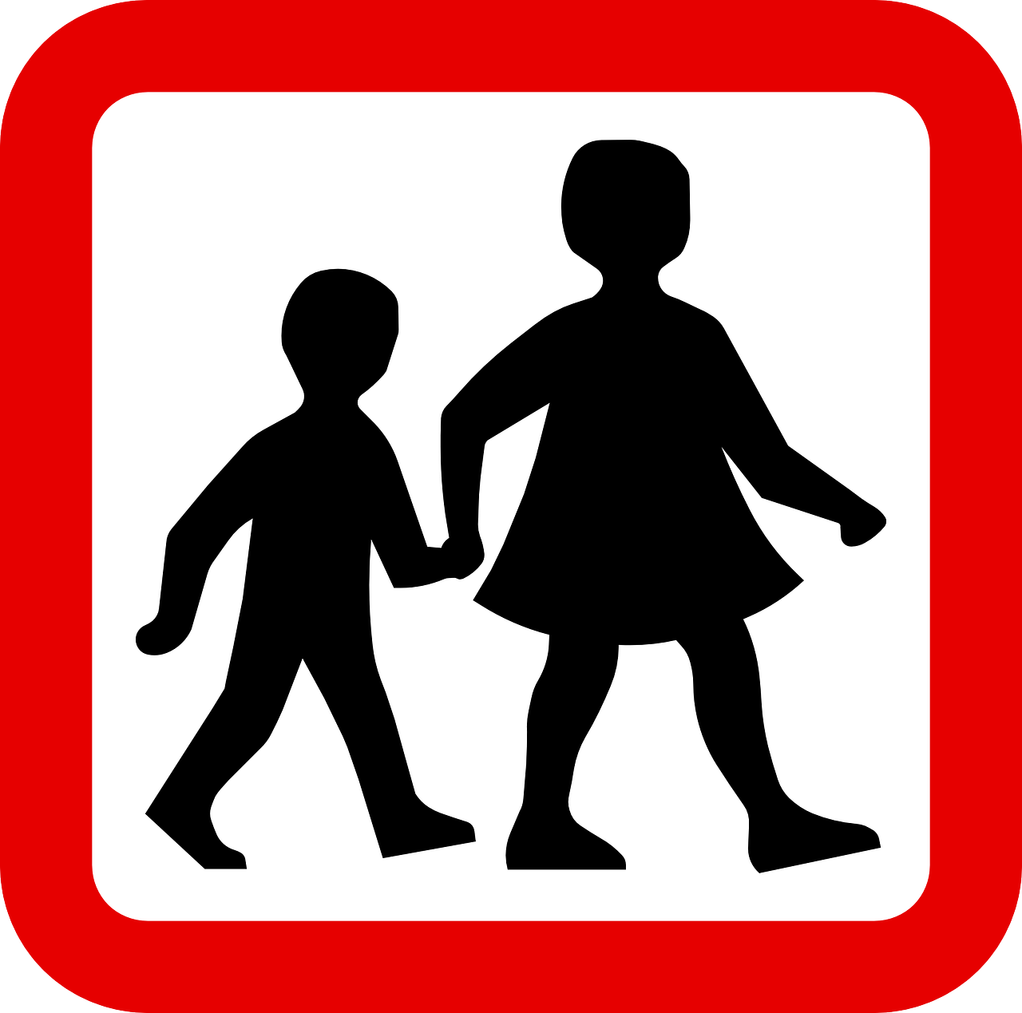
Activity: Only children sing

Image: https://pixabay.com/en/children-walking-sign-trafftic-sign-159352/

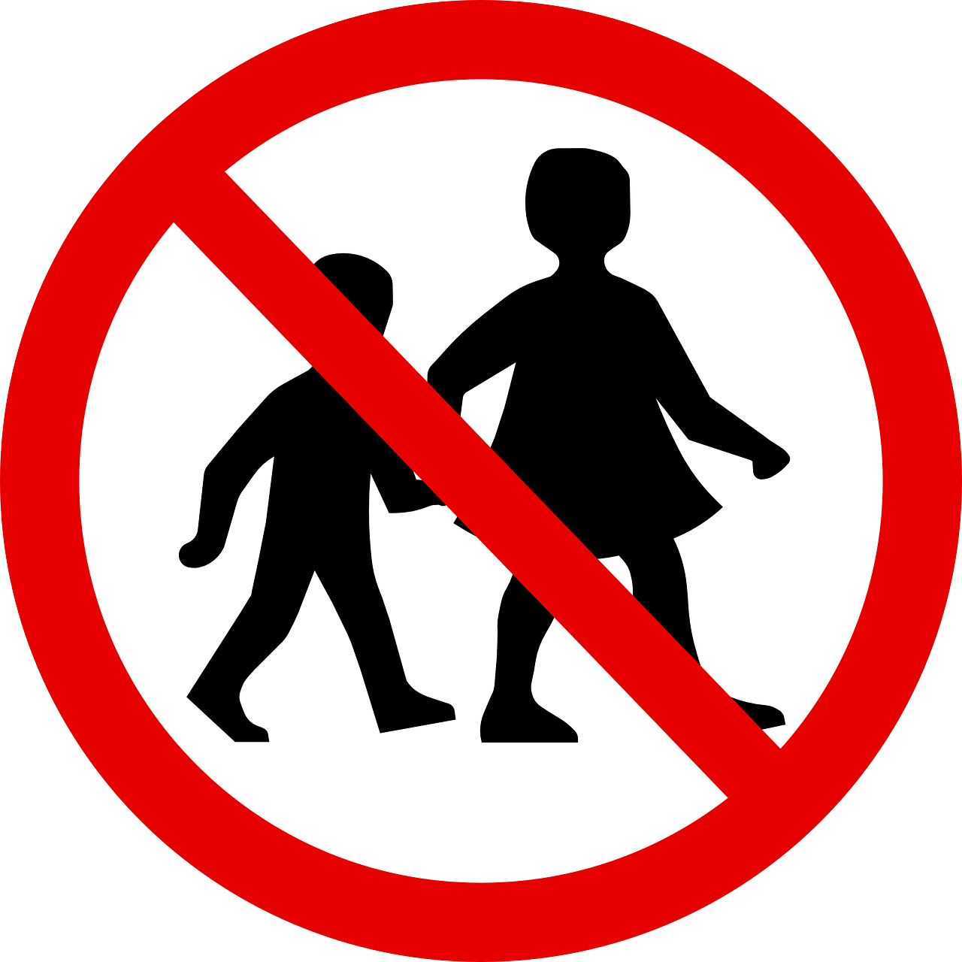
Activity: No children (i.e., teachers and Primary Presidency members only)

Image: https://pixabay.com/en/children-walking-forbidden-sign-159353/
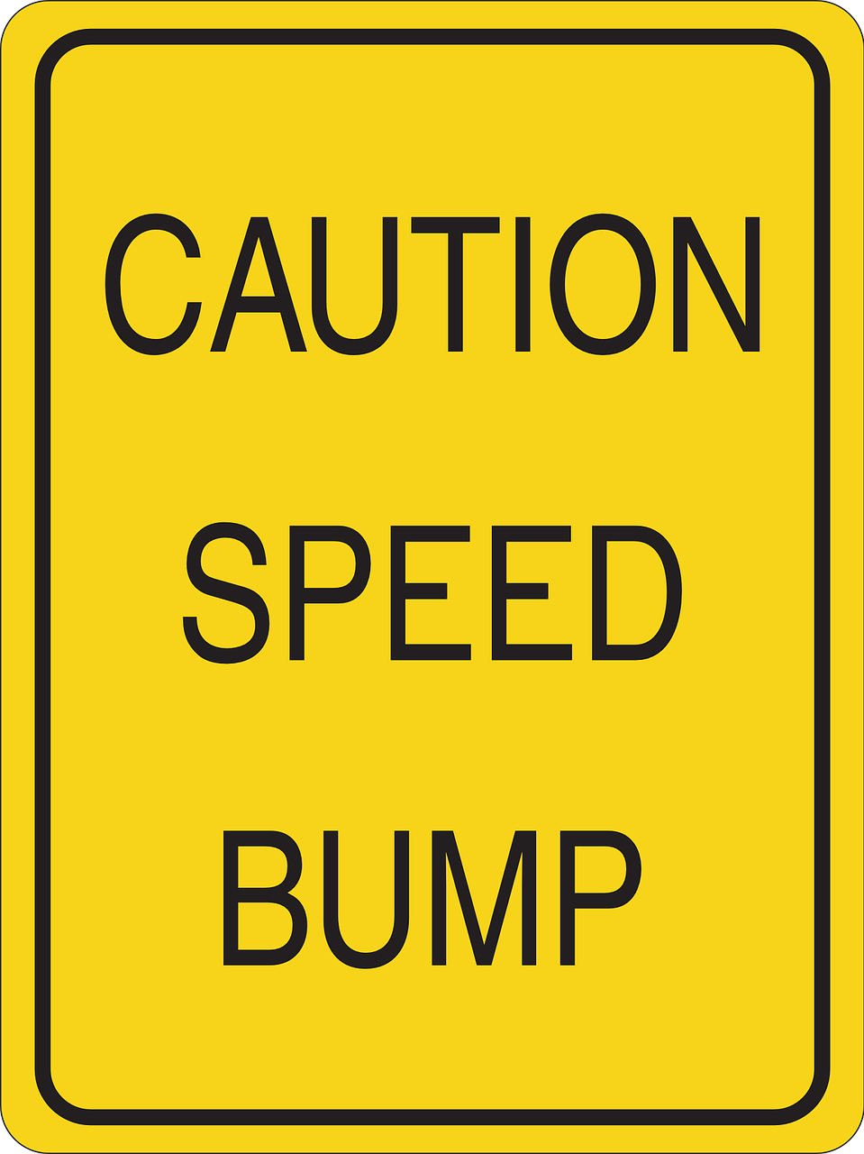

Possible Activities:
1) Pianist slows down randomly and
Primary follows

2) Sing while patting hands over
mouths as though going over bumps

image: https://pixabay.com/en/road-information-speed-bump-44143/

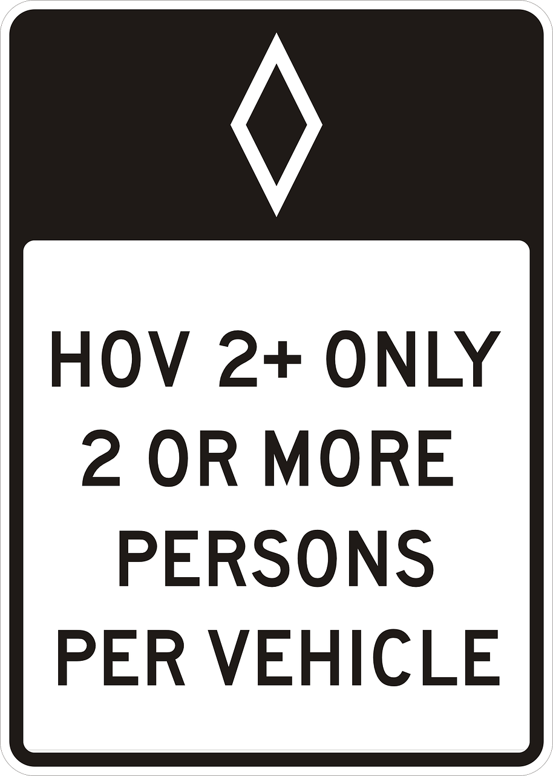

Activity: When chorister holds sign over a teacher’s head, that class sings with partner or small group

Image: https://pixabay.com/en/sign-attention-hov-expressway-161169/

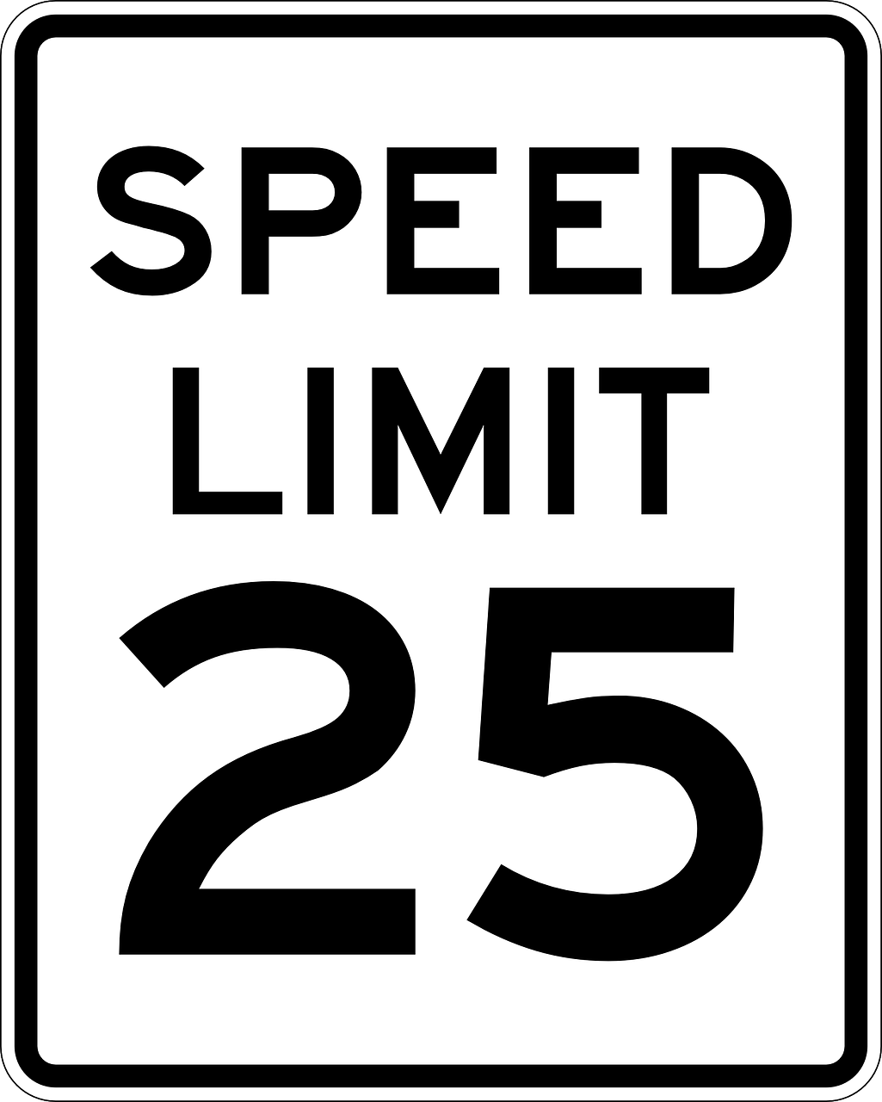
Activity: Sing very slowly

Image: https://pixabay.com/en/sign-speed-limit-25-miles-road-sign-161176/
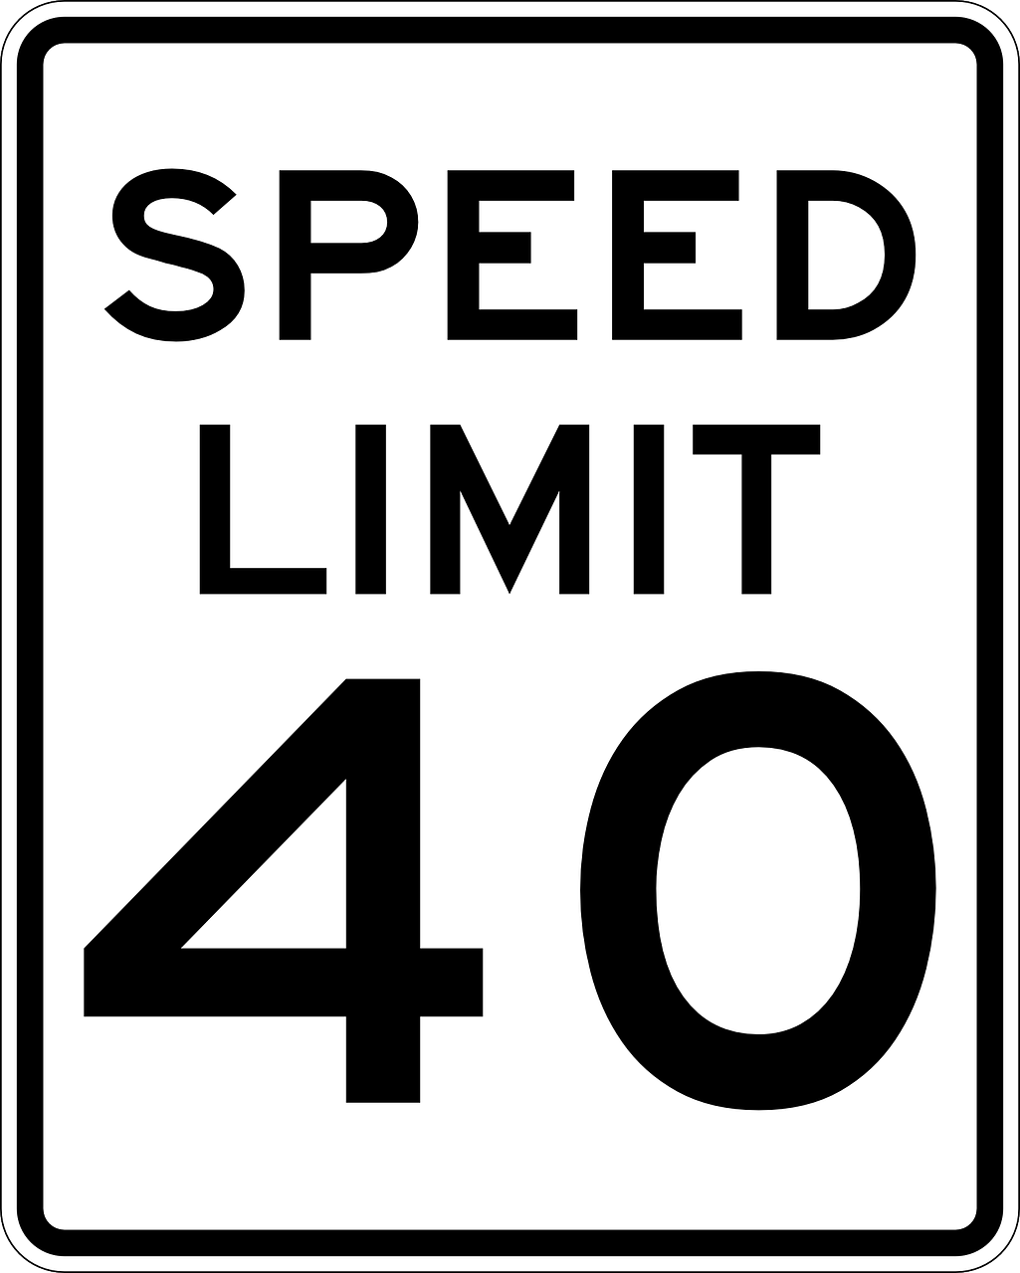
Activity: Sing at normal speed

Image: https://pixabay.com/en/sign-speed-limit-fourty-miles-161177/
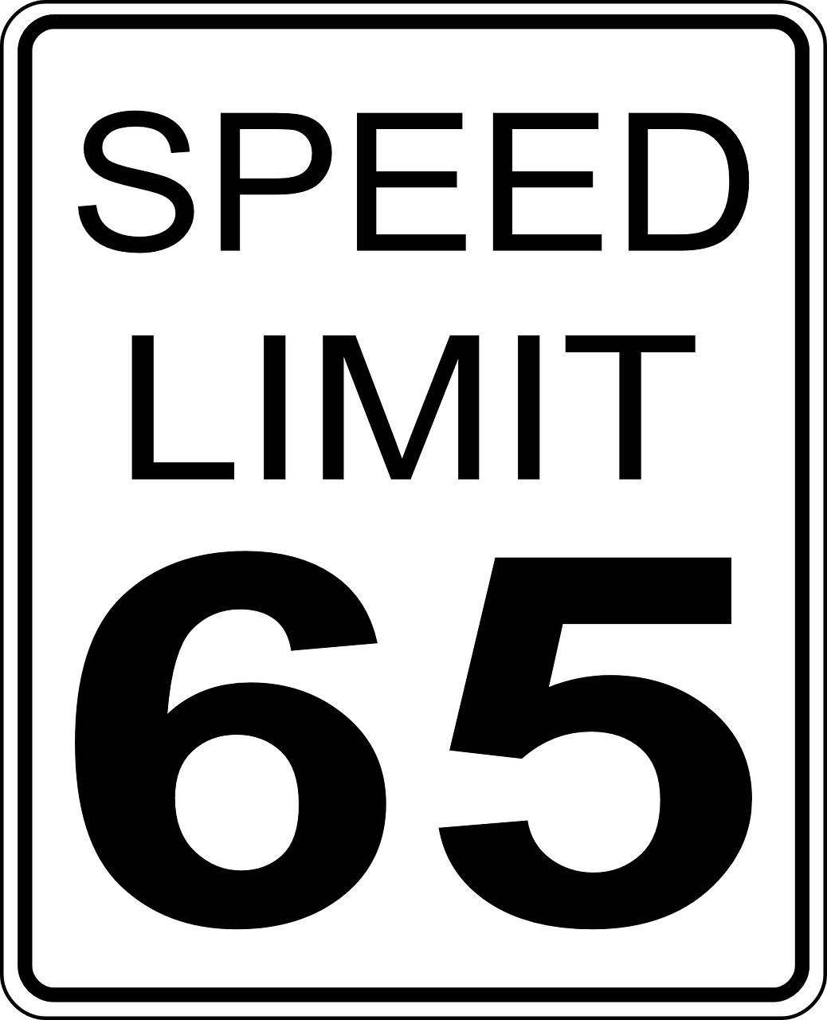
Activity: Sing fast

Image: https://pixabay.com/en/speed-limits-sign-united-states-32300/

Activity: Follow hand signals (choose different groups to sing, or direct dynamics)

Image: https://pixabay.com/en/stop-traffic-police-police-traffic-2164354/

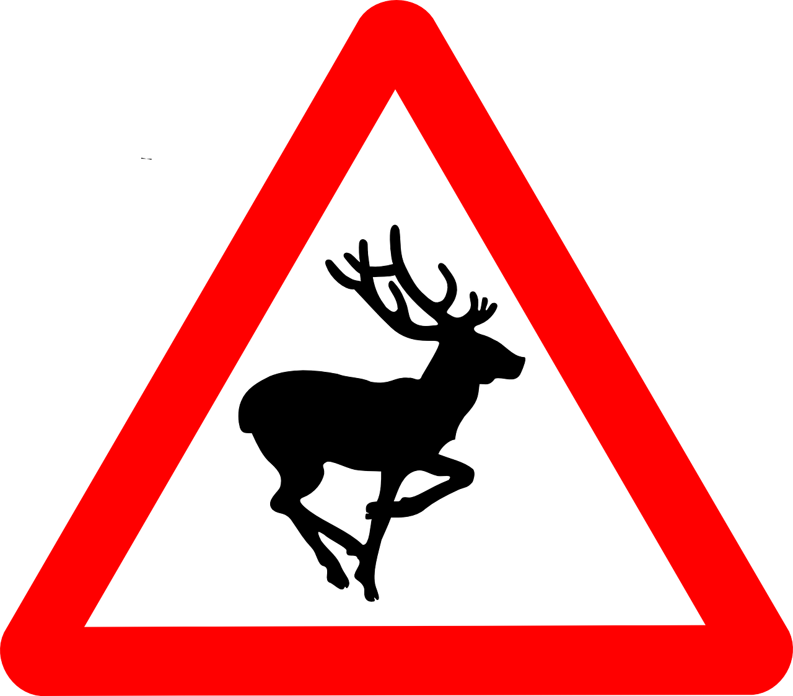
Activity: Stop singing whenever you see deer antlers pop out from behind piano (cut out of cardstock, a headband, or a stuffed animal)

Image: https://pixabay.com/en/deer-warning-signs-information-48015/

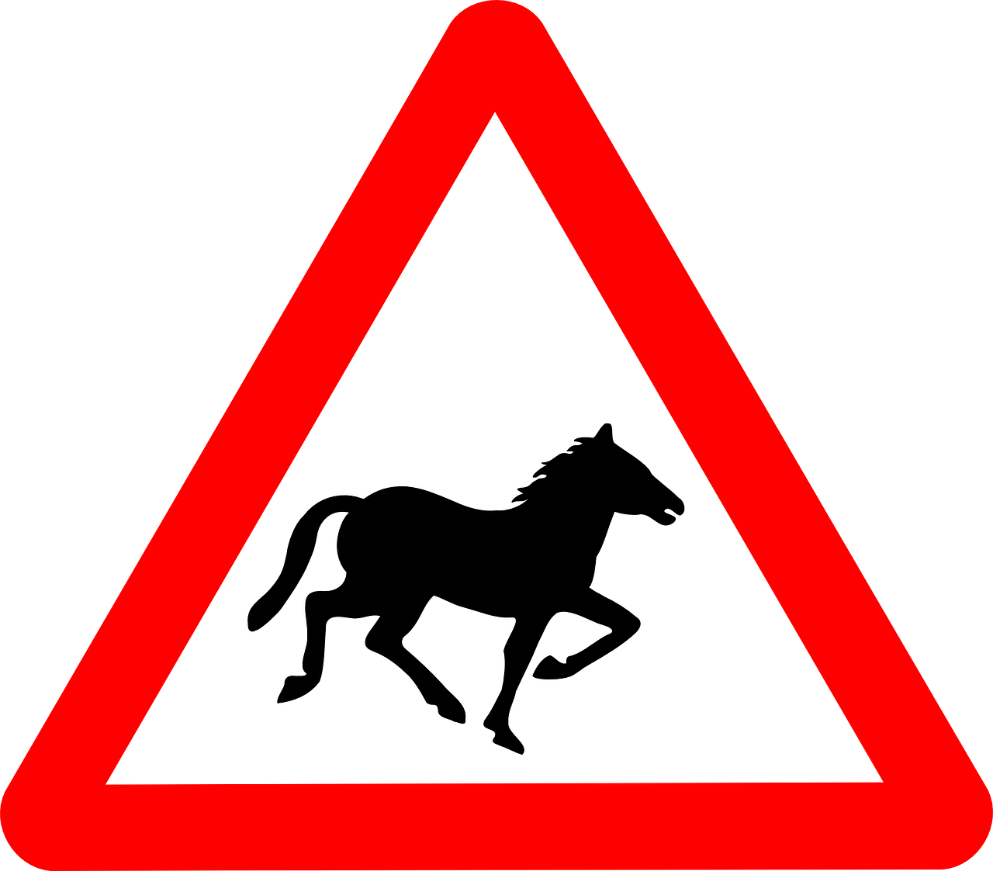
Activity: Gallop like a horse as you sing

Image: https://pixabay.com/en/horse-information-transport-road-48028/

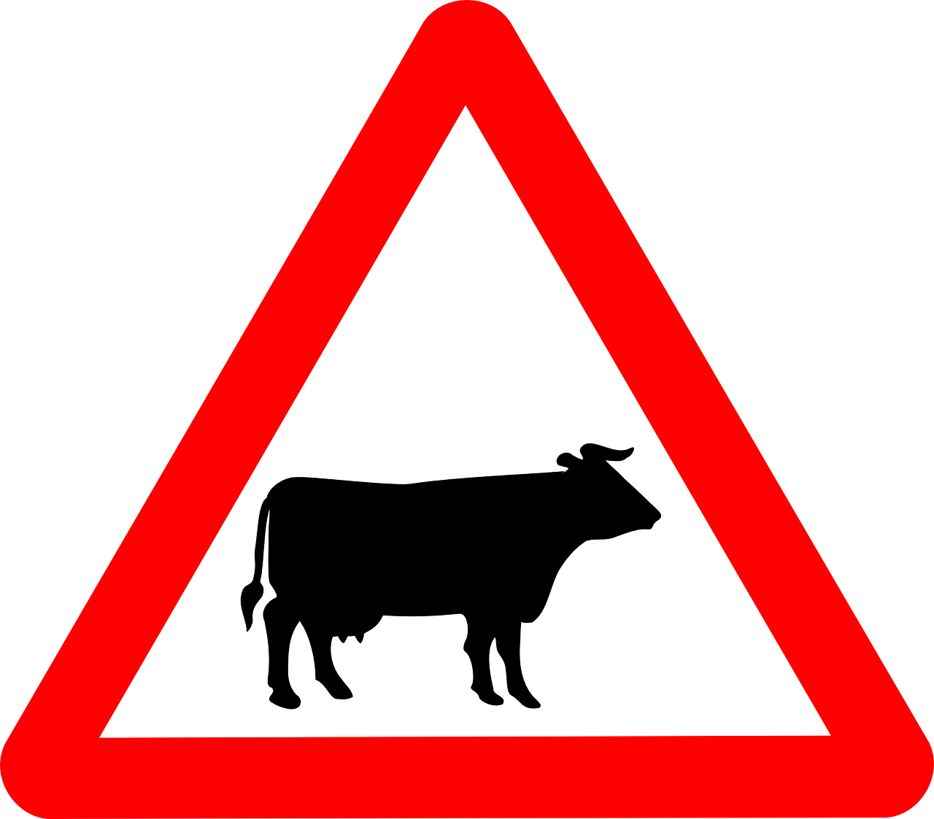
Activity: Whenever you hear the cowbell, stop singing and say, “Moooo” like a cow

Image: https://pixabay.com/en/cattle-crossing-signs-cattle-road-48010/

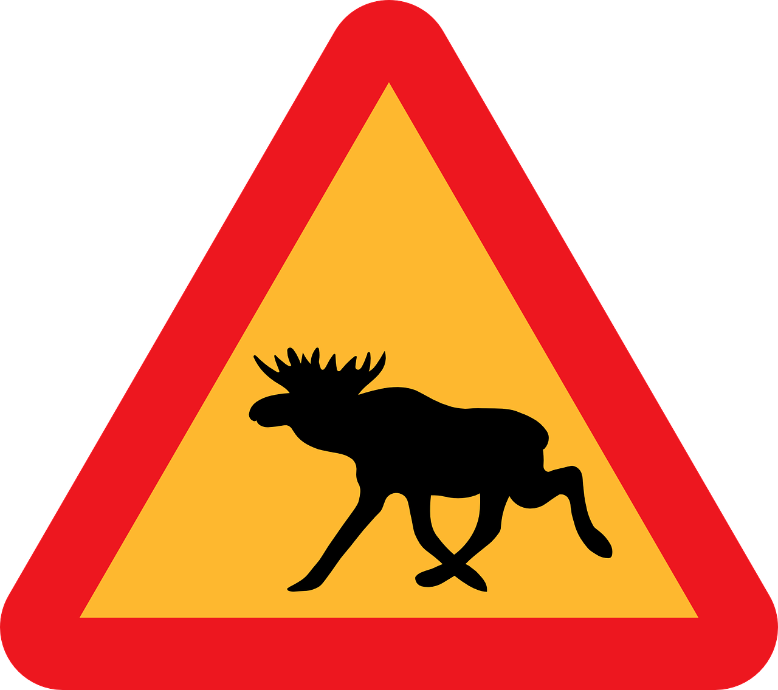

Activity: Whenever you see the moose, chew the grass (i.e., a straw) and hum

Image: https://pixabay.com/en/warning-moose-animal-road-street-34778/

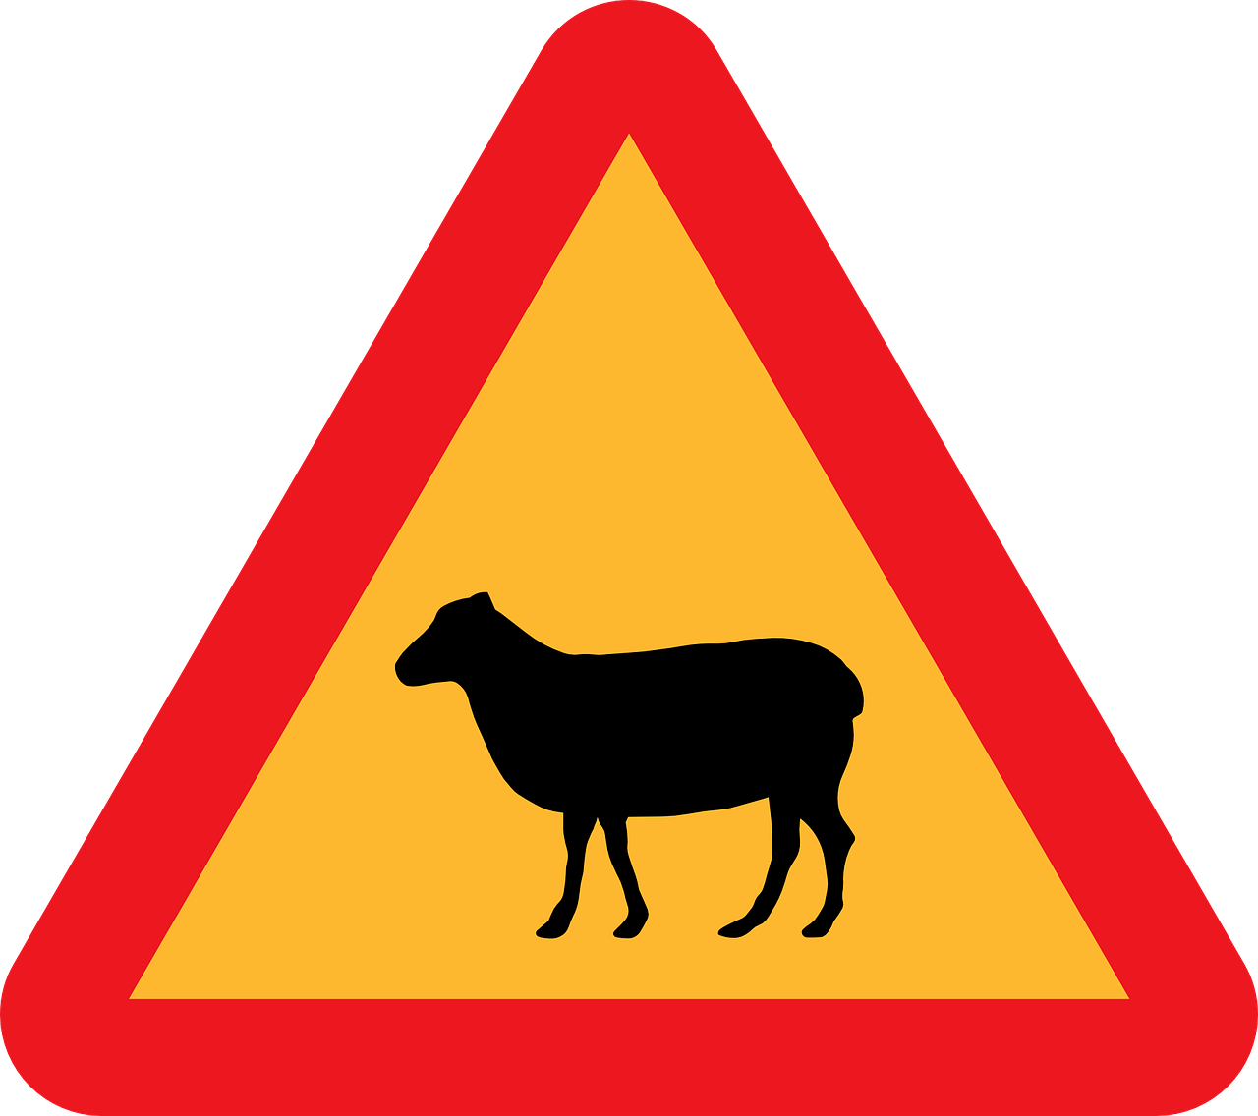

Activity: Whenever you see the sheep, make your voice wiggly as you sing the words like a sheep (or stop singing and say, “Baaaa!” like a sheep).

Image: https://pixabay.com/en/sheep-crossing-roadsign-road-sign-30925/

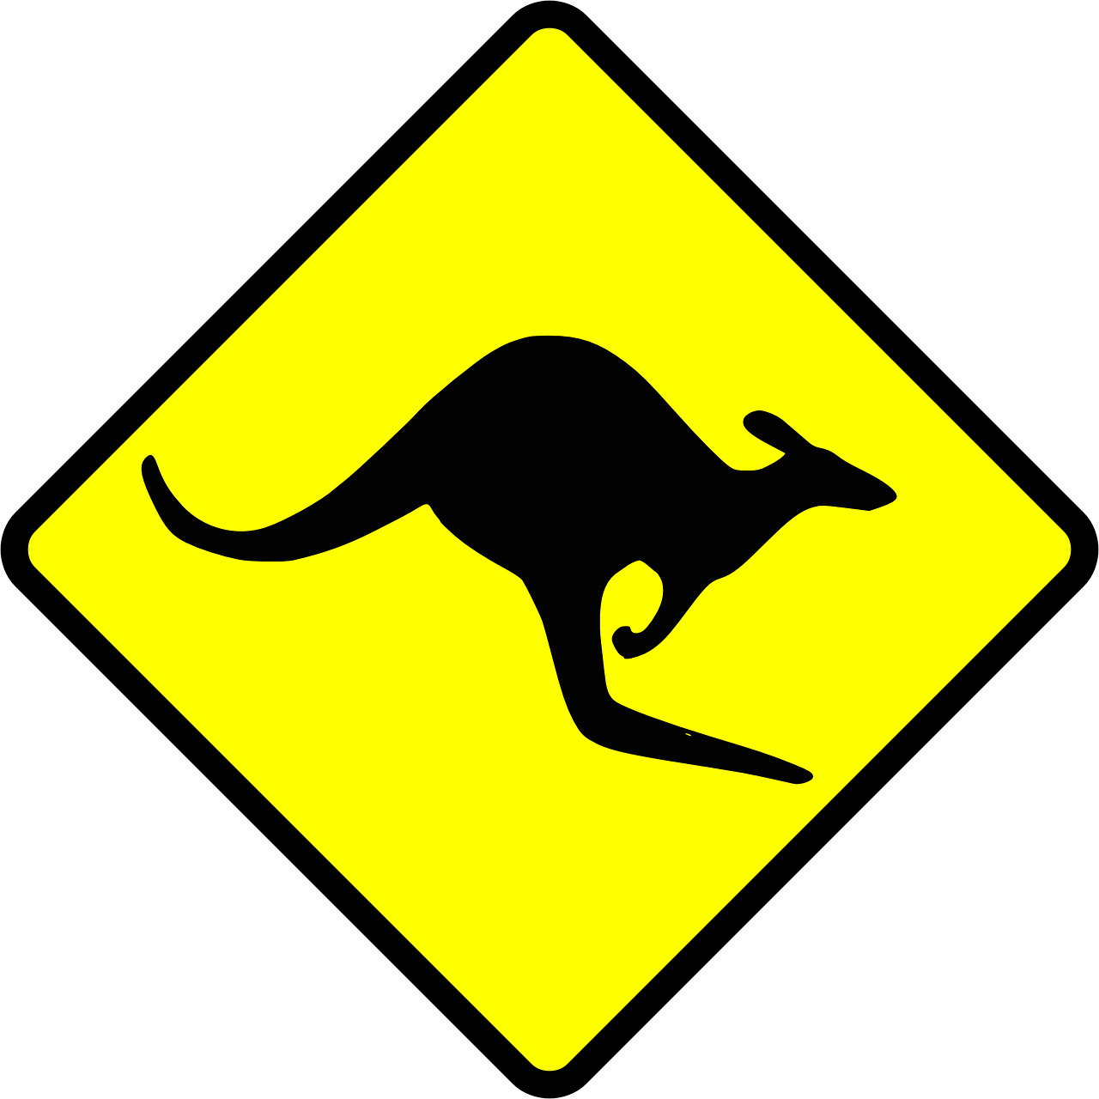
Activity: Hop in place like
a kangaroo as you sing

Image: https://pixabay.com/en/sign-symbols-kangaroo-australia-32619/

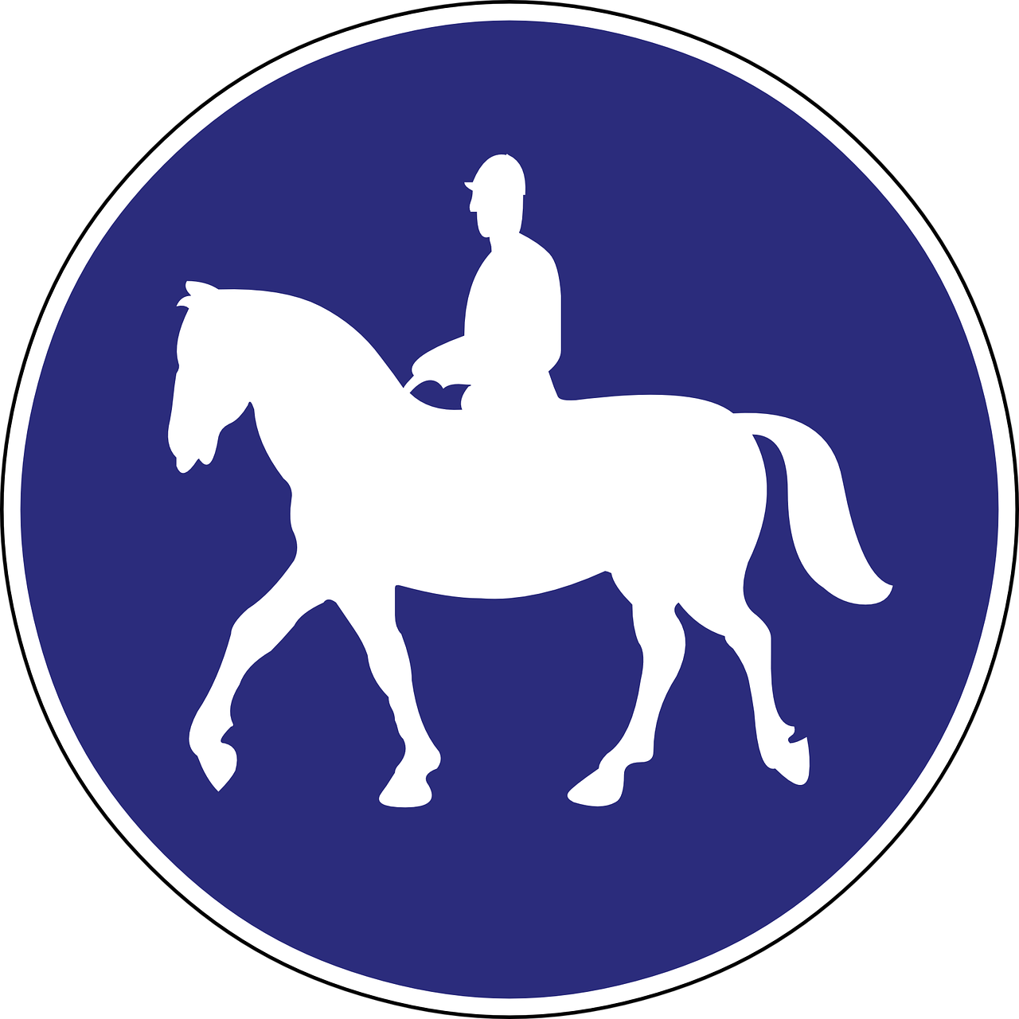
Activity: Pretend you are riding a horse as you sing

Image: https://pixabay.com/en/bridlepath-bridle-way-road-sign-909962/

Activity: Sing all of the verses without stopping

Image: https://pixabay.com/en/arrow-down-direction-symbols-signs-24112/

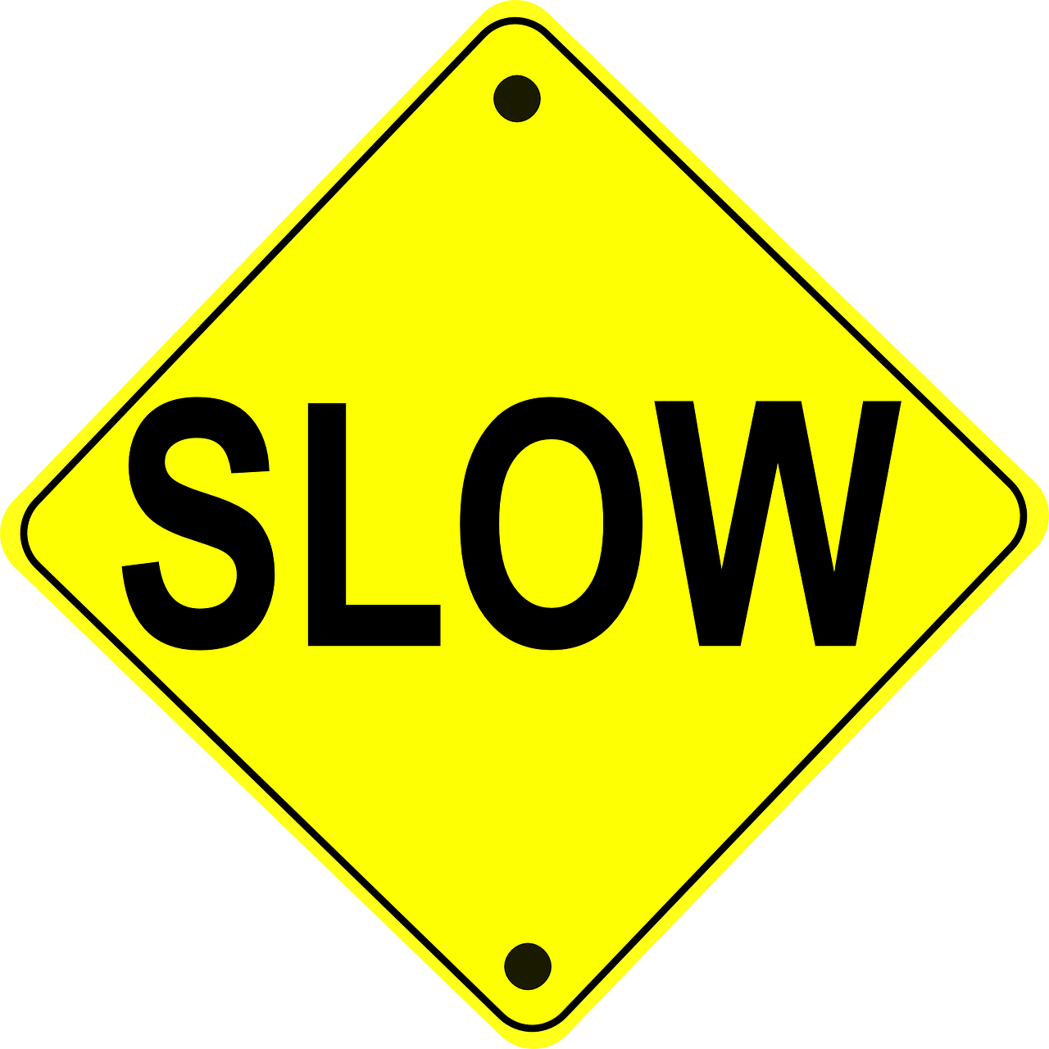
Activity: Sing as slowly as you can (or pianist gets progressively slower)

Image: https://pixabay.com/en/warning-sign-slow-traffic-safety-36602/

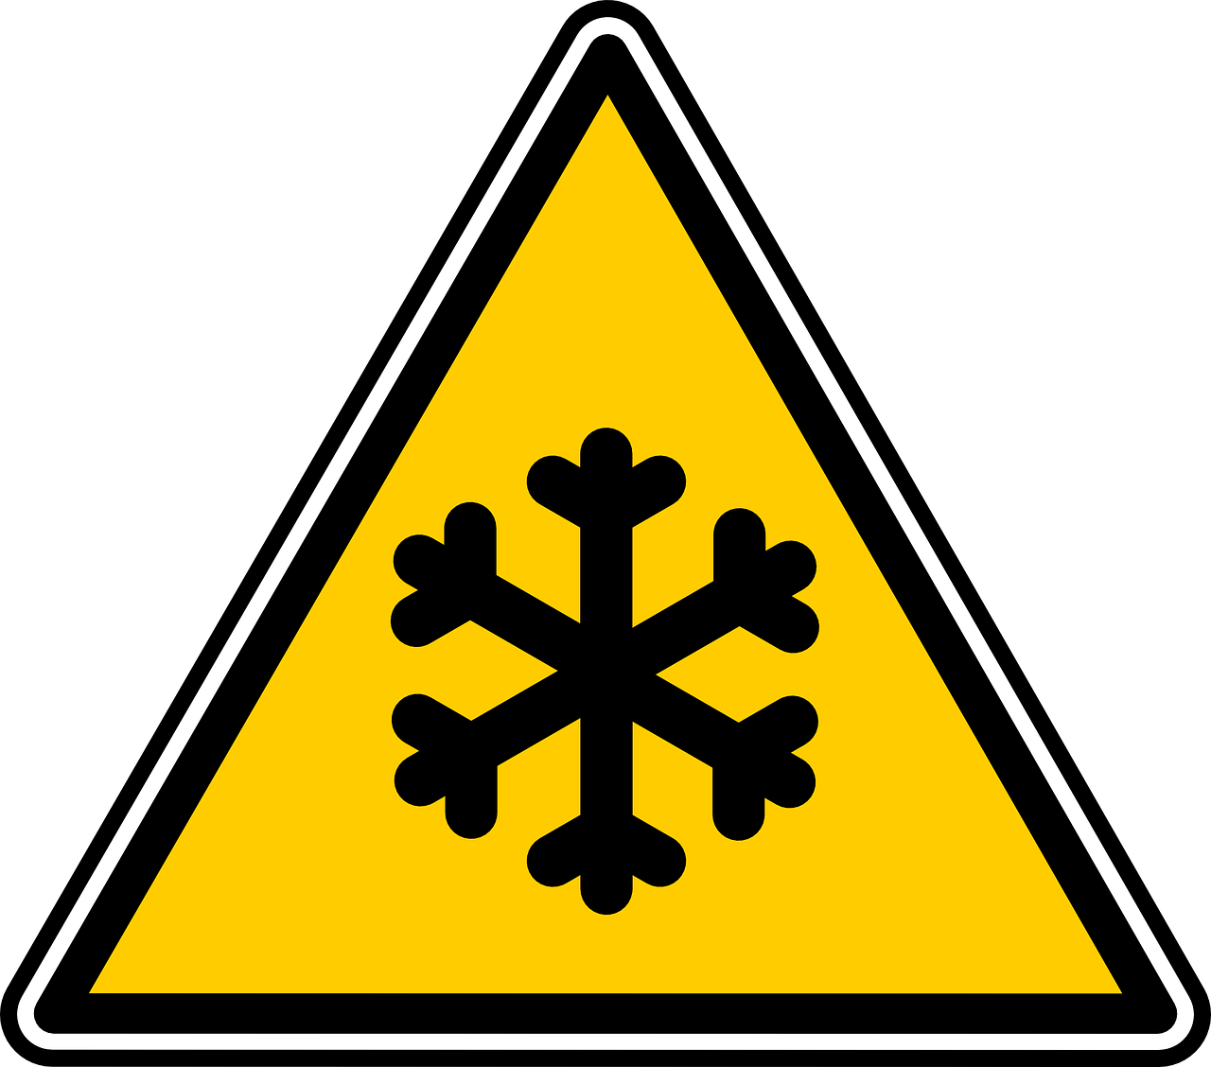
Activity: Make your voice and body shiver as you sing

Image: https://pixabay.com/en/signs-low-temperature-ice-snow-24072/

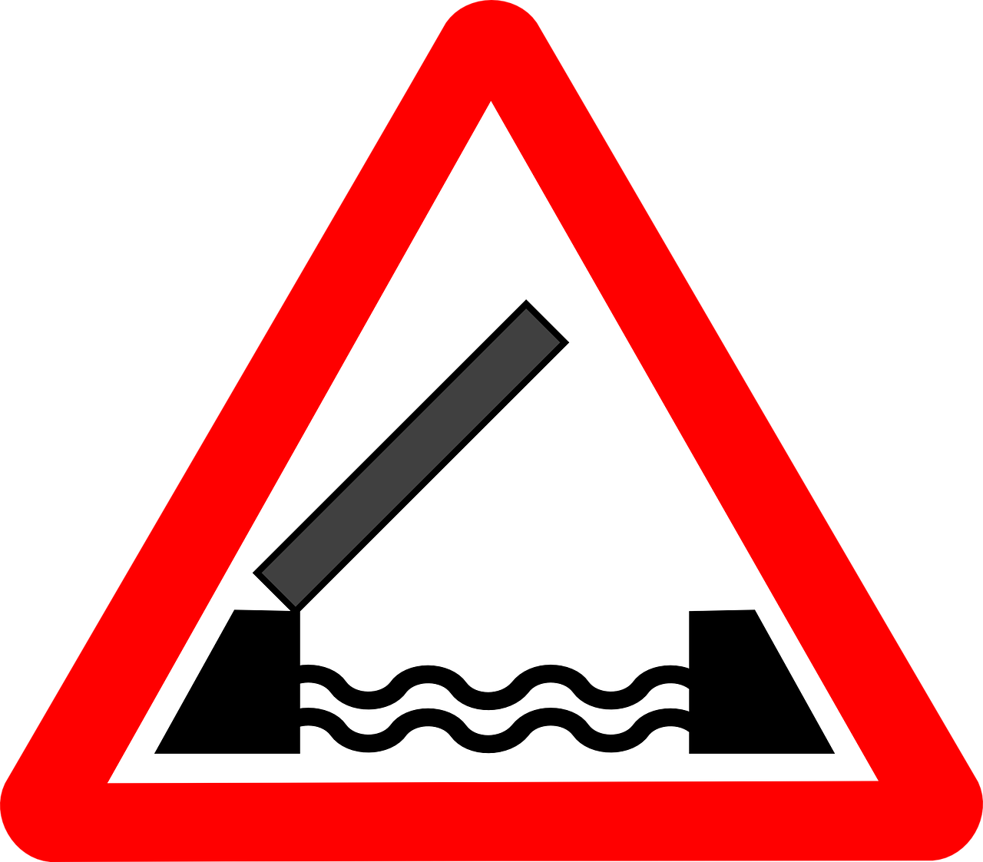
Activity: When the stop sign is showing to your class (or to the whole Primary), hum and sing the words in your head until it is your group’s turn to go
Activity:
1) A class lines up & the 2 children nearest
the end make a bridge with their arms
held up high.

2) The line of children begins going under
the bridge as the Primary sings.

3) When the pianist stops randomly, the
drawbridge comes down & the trapped
child must provide the next word or two.

Image: https://pixabay.com/en/drawbridge-signs-draw-transport-24335/

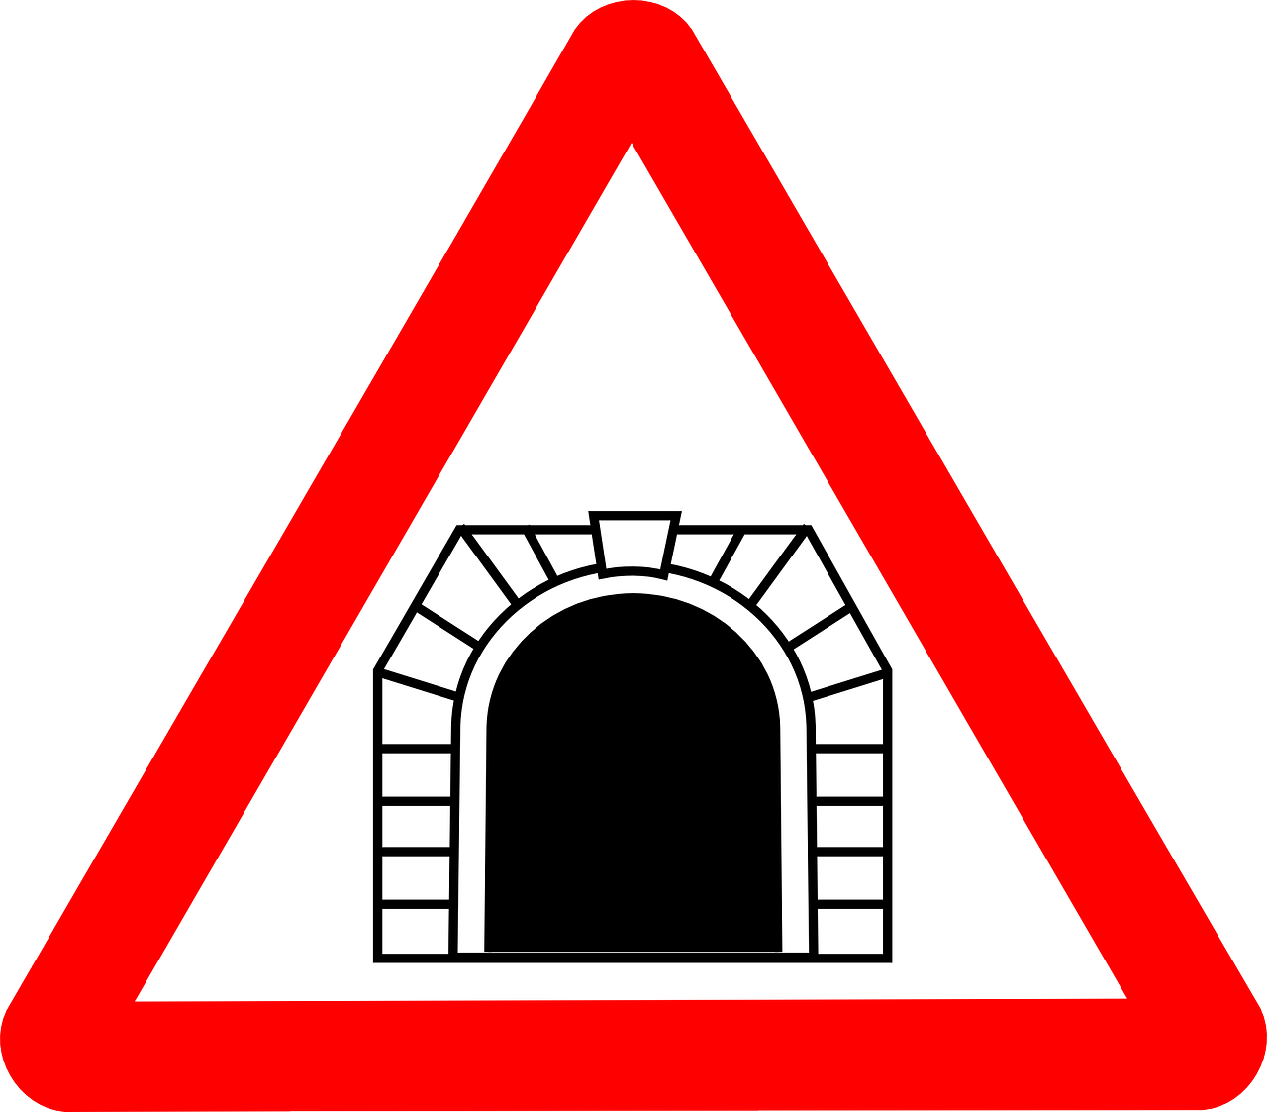
Activity:
1) Sing the song, but when a helper turns the lights out, everyone makes a train horn sound by saying, “Chooo whoooo!”

2) Sing choo, choo, choo instead of words.

Image: https://pixabay.com/en/sign-tunnel-road-train-ahead-24348/

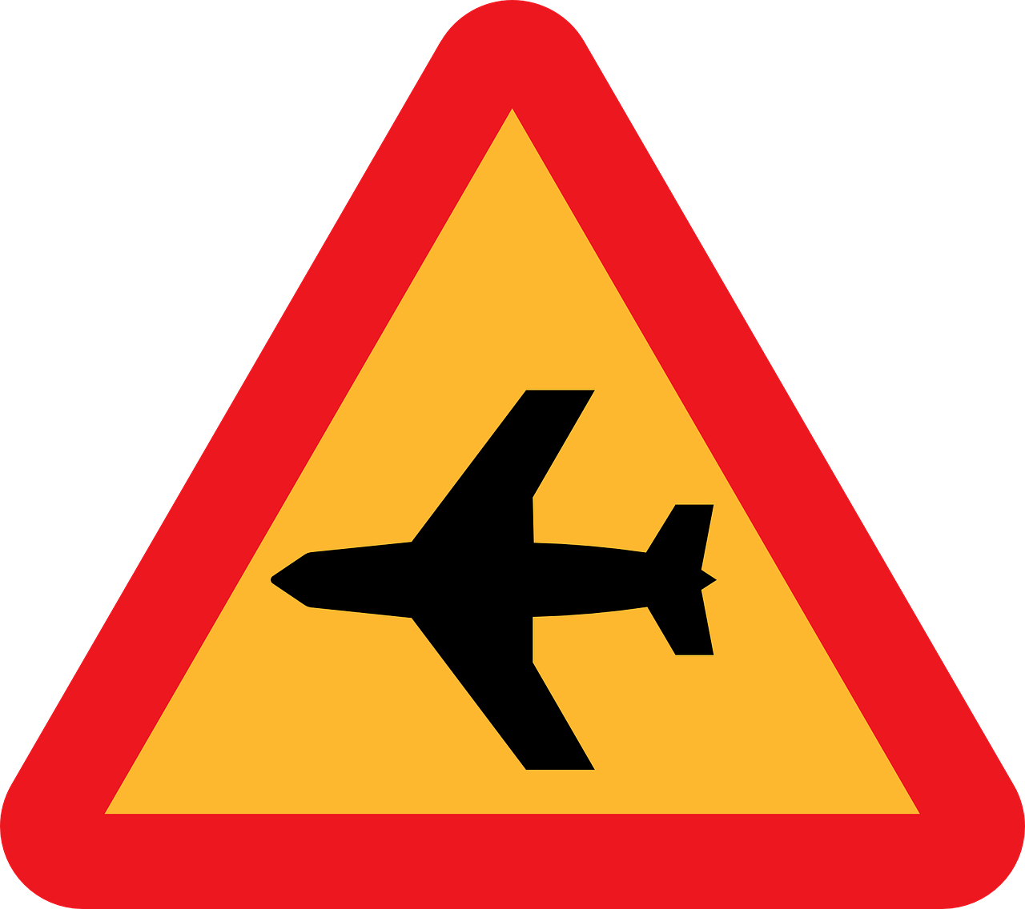
Activity: Move your arms like airplanes as you sing the song—singing softly as you stretch higher and loudly as you get lower to the ground (just like a plane)

Image: https://pixabay.com/en/low-flying-aircraft-sudden-noise-30940/

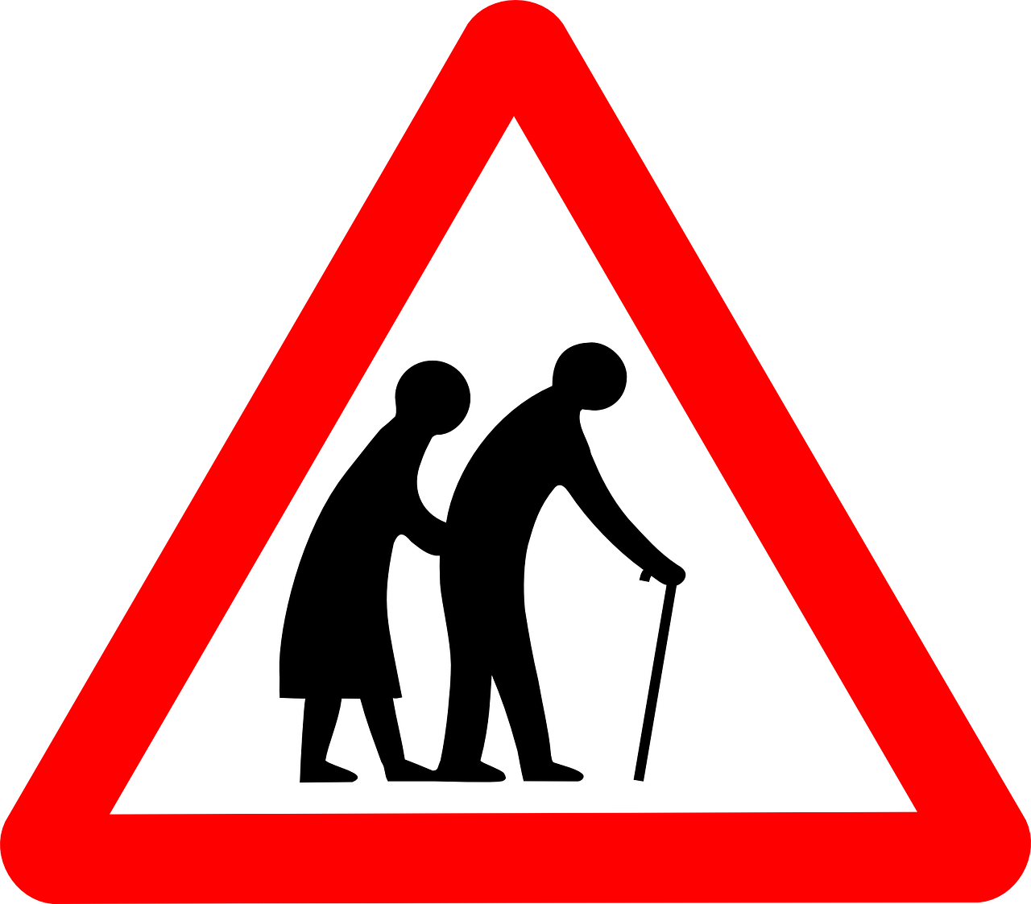
Activity: All the adults sing (or choose an activity for the children to do)

Image: https://pixabay.com/en/sign-old-people-crossing-elderly-24343/

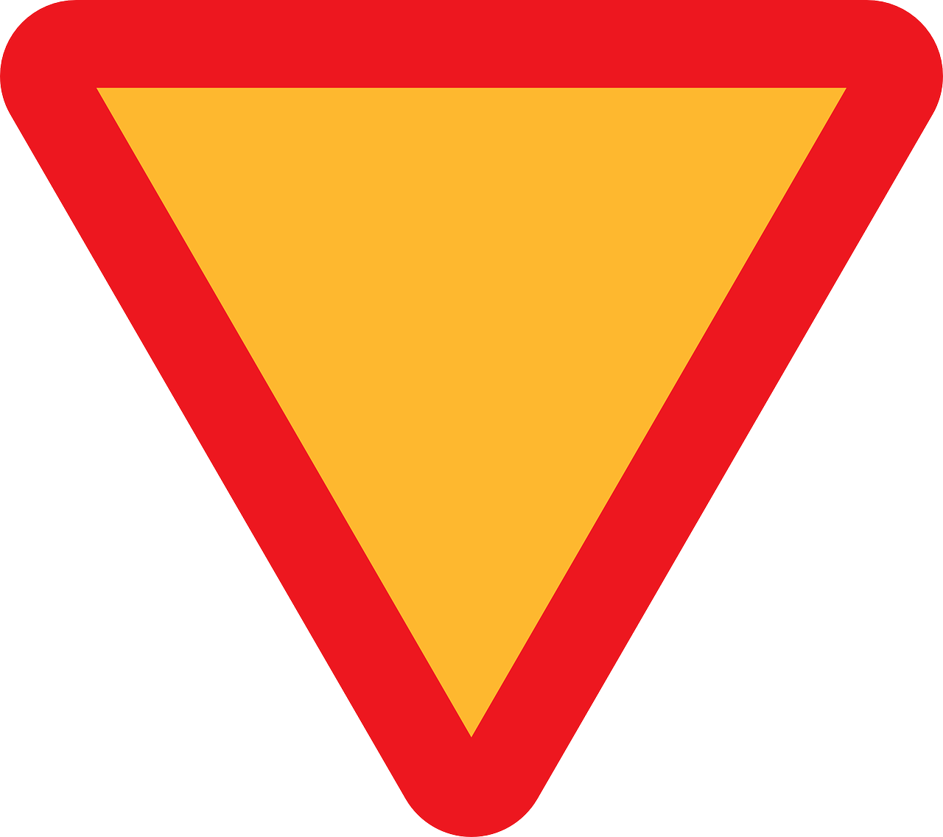
Activity: Children’s choice of activity as you sing the song

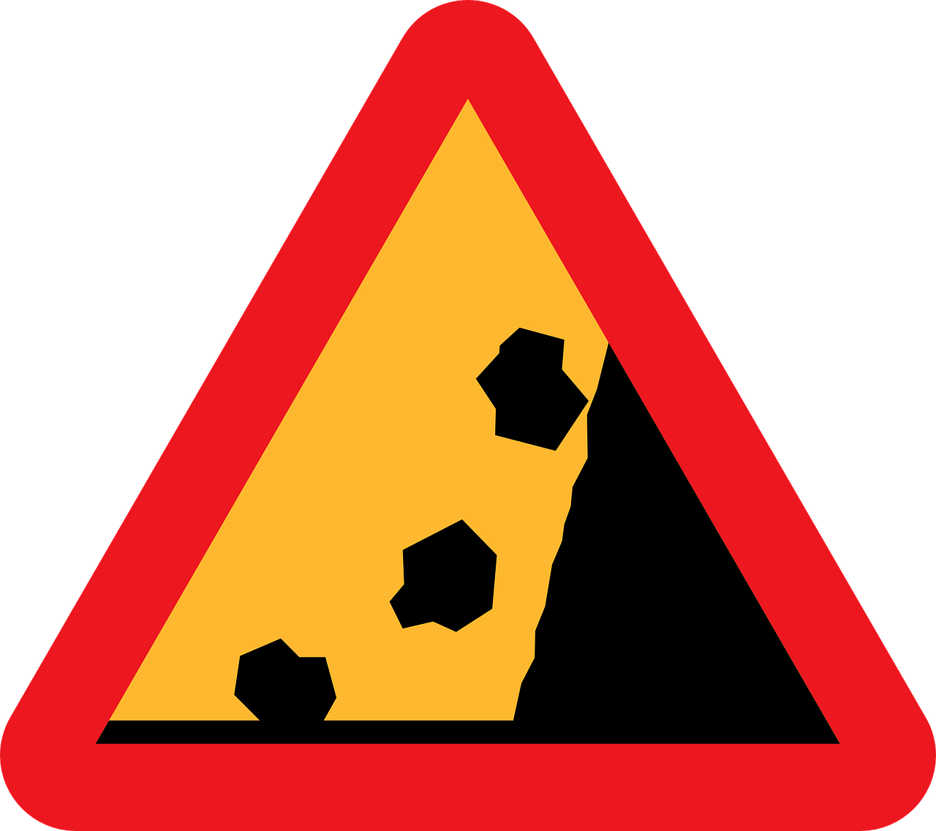
Activity: Children sing while rolling fake stones made of crumpled up brown paper down a fake mountain
Image: https://pixabay.com/en/falling-rocks-falling-stones-30931/

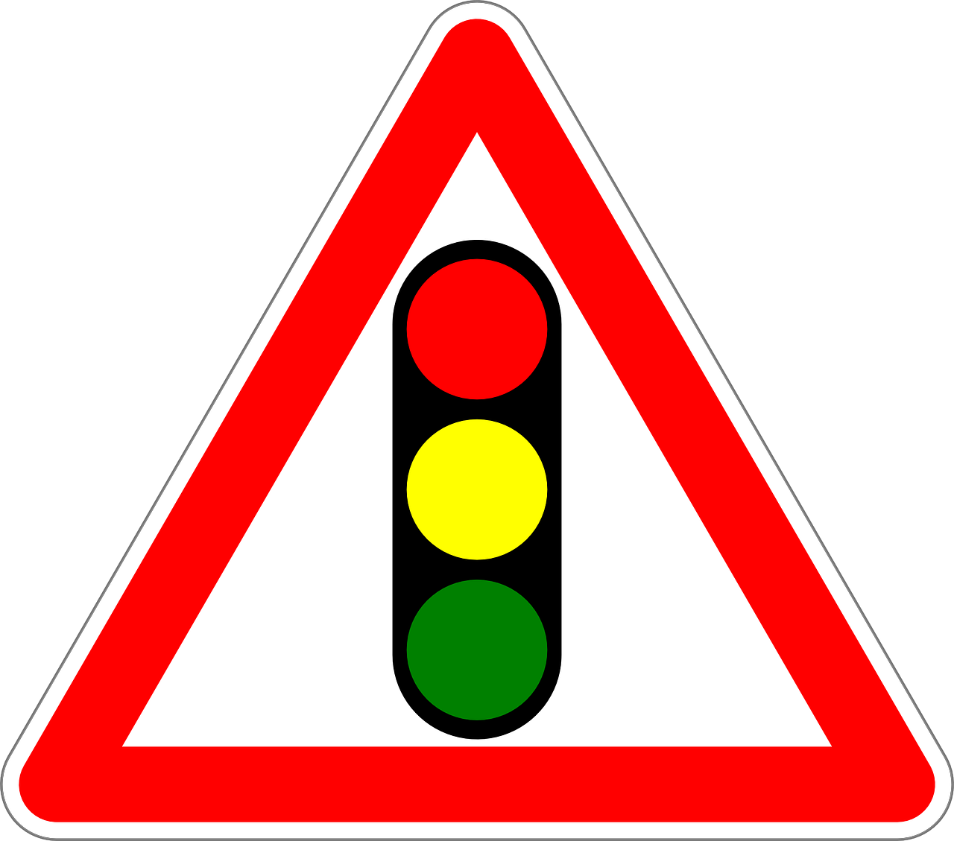
Activity: Sing according to the colored paper plates, which the chorister holds up as traffic signals (red = sing in your mind, yellow = hum like a car idling or sing slowly, green = sing normal speed)
Image: https://pixabay.com/en/traffic-sign-sign-traffic-signals-160660/

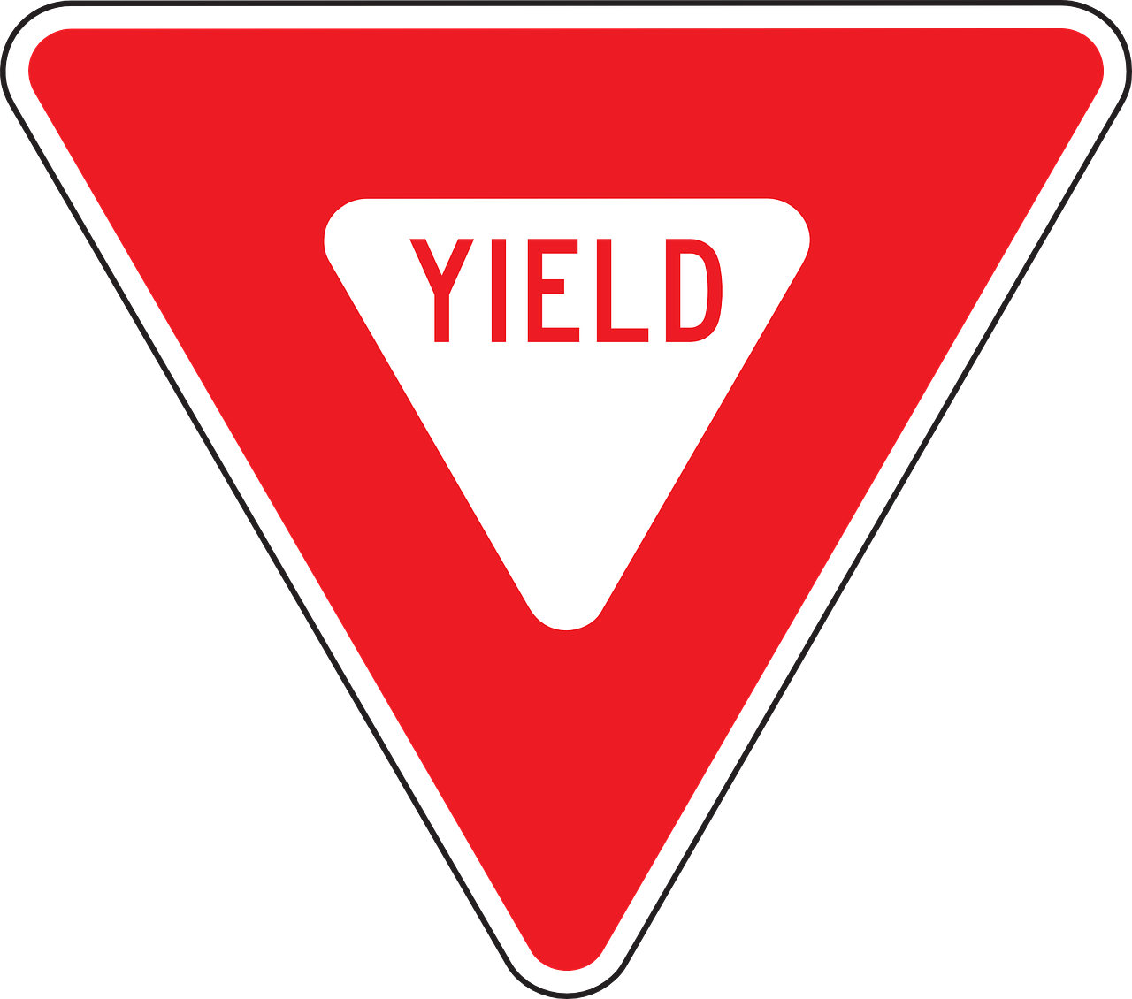
Activity: The chorister “yields” to the children, who choose the activity or the song

Image: https://pixabay.com/en/yield-give-way-sign-right-of-way-98931/

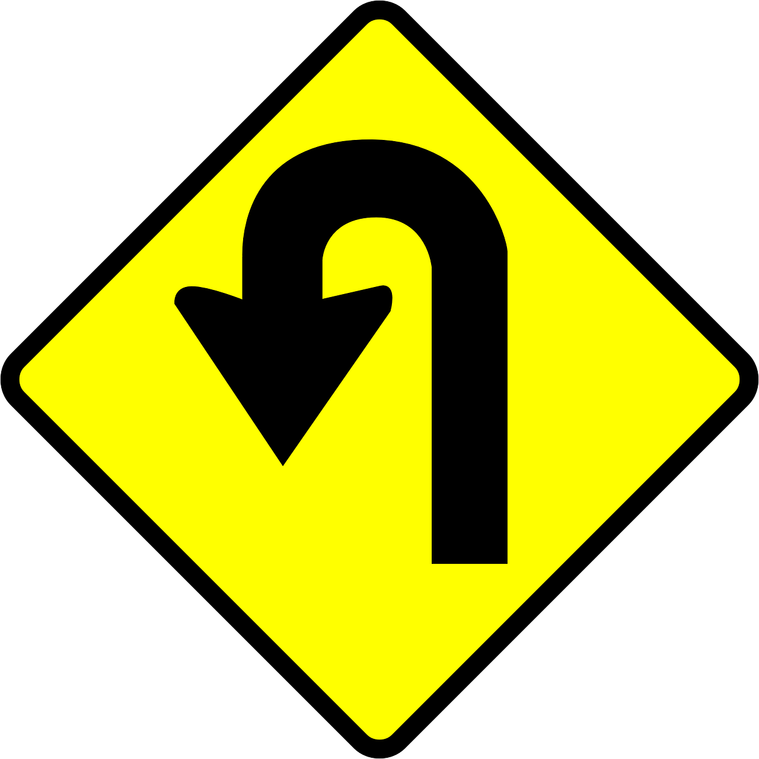
Activities:
1) Chorister sits and pretends to turn right, left, leans forward for fast and loud, back for soft and slow, and children copy and sing accordingly.
2) Make a U-turn & sing to class behind you.
3) Repeat the previous line again before moving on, OR sing the previous song again.

Image: https://pixabay.com/en/road-sign-roadsign-traffic-turning-145153/

Possible activities:

1) Pay a “fine” for “illegal driving”— pianist determines the penalty.

2) Skip the song and act it out instead as the pianist plays.

3) Recite the monthly scripture instead of singing.
Image: https://pixabay.com/en/no-entry-traffic-sign-sign-160681/

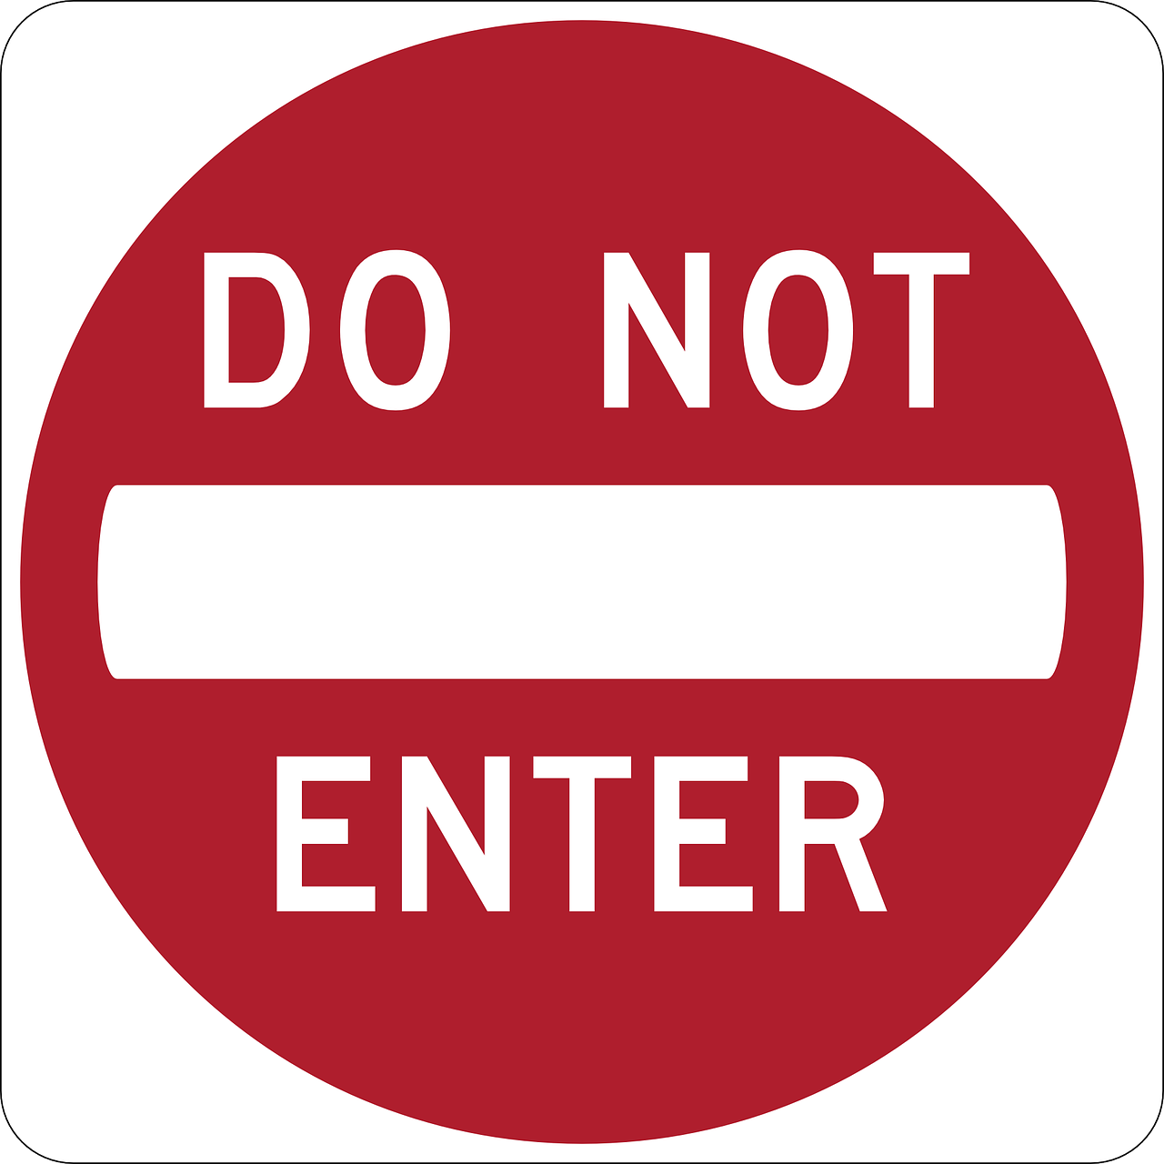
Activity: Tell about a good choice you made while the rest of the Primary hums the song

Image: https://pixabay.com/en/do-not-enter-wrong-way-98935/

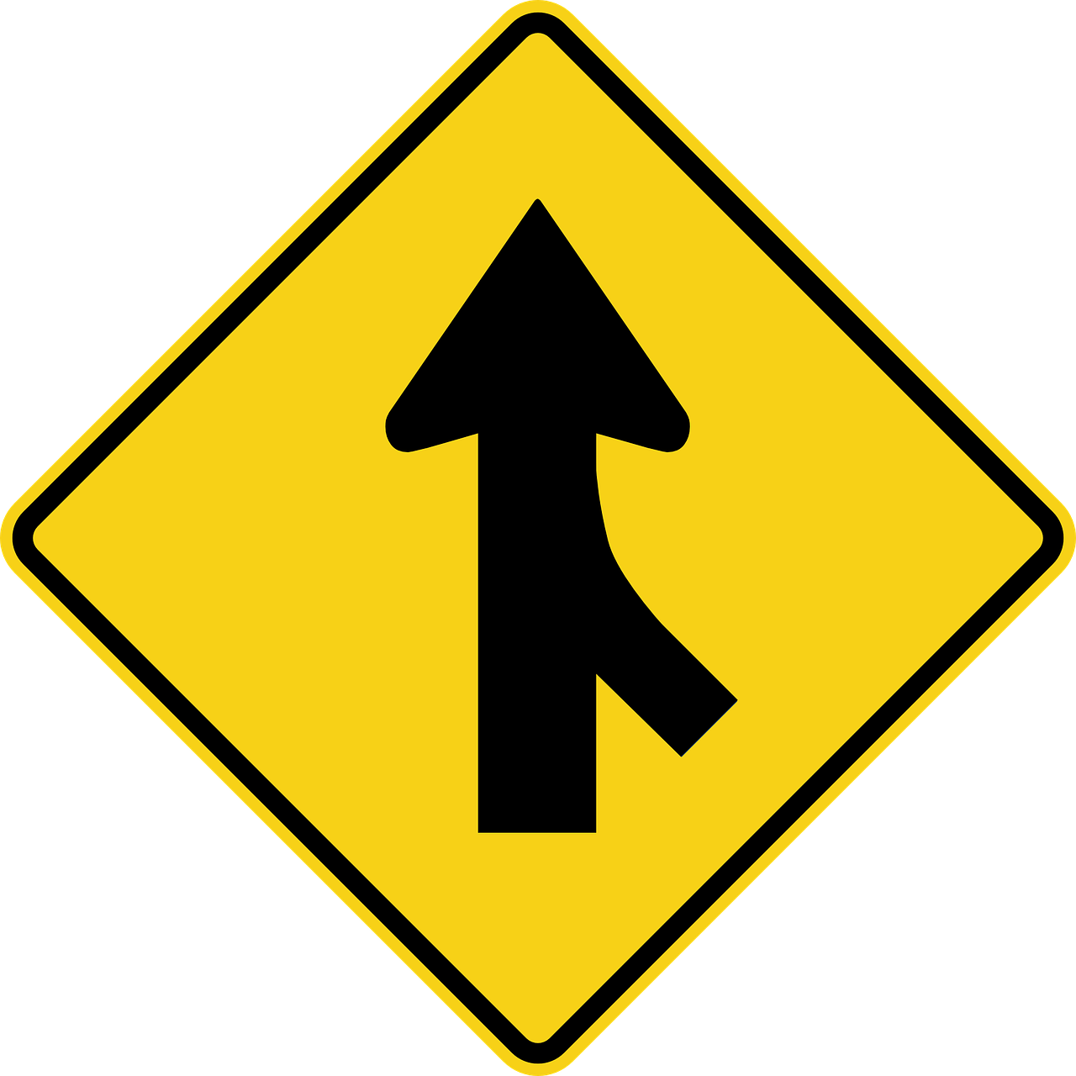
Activity: Merge your voices with others by singing harmony, or one class begins singing and a new class joins with each line of the song

Image: https://pixabay.com/en/merging-traffic-signs-road-39400/

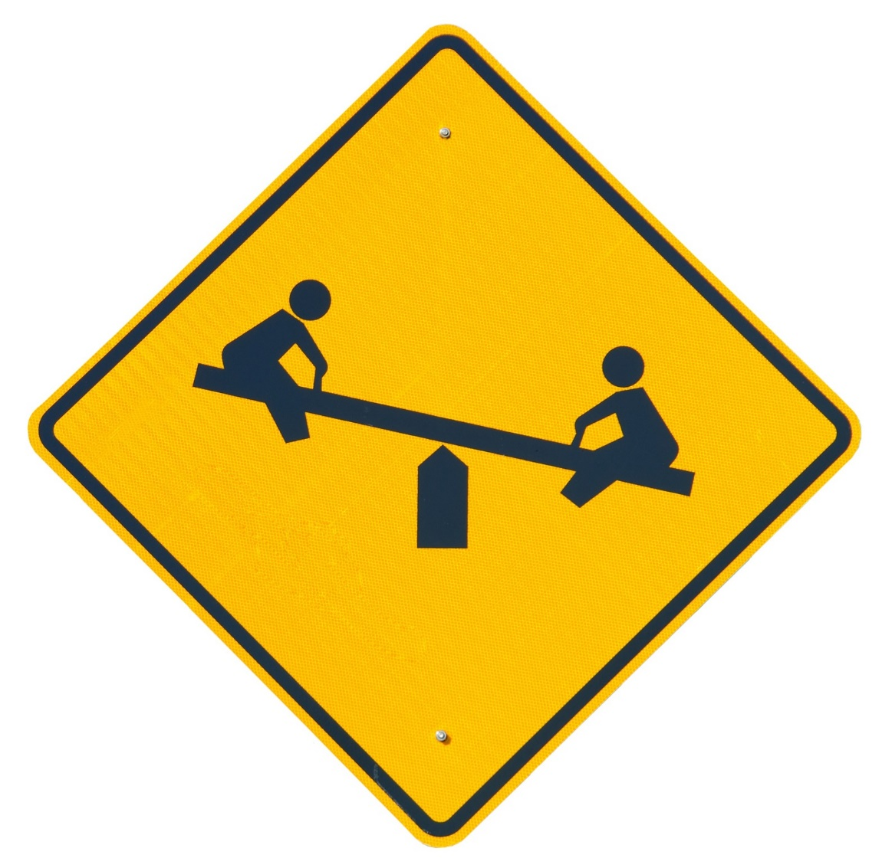
Activity: As you sing the song, act out something you enjoy doing when you play

https://pixabay.com/en/children-at-play-sign-warning-child-1744718/

