Activity: Gratitude Dinner, Cultural Hall, Wednesday, November 19, 2014 @ 7 p.m.

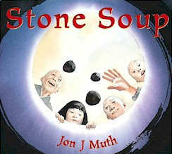Theme: Stone Soup

Key Concept: We need each sister in Relief Society and can accomplish much good in the world by combining our unique personalities, talents, and spiritual gifts.

Purposes:

- To recognize our divine nature by considering our unique personalities, talents, and spiritual gifts (1 Corinthians 12:4-31)
- To unify the sisters in using their spiritual gifts to serve their families, ward, and communities
- To develop gratitude for the Savior's atoning sacrifice and to learn to love others as He loves each and every individual

Opening Prayer: By invitation

Opening Song: (Possibilities below)

As Sisters in Zion – 309 (Church)
Lord, I Would Follow Thee – 220 (Savior’s Example)
Love One Another – 308 (Family)
Give Said the Little Stream
Kindness Begins with Me
When We're Helping We're Happy
I'm Trying to Be Like Jesus

Spiritual Thought: PowerPoint Presentation of Stone Soup story with the three Presidency members as the "travelers" and the sisters as the village people.

- Everyone is hungry
- There are different ways to be hungry: hungry for acceptance, emotional support, food, friendship, opportunities to feel successful, etc.
- Contexts (Where might we find the “hungry” who could benefit from learning to make “stone soup?”):
  - Family (Self, Husband, Children, Extended Family, Ancestors)
  - Church (Relief Society, YW, Primary, Missionary Work, Church Leaders)
  - Community (Friends, Neighbors, Colleagues, Community Organizations)

- Dinner & Display Tables: Display tables set up for sisters to look at as they wait in line to get food
- Soups/stews in crock pots
- Different kinds of breads with herb butter
- A simple dessert—something related to the idea of stones or rocks?

- Display Tables:

- SERVING OUR COMMUNITY – Canned food drive plus easy ideas for serving in the community

- SERVING OUR FAMILIES - Harvesting Happiness: Fun Family Home Evening ideas for service projects and serving our families

- SERVING THE LORD - Sowing Gospel Seeds: Ideas for keeping our lives balanced by serving the Lord through fasting and prayer, keeping the Sabbath Day holy, scripture study, etc. - House of order scripture

- SERVING OUR ANCESTORS – Fun ideas for recording family history, getting involved in genealogy, and doing temple work
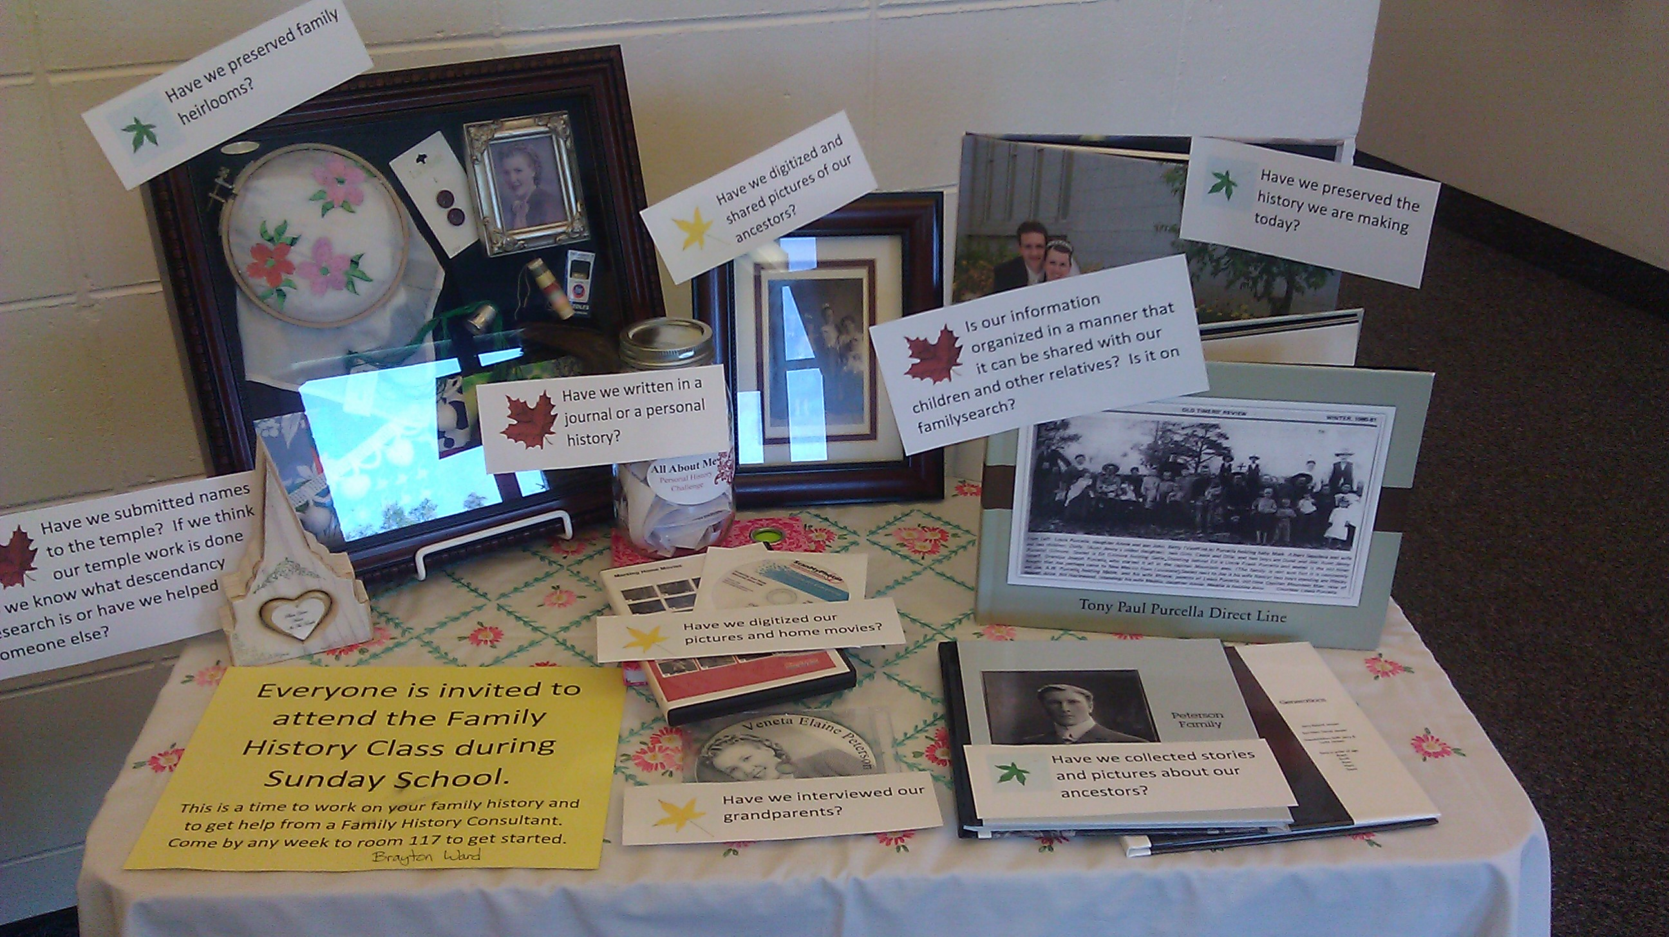

Table credit: Brianne Jensen; Photo credit: Cherice Montgomery

- SERVING OUR SISTERS - Souper Simple Ways to Visit Teach: Fun Ideas for Visiting Teaching with “Body of Christ Scripture”

Musical Number: #219 - Because I Have Been Given Much

- Slideshow - With photos of sisters in the ward with quotes and scriptures about spiritual gifts under each one as the music plays/is sung

Sharing of Stories – Testimony-like sharing of how people feel they have been served by the spiritual gifts of various sisters in the ward

Closing Quote: “As each person opened his heart to give, the next person opened his heart to give even more.” – Quote from one version of Stone Soup

Closing Prayer: By invitation

