Transition Songs
Do As I'm Doing – 276
Fun to Do – 253b
If You’re Happy - 266
I Wiggle – 271
Rain is Falling All Around – 241b
Goals
- Feel Heavenly Father’s Love
- Learn & understand the Gospel
- Feel and recognize the H.G.
- Prepare to make & keep covenants

Transitional Songs
Page | Song | Activity
177 | Teach Me To Walk  in the Light
109 | Search, Ponder, & Pray | Actions

 | CFM: I can ask H.F. to help me learn what is true, speak with kindness, be patient
 | SINGING TIME: Choosing Activity: Spin a Plate to see what food = song we sing
Picture |  | Scripture | Page | Song  Make it multicultural w/ Thanksgiving traditions around the world | Activity: Draw a feast  Give them paper plates, as we sing the songs, they get to draw the item on their plates that we spun
Bread, rolls |  | “I am the bread of life: he that cometh to me shall never hunger;” (John 6:35). | 71  16  263 | To Think About Jesus  Children All Over the World  We Are Different | 1: Show breads of the world  2: Spin a conversation with paper bag turkeys
Cider / water |  | “But whosoever drinketh of the water that I shall give him shall never thirst; but the water that I shall give him shall be in him a well of water springing up into everlasting life” (John 4:14). | 236  241b | “Give,” Said the Little Stream  Rain is Falling All Around | Stand/sit on G’s or S’s
Corn |  | “For the earth bringeth forth fruit of herself; first the blade, then the ear, after that the full corn in the ear” (Mark 4:28). | 20a  55 | A Song of Thanks  Jesus Once Was a Little Child  (Mention this means giving thanks even for the things that seem bad at first—buried in soil, popped in heat) | Don’t eat Pete!
Cranberry Sauce |  |  | 21b | For Thy Bounteous Blessings
Gravy |  | “For I was an hungered, and ye gave me meat” (Matthew 25:35). | 167 | Go the Second Mile | Stand on Gravy words, sit on Sauce words  Stand on the word “do”
Mashed Potatoes |  |  | 267a | Smiles | 1: Pass the Hot Potato, tell something you’re grateful for if it stops on you  2: Mashed Potatoes Game
Pie |  |  | 151  18 | I Am Glad for Many Things  I Need My Heavenly Father  (Make healthy choices) | 1: Hide pie slices around the room and play tic-tac-toe: One half is cream pies, the other are fruit pies  2: Pick a Pie (determines HOW we sing the song)  3: Toss the Whipped Cream (Laminate pie, then put shaving cream or whipped cream and they remove it to reveal the song)  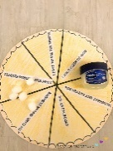
Salad |  |  | 246 | It’s Autumntime  (Eat a colorful plate) | 1: Stand based on clothing color (yellow, red, brown)  2: Salad Toss (like upset fruit basket?)
Stuffing |  | “…be filled with the Spirit; (Ephesians 5:18). | Music  107  105 | As a Child of God  Listen, Listen  The Holy Ghost | 1: Stuff the Turkey with the Spirit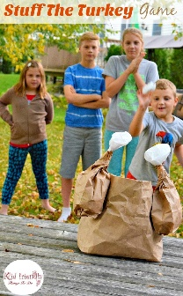
Sweet Potatoes |  | “Giving thanks always for all things unto God and the Father in the name of our Lord Jesus Christ” (Ephesians 5:20). | 20b | Thanks to Our Father | Yam Races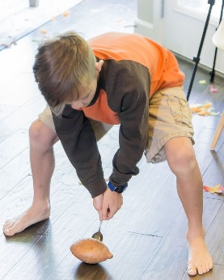
Turkey |  |  | 25a | We Bow Our Heads | 1: Gobble, gobble, gobble, run!  2: Mr. Potato Head (Turkeys)  3: Turkey Baster Relay 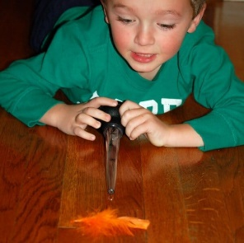
Vegetables |  |  | 21a | For Health & Strength | 1: Jumping jacks, etc.  2: Round
“And he who receiveth all things with thankfulness shall be made glorious, and the things of this earth shall be added unto him, even an hundred fold, yea, more” (Doctrine & Covenants 78:19).

