Flipchart for
The Things I Do, p. 170
Compiled by Cherice Montgomery
I’m much too young
to go abroad
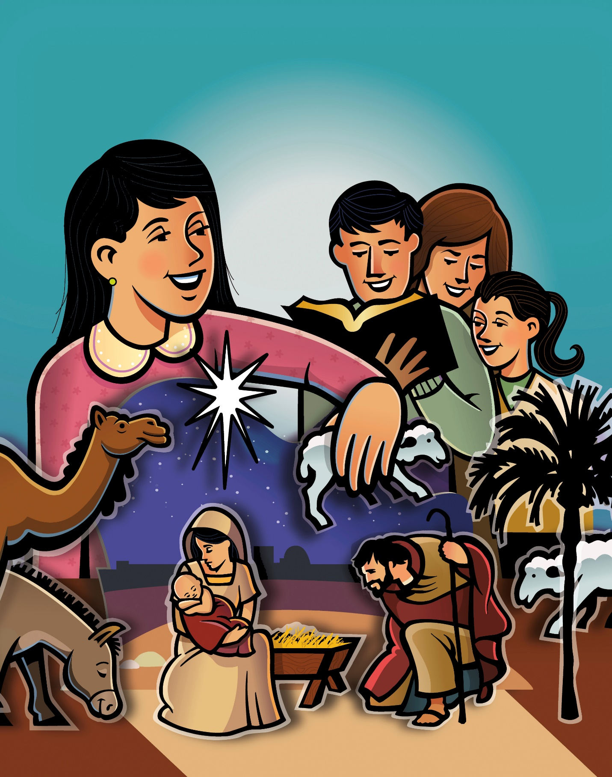
To teach and preach
the word of God,
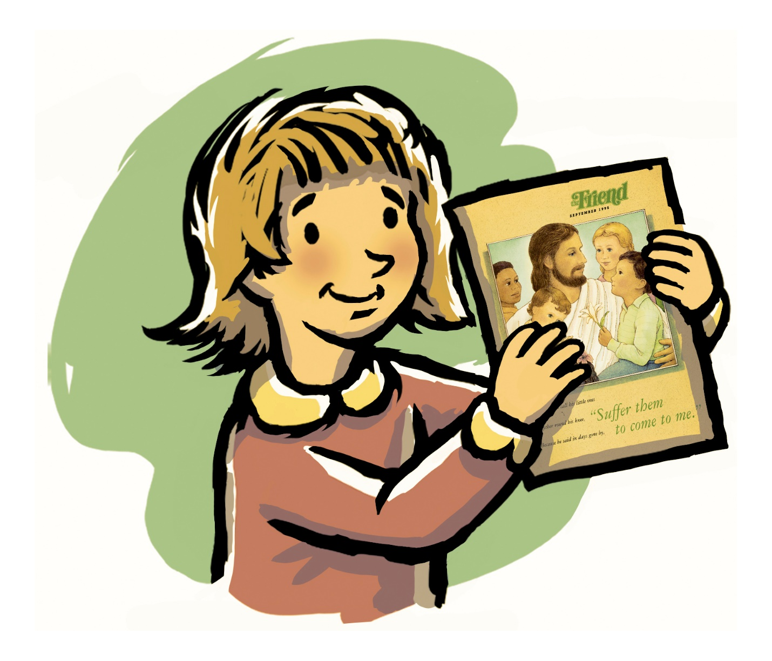
But I can show
I know it’s true,
Quite simply,
by the things I do.
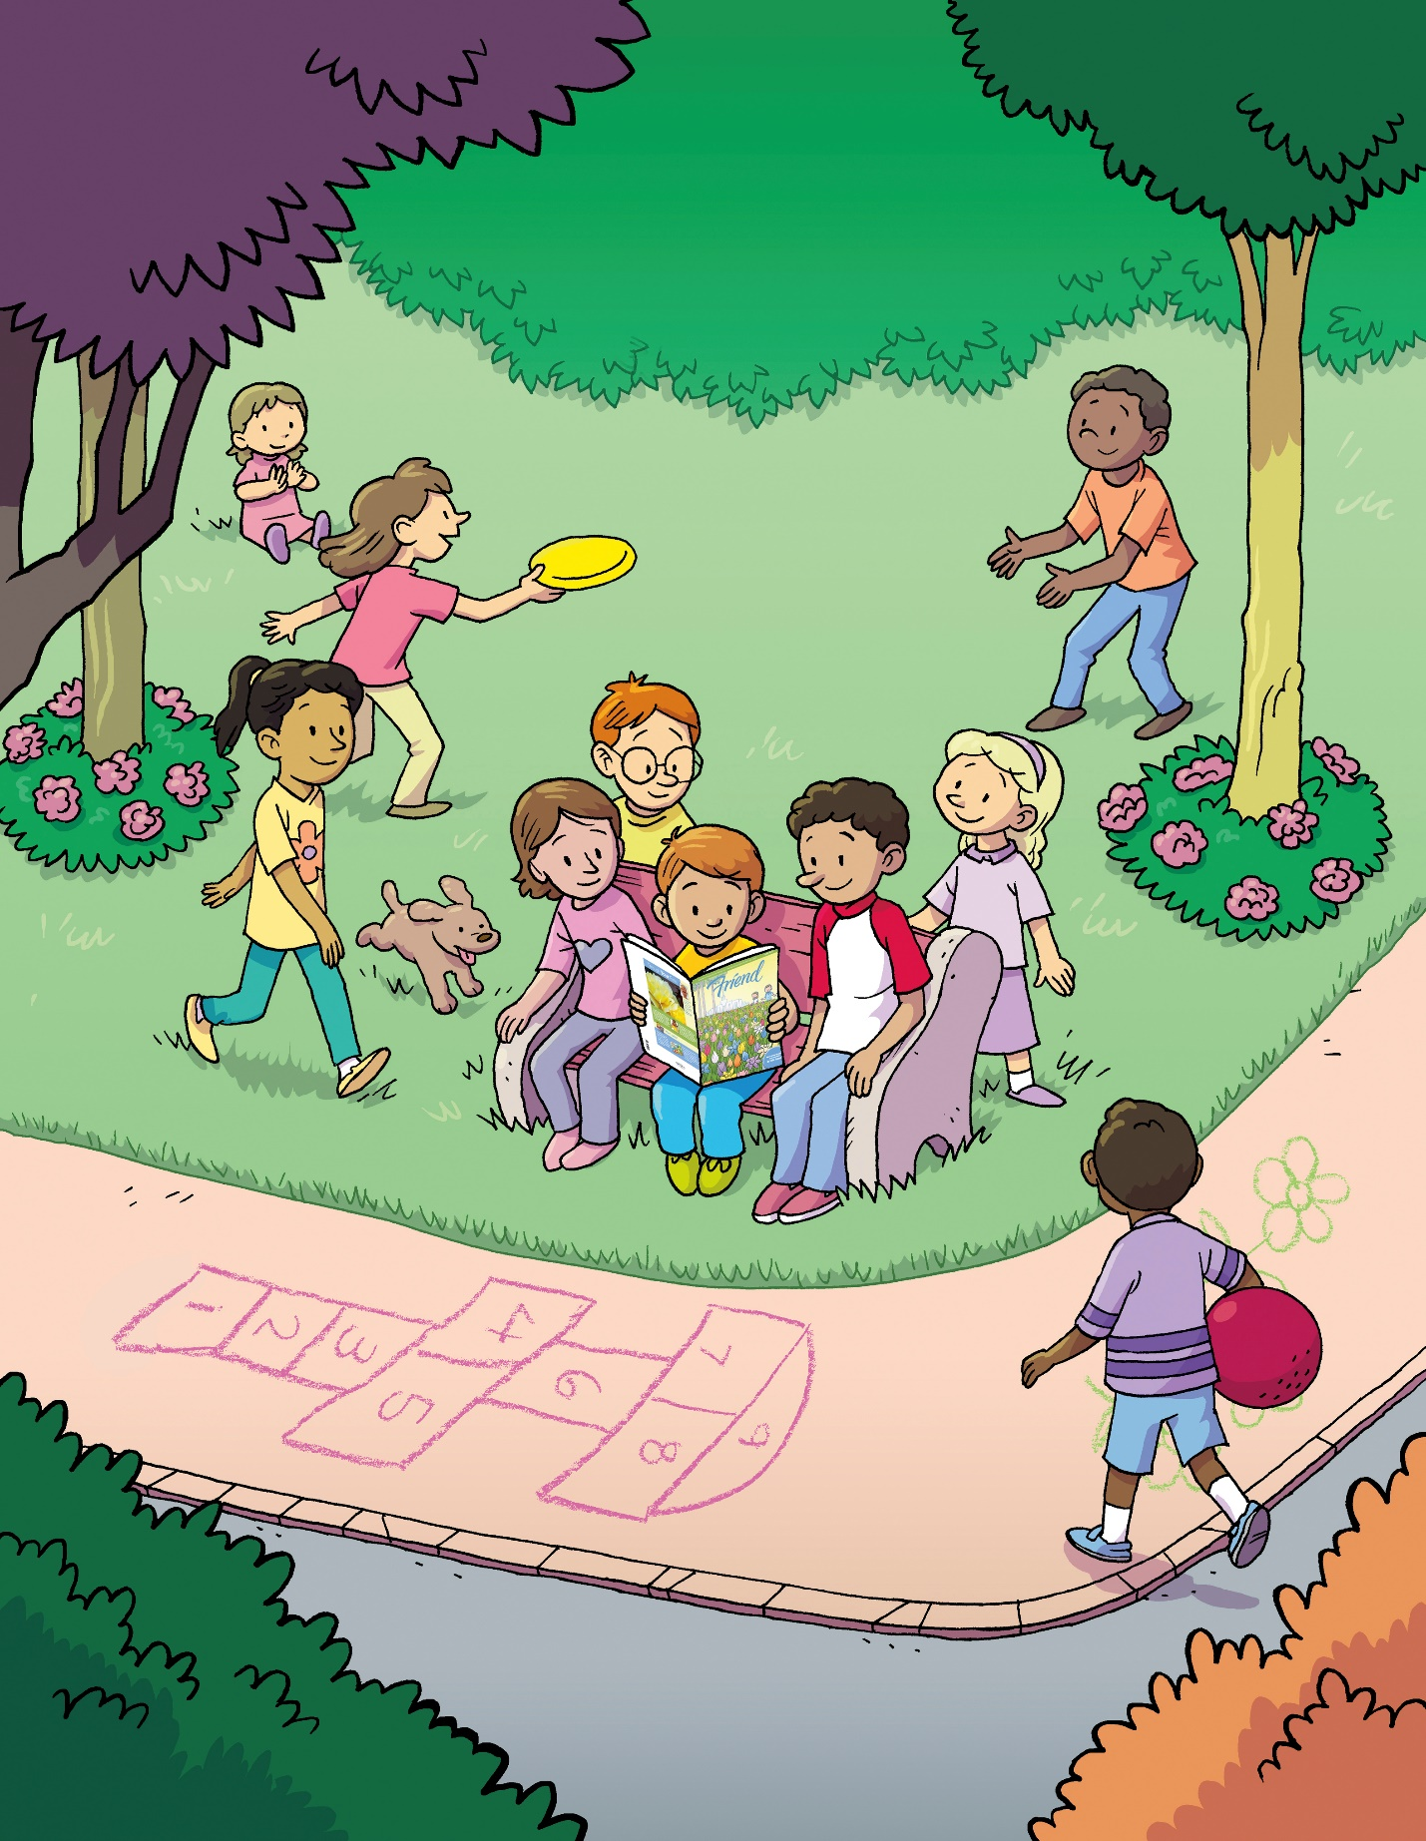
The people in my neighborhood

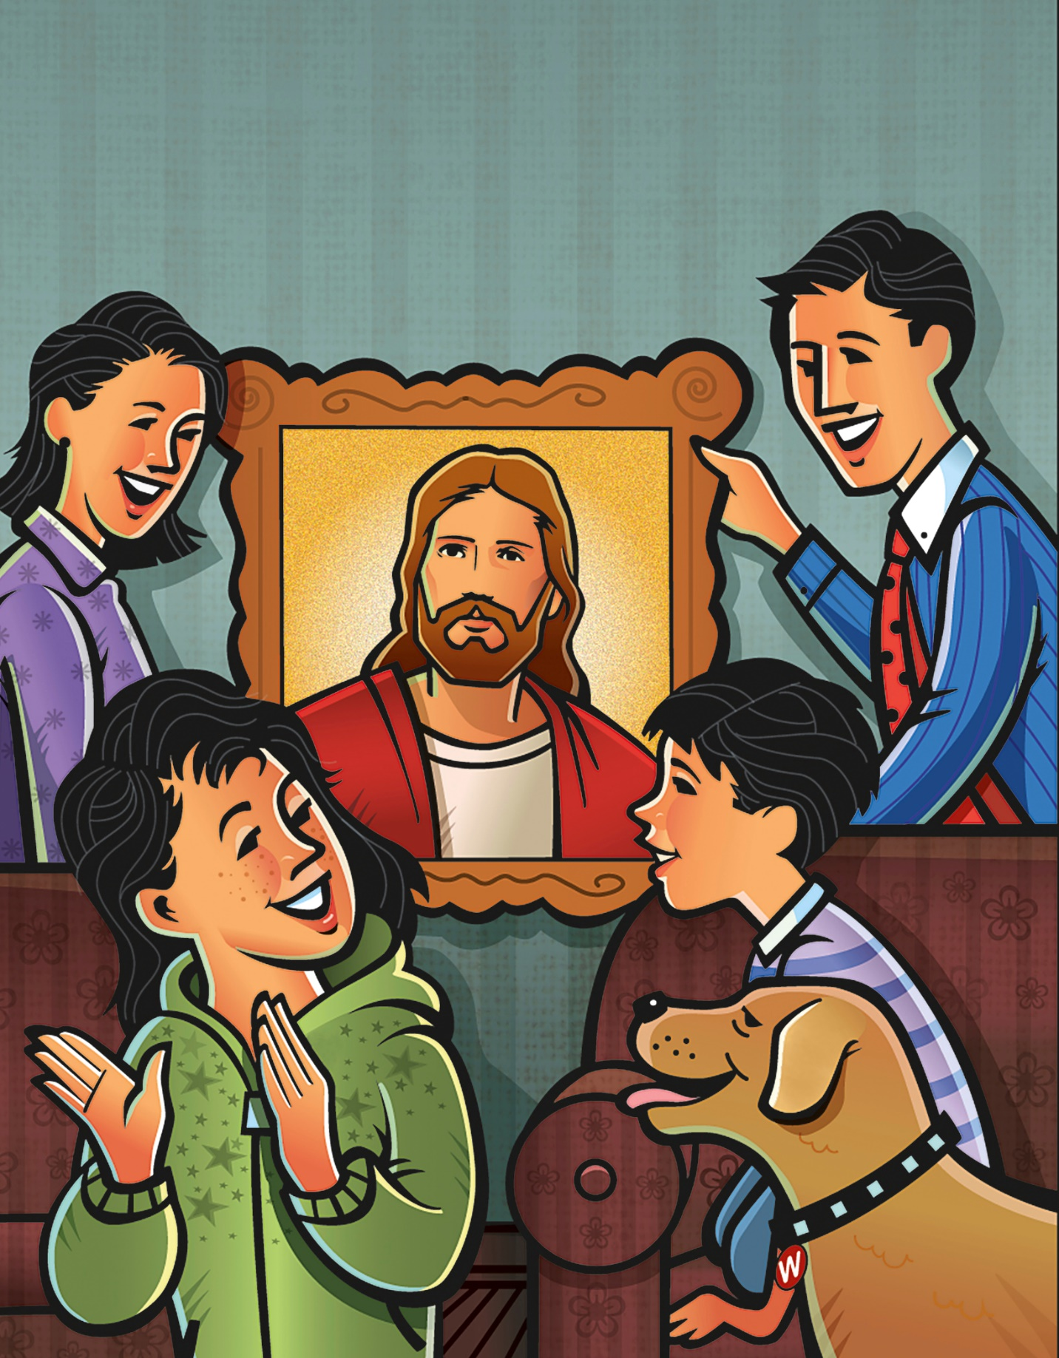
Will judge the gospel
bad or good
By how I act at work
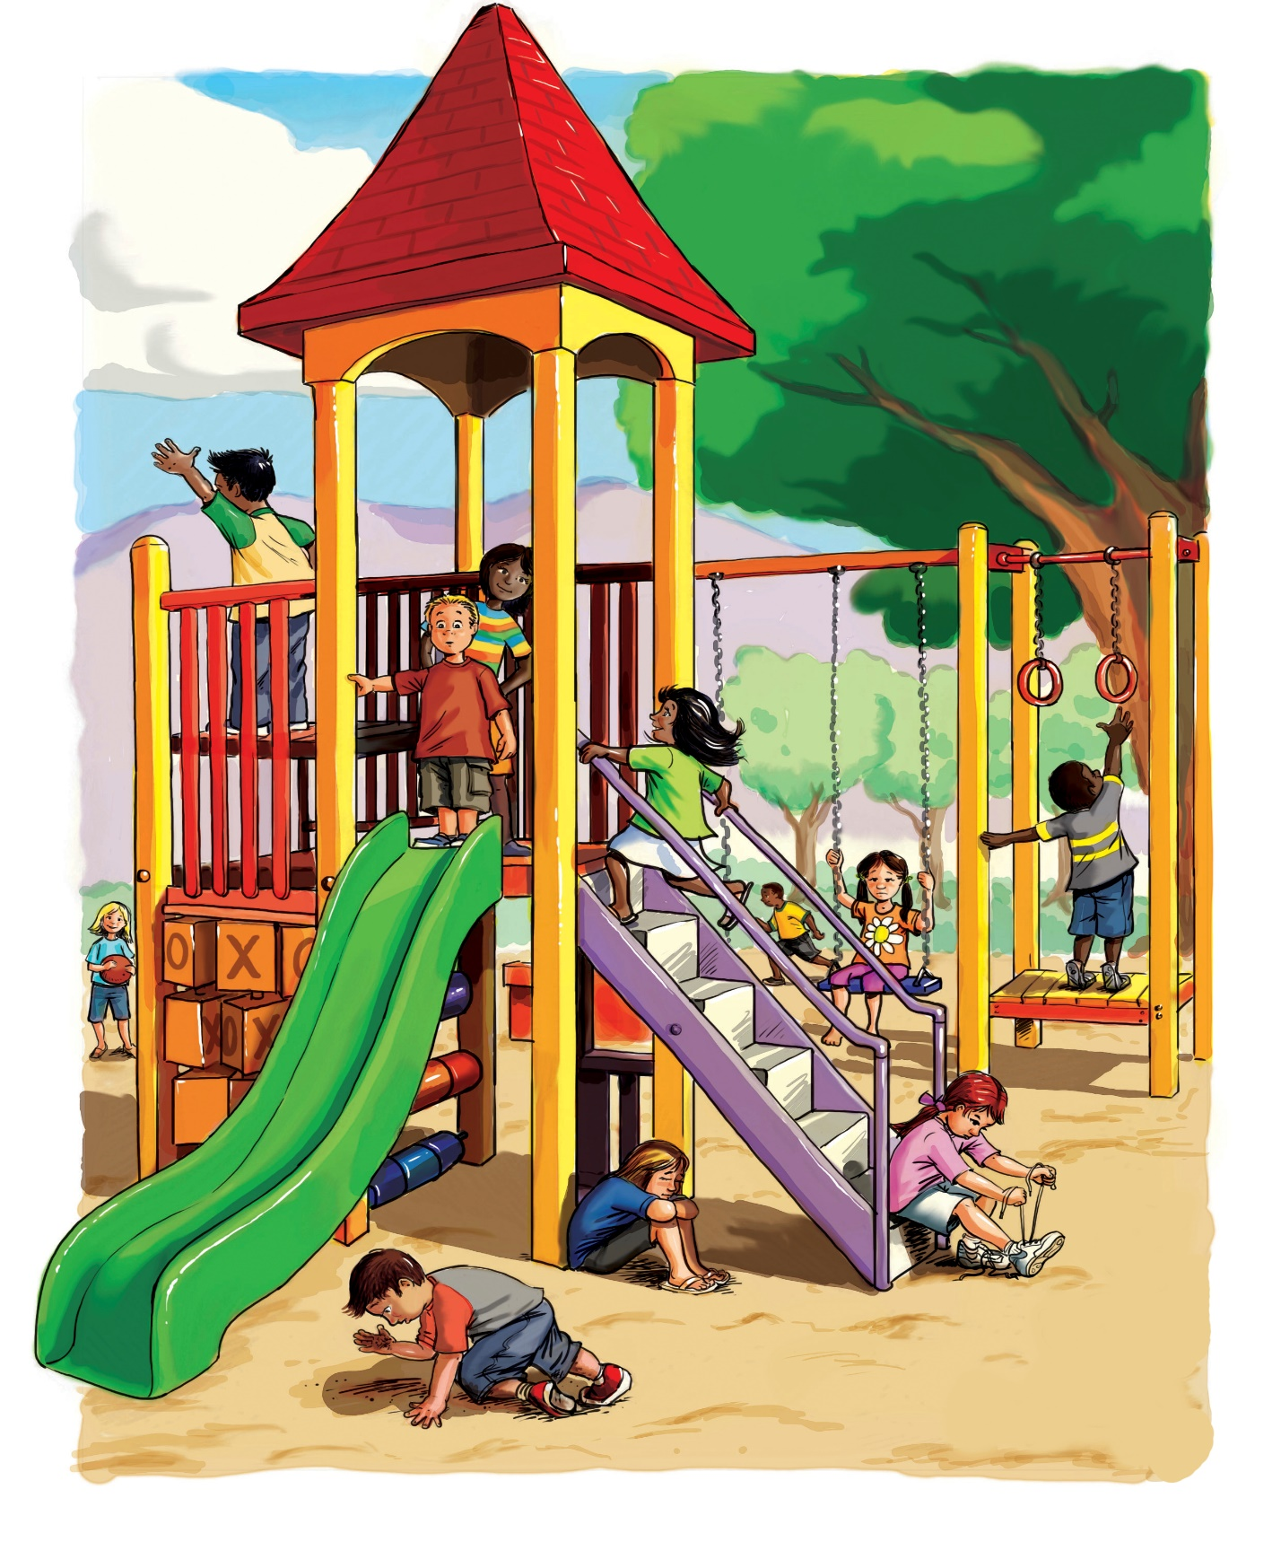
and play,
And not just
on the
Sabbath day.
And not just on
the Sabbath day.
Image Credits:

The Church of Jesus Christ of Latter-day Saints. A family at Christmas. The Church of Jesus Christ Media Library. Retrieved Jun. 11, 2023 from https://www.churchofjesuschrist.org/media/image/family-nativity-set-43df0e0?lang=eng&collectionId=408040e2e846420e8df818f3169c9543

The Church of Jesus Christ of Latter-day Saints. At the park. The Church of Jesus Christ Media Library. Retrieved Jun. 11, 2023 from https://www.churchofjesuschrist.org/media/image/faithful-friend-wonderful-gift-6b0c6bd?lang=eng&collectionId=408040e2e846420e8df818f3169c9543

The Church of Jesus Christ of Latter-day Saints. At the park. The Church of Jesus Christ Media Library. Retrieved Jun. 11, 2023 from https://www.churchofjesuschrist.org/media/image/children-playground-bd50229?lang=eng&collectionId=408040e2e846420e8df818f3169c9543
The Church of Jesus Christ of Latter-day Saints. Family at the temple. The Church of Jesus Christ Media Library. Retrieved Jun. 11, 2023 from https://www.churchofjesuschrist.org/media/image/family-approaching-temple-cb07c2d?lang=eng&collectionId=408040e2e846420e8df818f3169c9543

The Church of Jesus Christ of Latter-day Saints. Holding hands. The Church of Jesus Christ Media Library. Retrieved Jun. 11, 2023 from https://www.churchofjesuschrist.org/media/image/holding-hands-d27bd9b?lang=eng&collectionId=408040e2e846420e8df818f3169c9543

The Church of Jesus Christ of Latter-day Saints. Lily in bloom. The Church of Jesus Christ Media Library. Retrieved Jun. 11, 2023 from https://www.churchofjesuschrist.org/media/image/children-finding-easter-lily-25cb48a?lang=eng&collectionId=408040e2e846420e8df818f3169c9543

The Church of Jesus Christ of Latter-day Saints. On the computer. The Church of Jesus Christ Media Library. Retrieved Jun. 11, 2023 from https://www.churchofjesuschrist.org/media/image/boy-typing-8c7d68a?lang=eng&collectionId=408040e2e846420e8df818f3169c9543

The Church of Jesus Christ of Latter-day Saints. Picture of Christ. The Church of Jesus Christ Media Library. Retrieved Jun. 11, 2023 from https://www.churchofjesuschrist.org/media/image/family-jesus-christ-picture-d104a0c?lang=eng&collectionId=408040e2e846420e8df818f3169c9543

The Church of Jesus Christ of Latter-day Saints. Primary class. The Church of Jesus Christ Media Library. Retrieved Jun. 11, 2023 from https://www.churchofjesuschrist.org/media/image/girl-primary-fellowshipping-830258b?lang=eng&collectionId=408040e2e846420e8df818f3169c9543

The Church of Jesus Christ of Latter-day Saints. Singing hymns. The Church of Jesus Christ Media Library. Retrieved Jun. 11, 2023 from https://www.churchofjesuschrist.org/media/image/family-singing-sacrament-meeting-982d876?lang=eng&collectionId=408040e2e846420e8df818f3169c9543

The Church of Jesus Christ of Latter-day Saints. The Friend magazine. The Church of Jesus Christ Media Library. Retrieved Jun. 11, 2023 from https://www.churchofjesuschrist.org/media/image/friend-magazine-illustration-5cce8cd?lang=eng&collectionId=408040e2e846420e8df818f3169c9543

