Instructions:
1) Print fish.
2) Laminate and cut out fish.
3) Write a song on the back of each fish.
4) Lay the fish on a blue cloth on the floor (or use magnets to post inside an aquarium on the chalkboard.
5) Have children “fish” for a song using a magnet suspended from a stick.
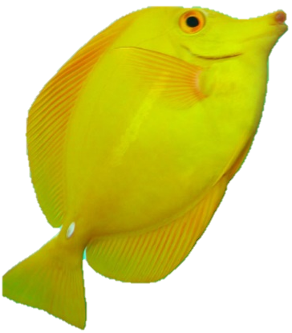

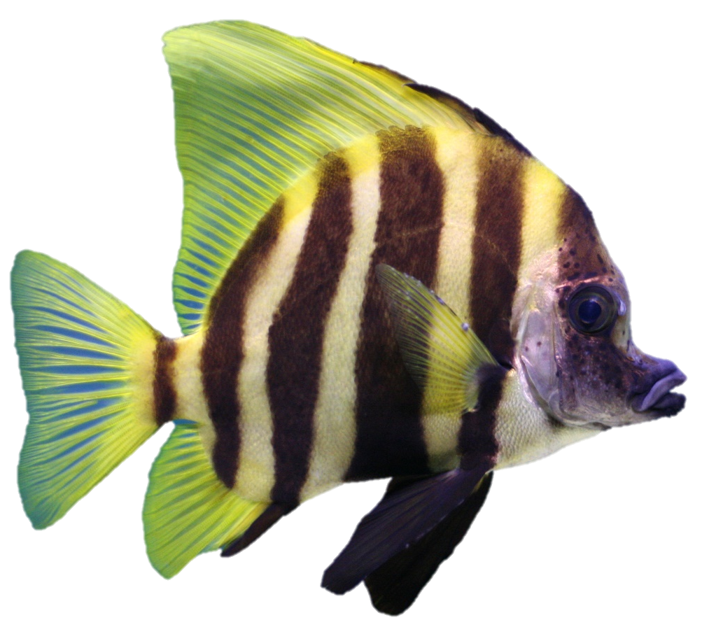

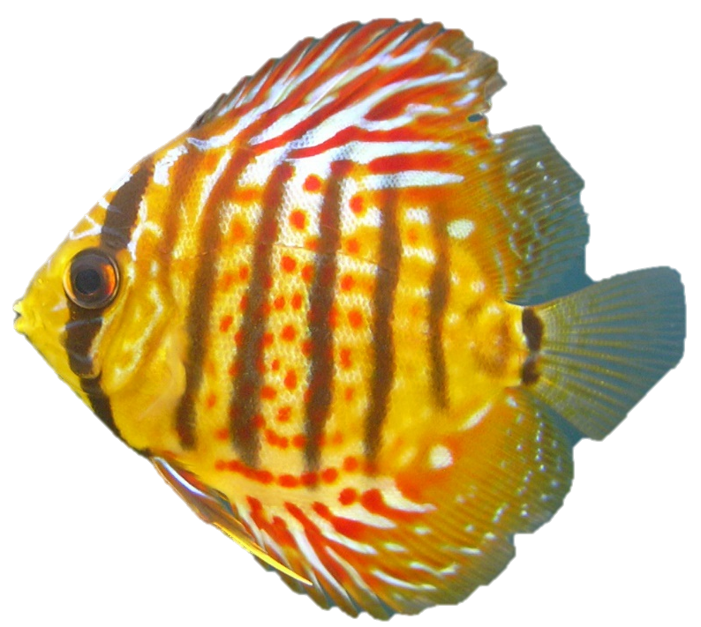

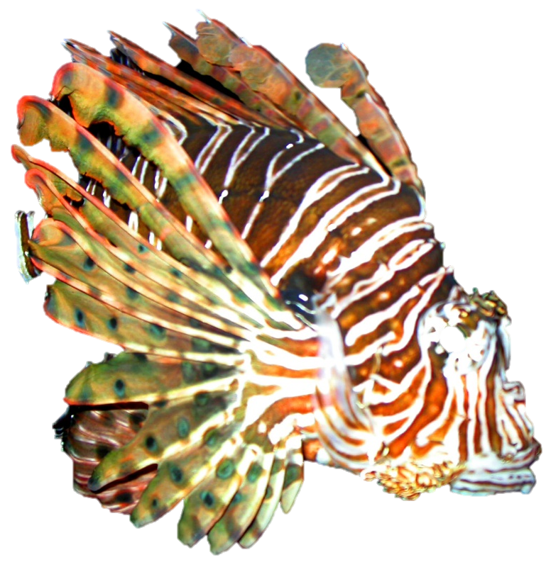

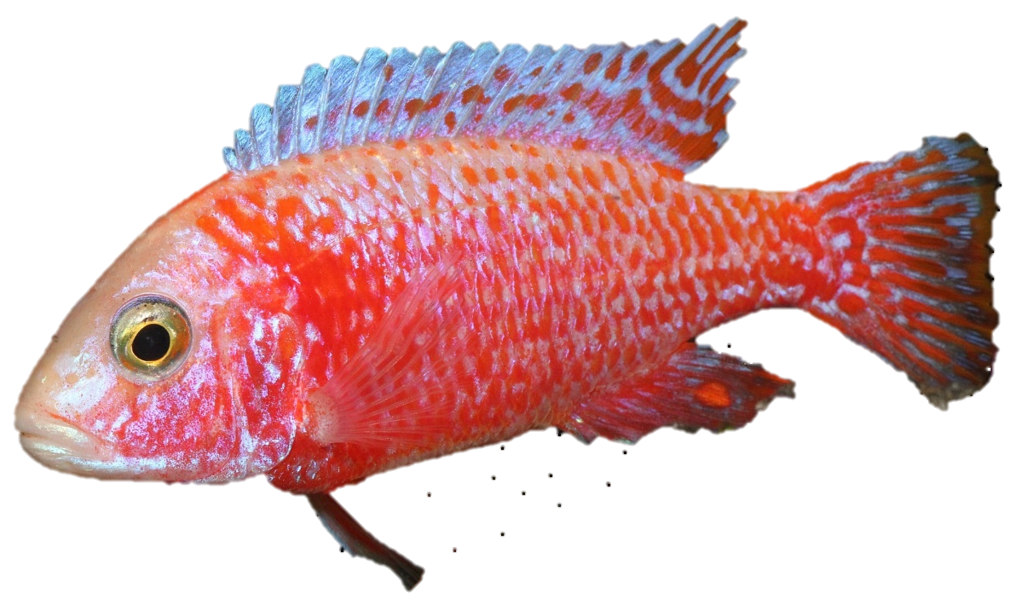

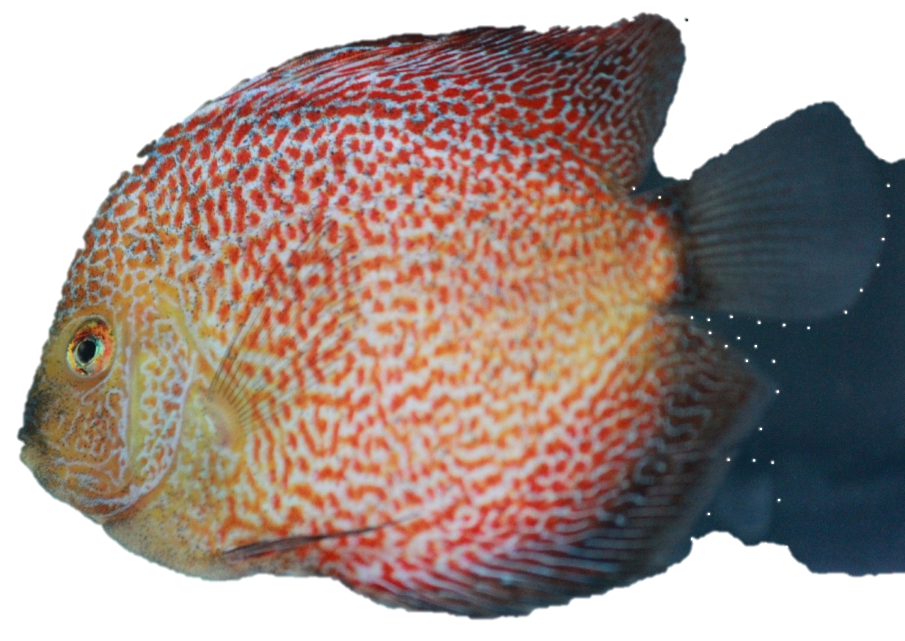

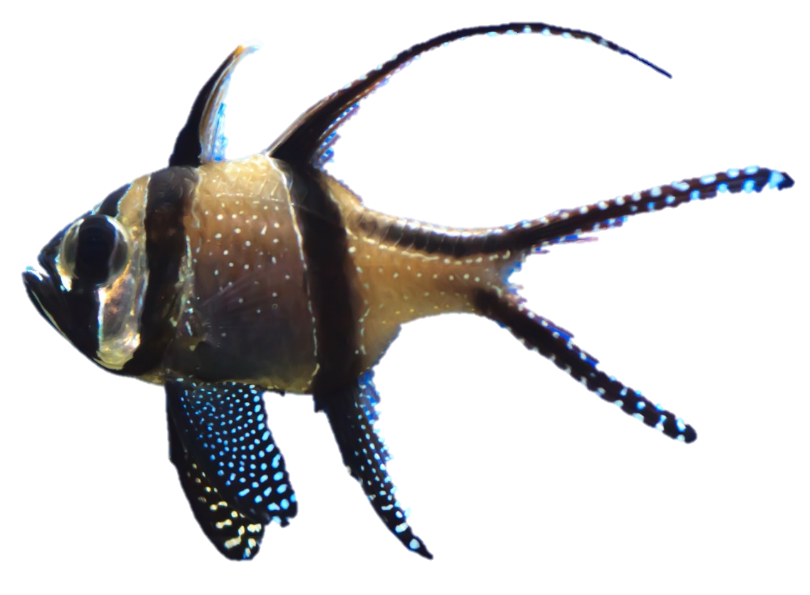

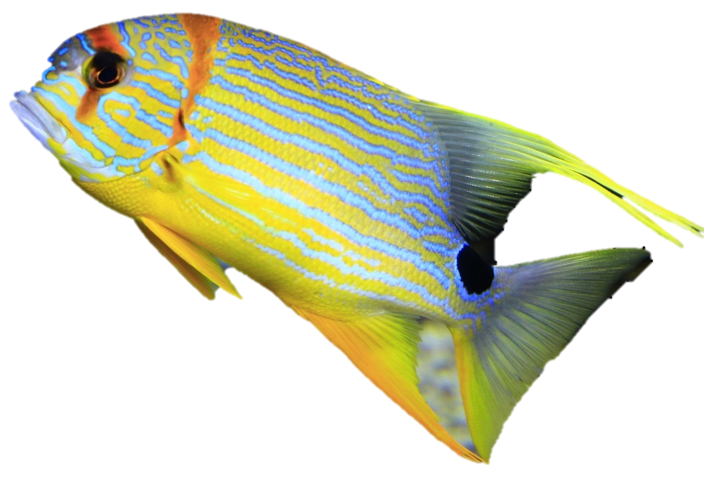

Image Credits:
Annunako. (2016, May 1). Reef sea underwater fish water 1758132. Pixabay. Retrieved April 9, 2017, from https://pixabay.com/en/reef-sea-underwater-fish-water-1758132/ Used under a CCO Public Domain License. Free for commercial use. No attribution required.
Blaine, Alexis. (2004, October 18). Lion fish 1512422. FreeImages.com. Retrieved April 9, 2017 from http://www.freeimages.com/photo/lionfish-1512422. Used under a FreeImages.com Content License.
Lisa. (n.d.). Yellow tang 1254293. FreeImages.com. Retrieved April 9, 2017 from http://www.freeimages.com/photo/yellow-tang-1254293. Used under a FreeImages.com Content License.
Modman. (2015, May 23). Cichlid fish peacock strawberry 780124. Pixabay. Retrieved April 9, 2017, from https://pixabay.com/en/cichlid-fish-peacock-strawberry-780124/ Used under a CCO Public Domain License. Free for commercial use. No attribution required.
Peters, Gareth. (n.d.). Discus fish 1387315. FreeImages.com. Retrieved April 9, 2017 from http://www.freeimages.com/photo/discus-fish-1387315. Used under a FreeImages.com Content License.
Paulbr75. (2016). Tropical fish colorful fish 1592925. Pixabay. Retrieved April 9, 2017, from https://pixabay.com/en/tropical-fish-colorful-fish-1592925/ Used under a CCO Public Domain License. Free for commercial use. No attribution required.
PDPics. (2014, July 15). Fish red dots fish tank aquarium 390124. Pixabay. Retrieved April 9, 2017, from https://pixabay.com/en/fish-red-dots-fish-tank-aquarium-390124/ Used under a CCO Public Domain License. Free for commercial use. No attribution required.
Public Domain Pictures. (2012, February 29). Animal aqua aquarium acuatic blue 19076. Pixabay. Retrieved April 9, 2017, from https://pixabay.com/en/animal-aqua-aquarium-aquatic-blue-19076/ Used under a CCO Public Domain License. Free for commercial use. No attribution required.
Skeeze. (1998). Clownfish anemonefish tropical fish 585473. Pixabay. Retrieved April 9, 2017, from https://pixabay.com/en/clownfish-anemonefish-tropical-fish-585473/ Used under a CCO Public Domain License. Free for commercial use. No attribution required.
Zajdowicz, Thad. (2007, June 20). Tropical fish 117398. FreeImages.com. Retrieved April 9, 2017 from http://www.freeimages.com/photo/fish-2-1177398. Used under a FreeImages.com Content License.
Zajdowicz, Thad. (2007, June 8). Tropical fish 1176775. FreeImages.com. Retrieved April 9, 2017 from http://www.freeimages.com/photo/tropical-fish-1176775 Used under a FreeImages.com Content License.

