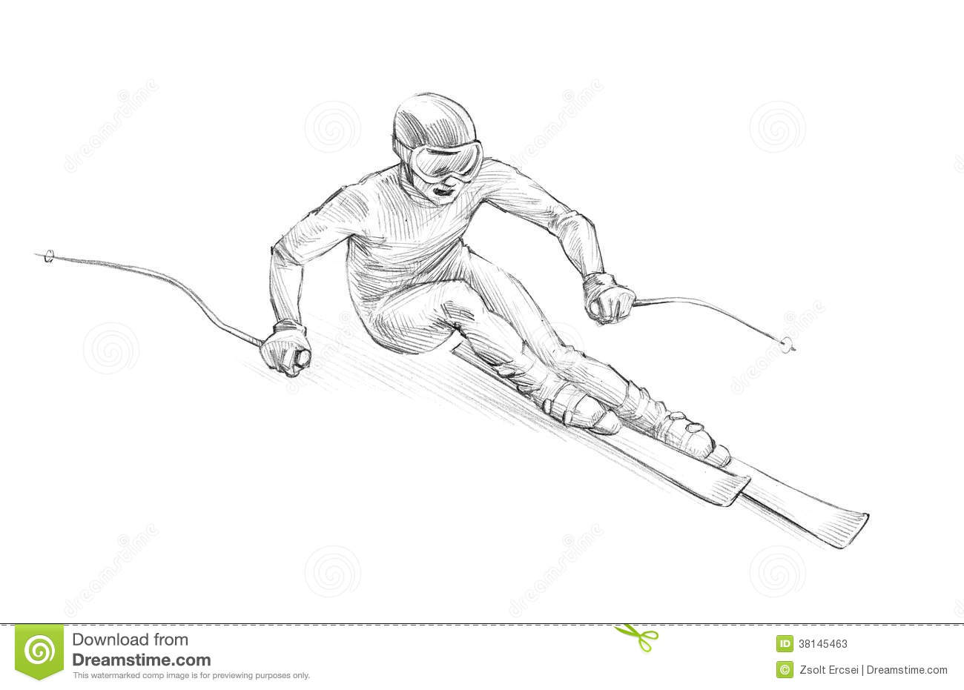

GREATEST SNOW ON EARTH

**LIFE** ELEVATED

UTAH

CHLD 0GD



GREATEST SNOW ON EARTH

**LIFE** ELEVATED

UTAH

CHZDARIT



GREATEST SNOW ON EARTH

**LIFE** ELEVATED

UTAH

ITRY2BLKJS



GREATEST SNOW ON EARTH

**LIFE** ELEVATED

UTAH

NEE5 CRG



GREATEST SNOW ON EARTH

**LIFE** ELEVATED

UTAH

STD4RIT



GREATEST SNOW ON EARTH

**LIFE** ELEVATED

UTAH

WIZ MAN



GREATEST SNOW ON EARTH

**LIFE** ELEVATED

UTAH

2THNKJS

UTAH



GREATEST SNOW ON EARTH

**LIFE** ELEVATED

WIMBPTZD

UTAH



GREATEST SNOW ON EARTH

**LIFE** ELEVATED

WER DIF



GREATEST SNOW ON EARTH

**LIFE** ELEVATED

UTAH

ILWKWU



GREATEST SNOW ON EARTH

**LIFE** ELEVATED

UTAH

DOASIDO



GREATEST SNOW ON EARTH

**LIFE** ELEVATED

UTAH

ILV2SEE



GREATEST SNOW ON EARTH

**LIFE** ELEVATED

UTAH

4THAOF



GREATEST SNOW ON EARTH

**LIFE** ELEVATED

UTAH

TCH2WLK



GREATEST SNOW ON EARTH

**LIFE** ELEVATED

UTAH

IFLSVRS♥

UTAH

GTHSME



GREATEST SNOW ON EARTH

**LIFE** ELEVATED