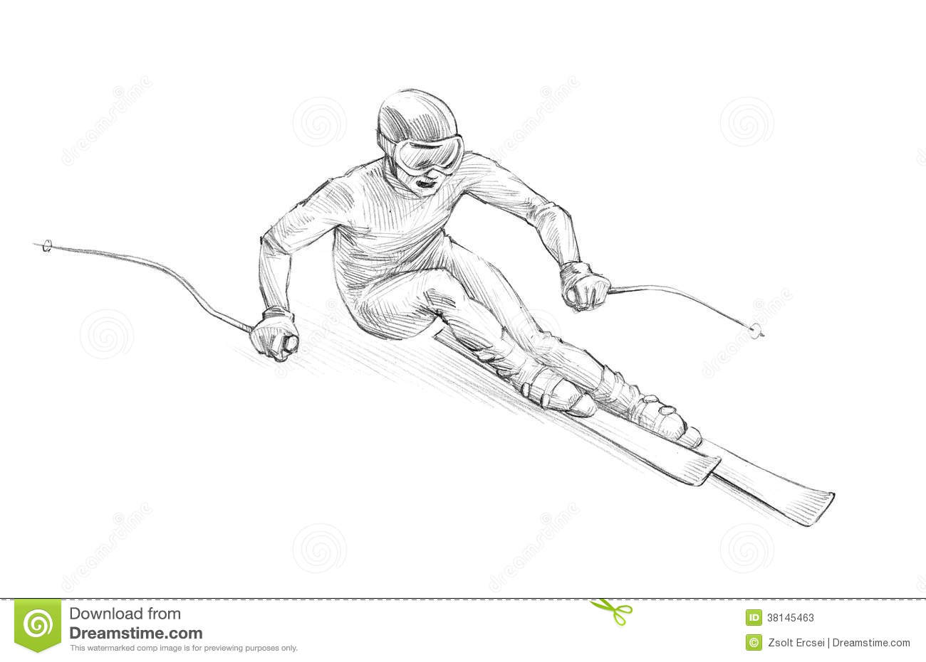

GREATEST SNOW ON EARTH

**LIFE** ELEVATED

UTAH

IFLSVRSLV



GREATEST SNOW ON EARTH

**LIFE** ELEVATED

UTAH

CMFLWME



GREATEST SNOW ON EARTH

**LIFE** ELEVATED

UTAH

ITRY2BLKJS



GREATEST SNOW ON EARTH

**LIFE** ELEVATED

UTAH

KPCMDTS



GREATEST SNOW ON EARTH

**LIFE** ELEVATED

UTAH

ESNTHZSN



GREATEST SNOW ON EARTH

**LIFE** ELEVATED

UTAH

HLY GST



GREATEST SNOW ON EARTH

**LIFE** ELEVATED

UTAH

2 BLK JZS

UTAH



GREATEST SNOW ON EARTH

**LIFE** ELEVATED

BAP TZM

UTAH



GREATEST SNOW ON EARTH

**LIFE** ELEVATED

SRCH PNDR



GREATEST SNOW ON EARTH

**LIFE** ELEVATED

UTAH

ILWKWU



GREATEST SNOW ON EARTH

**LIFE** ELEVATED

UTAH

IWNT2LVGSPL



GREATEST SNOW ON EARTH

**LIFE** ELEVATED

UTAH

RPNTNC



GREATEST SNOW ON EARTH

**LIFE** ELEVATED

UTAH

JZSSD♥



GREATEST SNOW ON EARTH

**LIFE** ELEVATED

UTAH

TCH2WLK



GREATEST SNOW ON EARTH

**LIFE** ELEVATED

UTAH

IFLSVRS♥

UTAH

THMRCL



GREATEST SNOW ON EARTH

**LIFE** ELEVATED