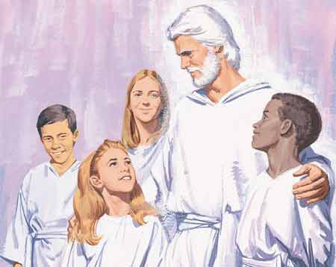**I Am A Child**

**Child**

**of**

**God**

**I Am A**



**He**

**Has a Plan for Me**

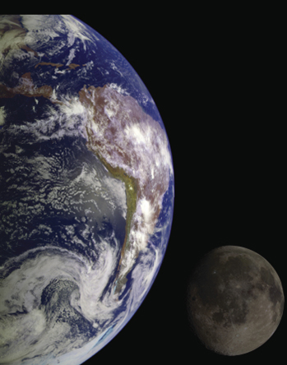

**The**

**Earth was created for me**

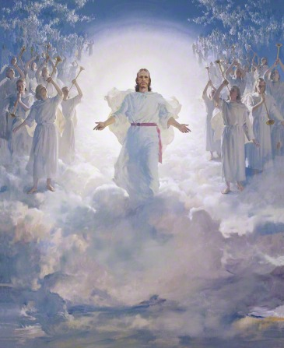

**Jesus Christ is Our Savior**

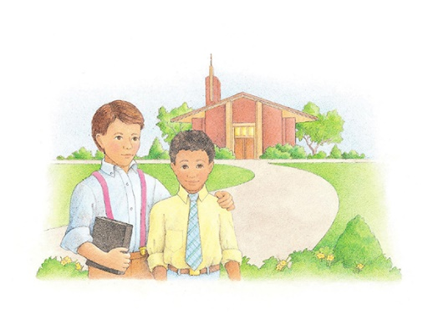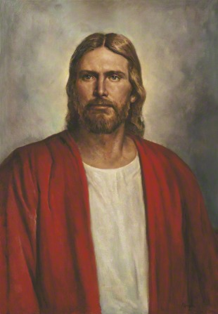

**Jesus Christ**

**Restored His Church**

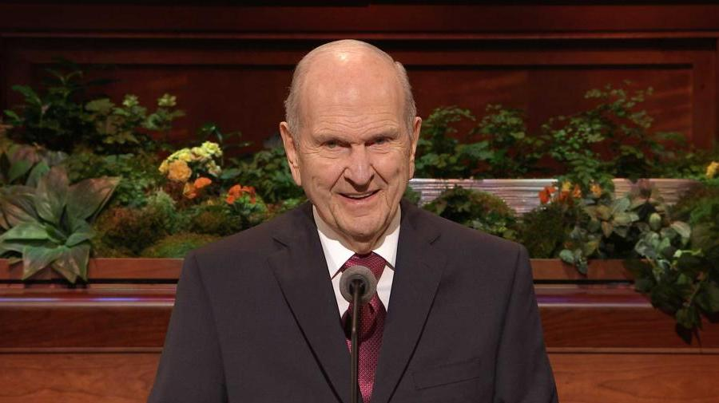

**Prophets Teach Us to Live the Gospel**

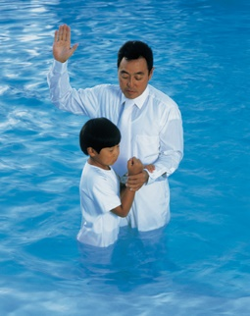

**I Will Follow Heavenly Father’s Plan for Me**

**By Being Baptized & Confirmed**

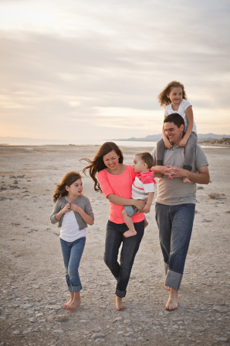

**Families Are a Part of Heavenly Father’s Plan**

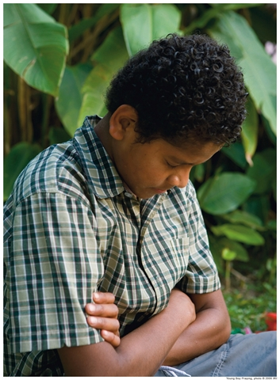

**Heavenly Father Hears & Answers My Prayers**

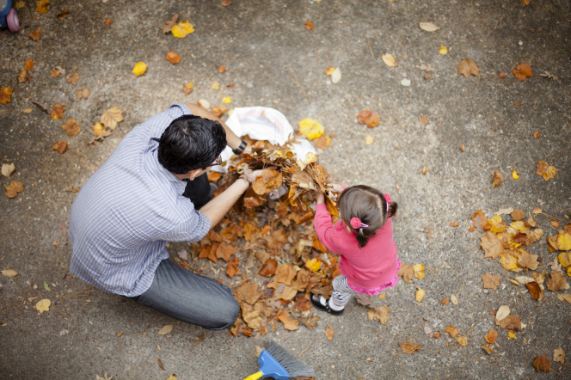

**I Will Serve God**

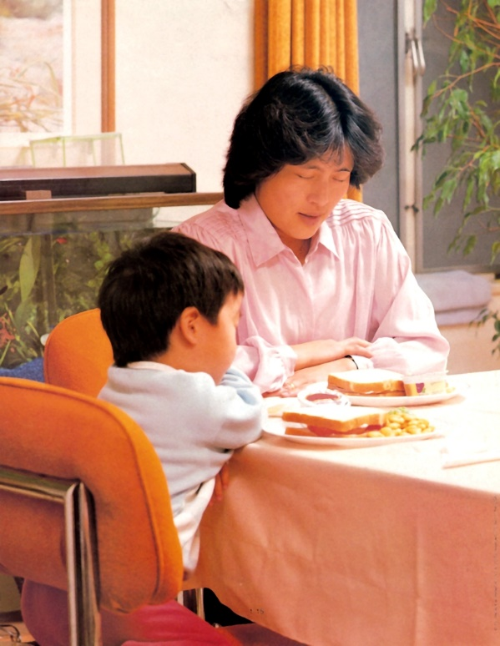

**We Are to Thank God in All Things**



**I Will Share**

**the Gospel**