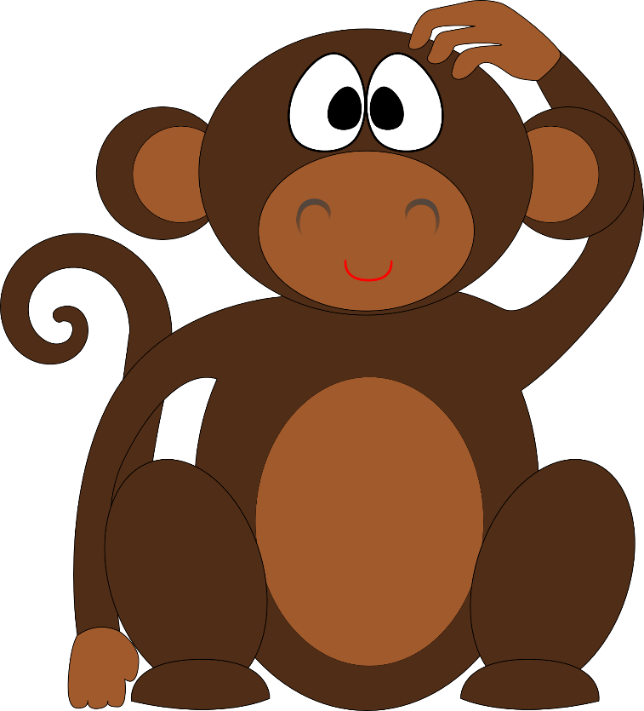
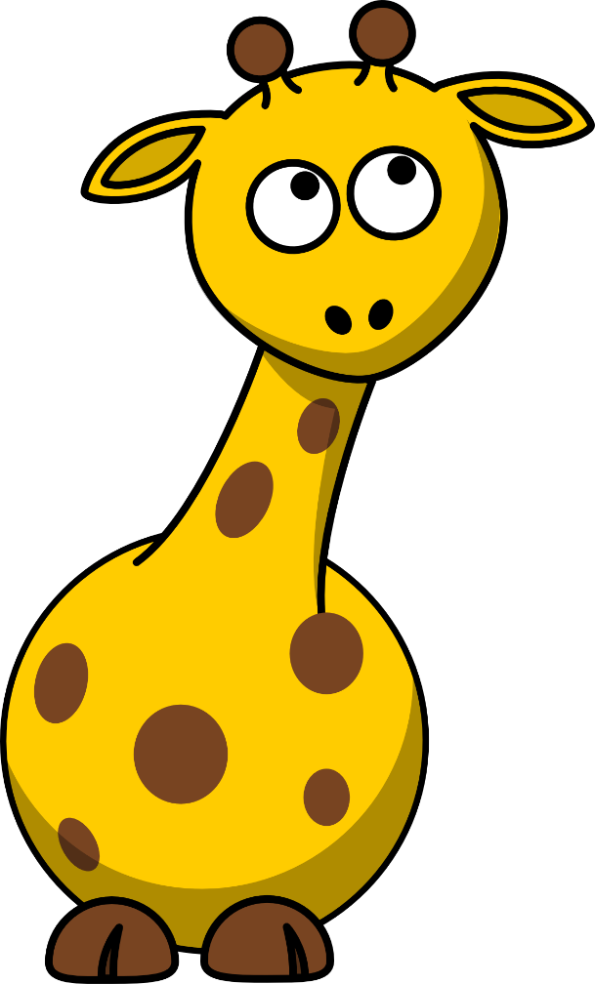
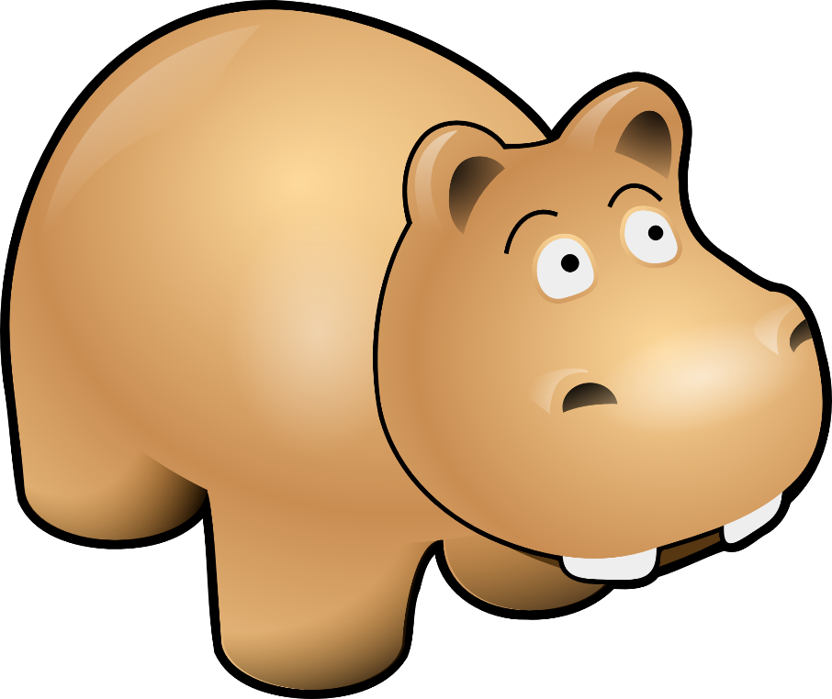
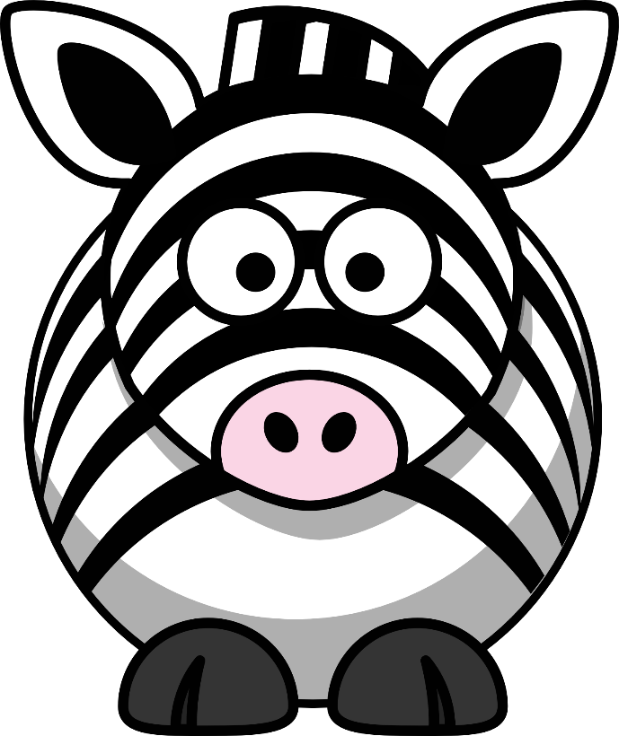
Singing Safari

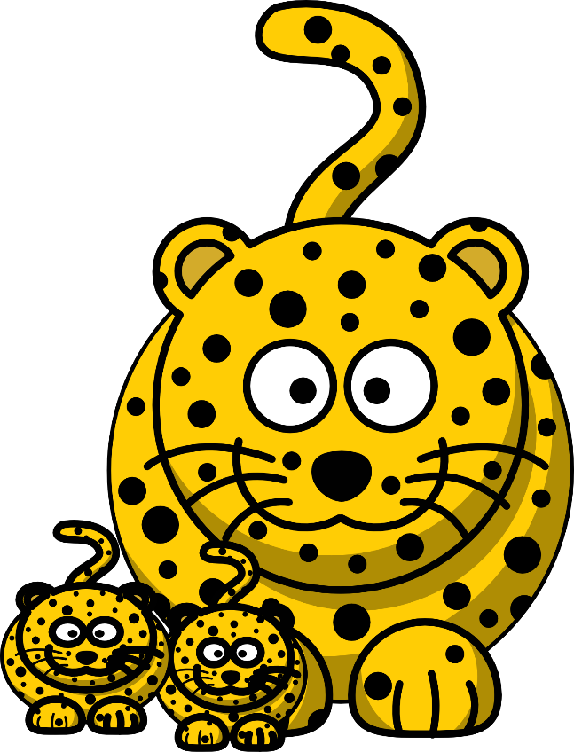
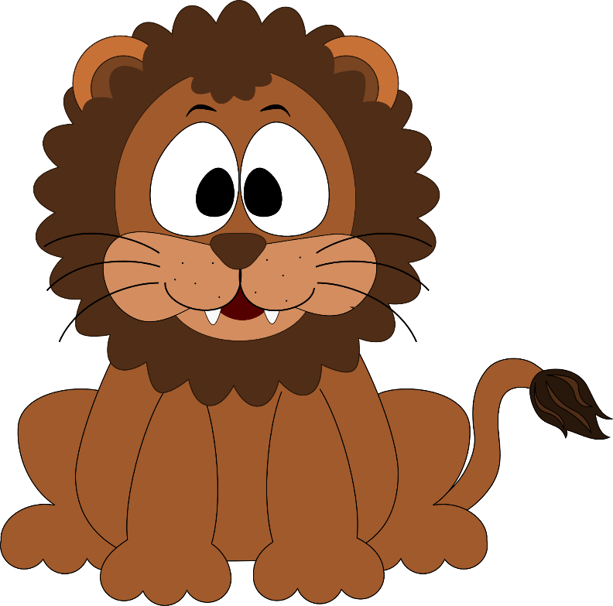

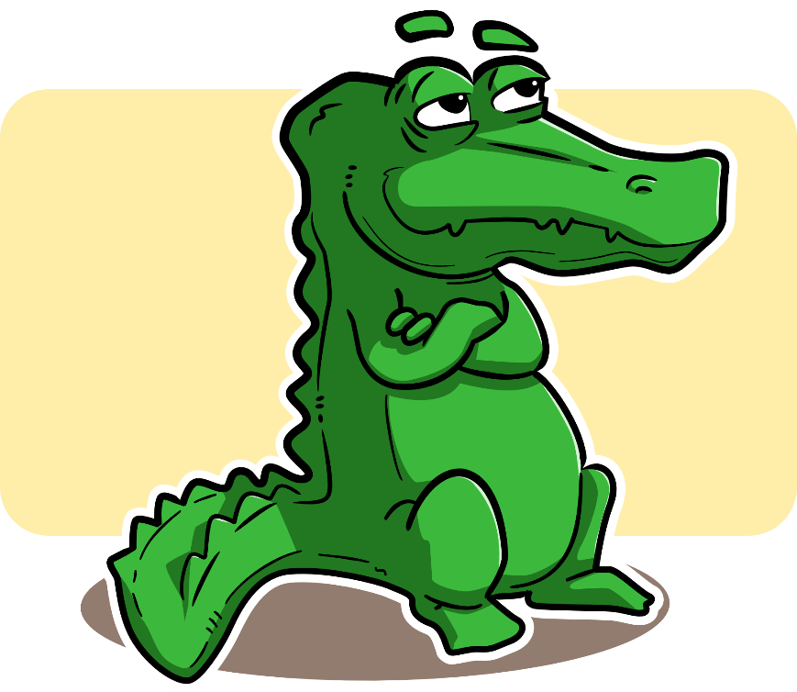

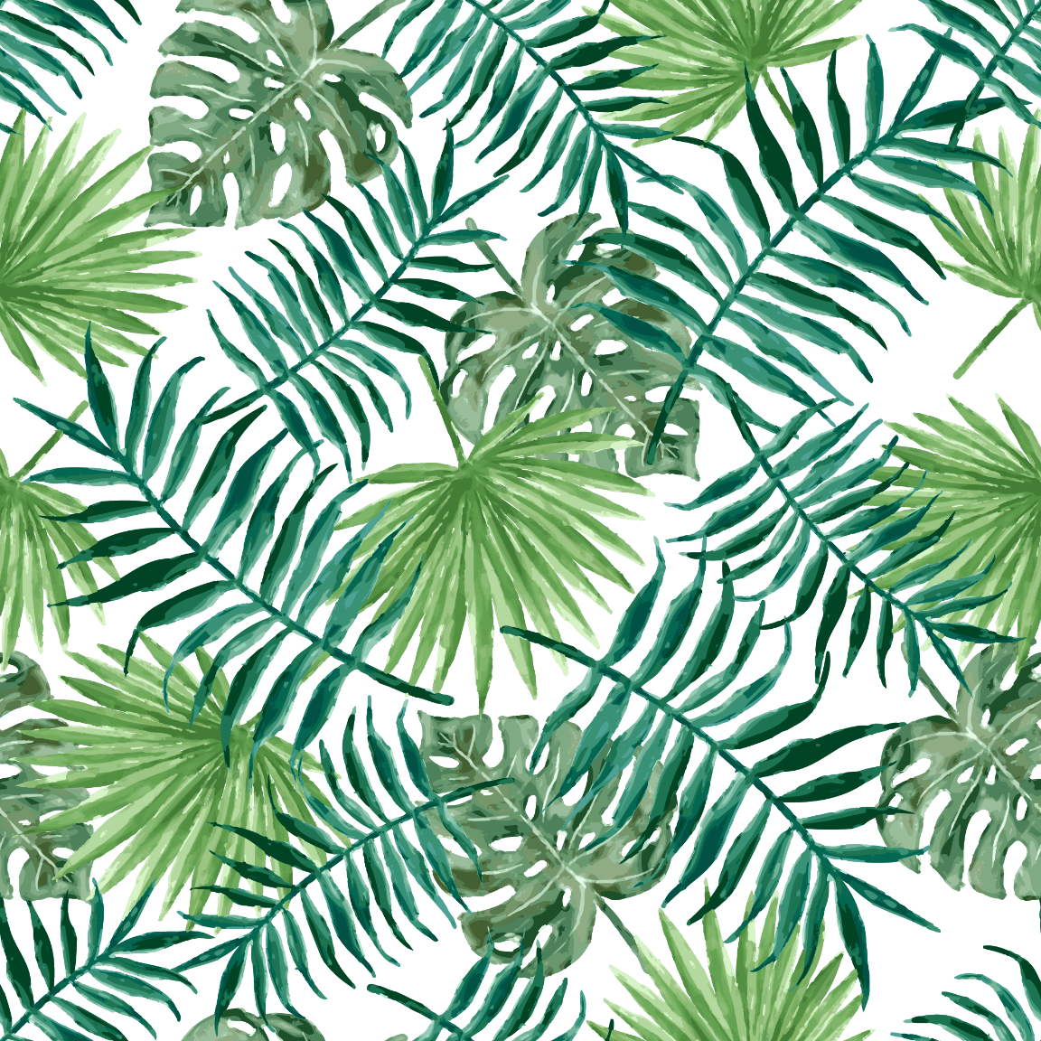

Singing

Safari
Image Credits

Crocodile
https://pixabay.com/en/alligator-animal-crocodile-reptile-161909/

Elephant
https://pixabay.com/en/elephant-animal-mammal-black-grey-35527/

Giraffe
https://pixabay.com/en/baby-giraffe-cute-cartoon-funny-307016/
https://pixabay.com/en/giraffe-animal-mammal-safari-303601/

Hippo
https://pixabay.com/en/hippo-brown-mammal-danger-wildlife-30687/

Leaves
https://pixabay.com/en/textile-fabric-leaf-plant-palm-2310247/

Leopard
https://pixabay.com/en/leopard-cheetah-hunting-leopard-306264/

Lion
https://pixabay.com/en/loin-cartoon-inkscape-design-cute-470302/

Monkey
https://pixabay.com/en/monkey-chimp-ape-chimpanzee-animal-474147/

Rhino
https://pixabay.com/en/rhinoceros-baby-face-funny-wild-37393/

Tiger
https://pixabay.com/en/tiger-cat-cute-animal-happy-156944/

Zebra
https://pixabay.com/en/zebra-animal-head-eyes-happy-face-37396/
https://pixabay.com/en/zebra-cartoon-animal-zoo-wildlife-470305/
https://pixabay.com/en/zebra-safari-africa-animal-mammal-296835/

