As a Child of God Flipchart
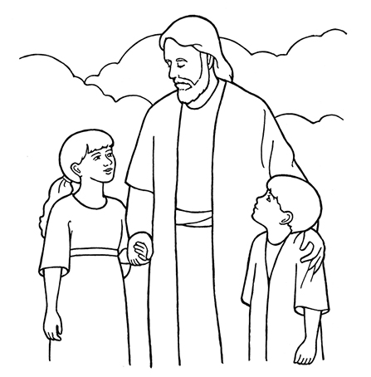

Words & Music by Janice Kapp Perry

Flipchart adapted by Cherice Montgomery from an idea by Cara Webber
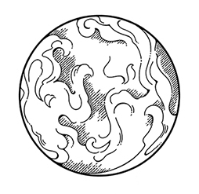

I
came to

power

with

to choose.

Good
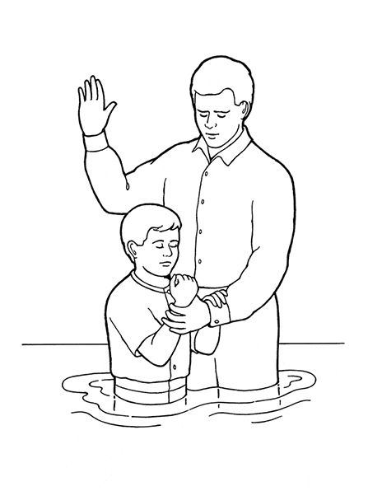

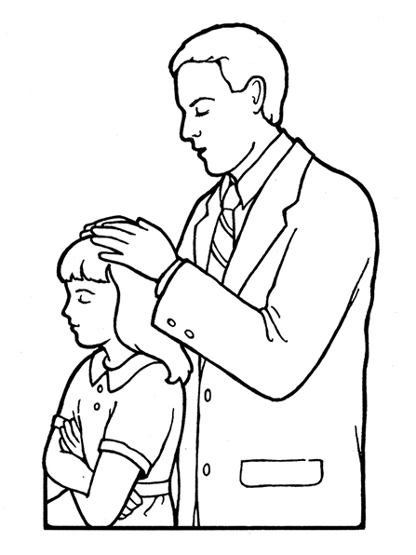

me
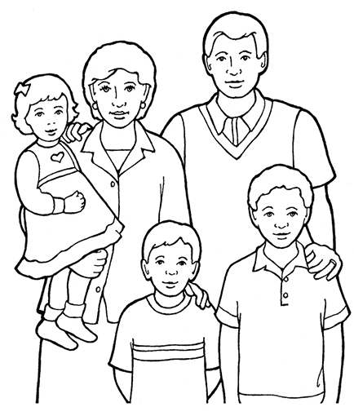

and my

too.

As a


I receive

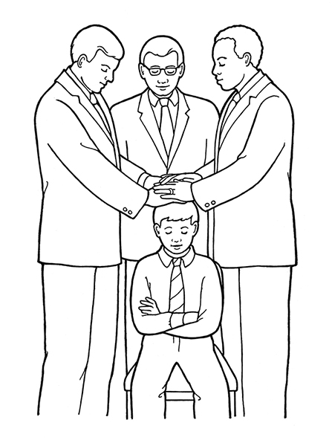

helps
me



to
know
what is
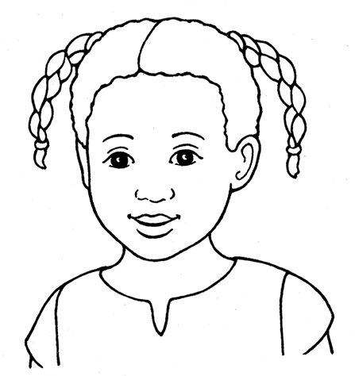
because

I feel so
safe and

Such feelings of peace come from

As a

I receive

helps
me

to
know
what is

In my own

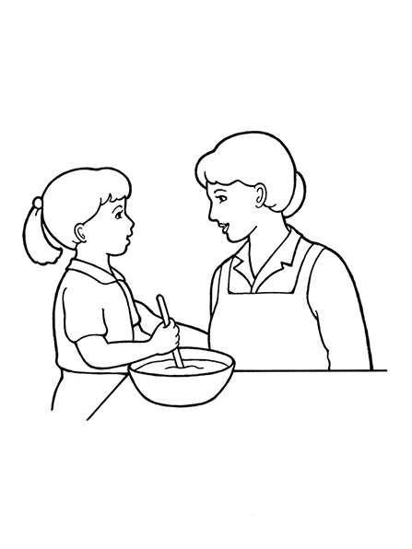

I’ll happily

I’ll strengthen my
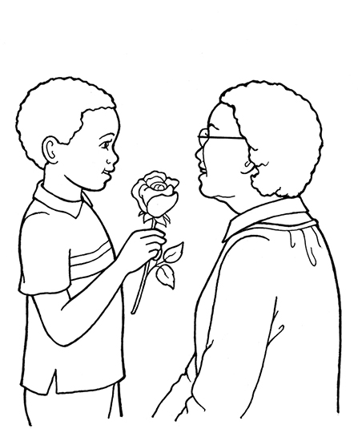

by
my
good

As a

I receive

helps
me

to
know
what is
Image Credits

The Creation Beth M Whittaker: https://www.lds.org/media-library/images/the-creation-beth-m-whittaker-351433?lang=eng

Boy Being Baptized: https://www.lds.org/media-library/images/boy-being-baptized-398319?lang=eng&_r=1

Girl Blessing Priesthood: https://www.lds.org/media-library/images/girl-blessing-priesthood-1238169?lang=eng&_r=1

General Conference Activity Packet Children: https://www.lds.org/media-library/images/general-conference-activity-packet-children-694941?lang=eng&_r=1

Jesus with Children Whitaker: https://www.lds.org/media-library/images/jesus-with-children-whitaker-346851?lang=eng&_r=1

Crescent Moon & Stars: https://www.lds.org/media-library/images/crescent-moon-and-stars-whitaker-368211?lang=eng&_r=1
Boy Being Confirmed: https://www.lds.org/media-library/images/boy-being-confirmed-398317?lang=eng&_r=1

CTR Logo: https://www.lds.org/media-library/images/ctr-logo-696056?lang=eng&_r=1

Family & Home Whitaker: https://www.lds.org/media-library/images/family-and-home-whitaker-387249?lang=eng&_r=1

Mother Daughter Cooking Whitaker:
https://www.lds.org/media-library/images/mother-daughter-cooking-whitaker-368212?lang=eng&_r=1

Boy Rose Mother: https://www.lds.org/media-library/images/boy-rose-mother-1238170?lang=eng&_r=1

