Instructions:
1) Print fish.
2) Laminate and cut out fish.
3) Write a song on the back of each fish.
4) Lay the fish on a blue cloth on the floor (or use magnets to post inside an aquarium on the chalkboard.
5) Have children “fish” for a song using a magnet suspended from a stick.

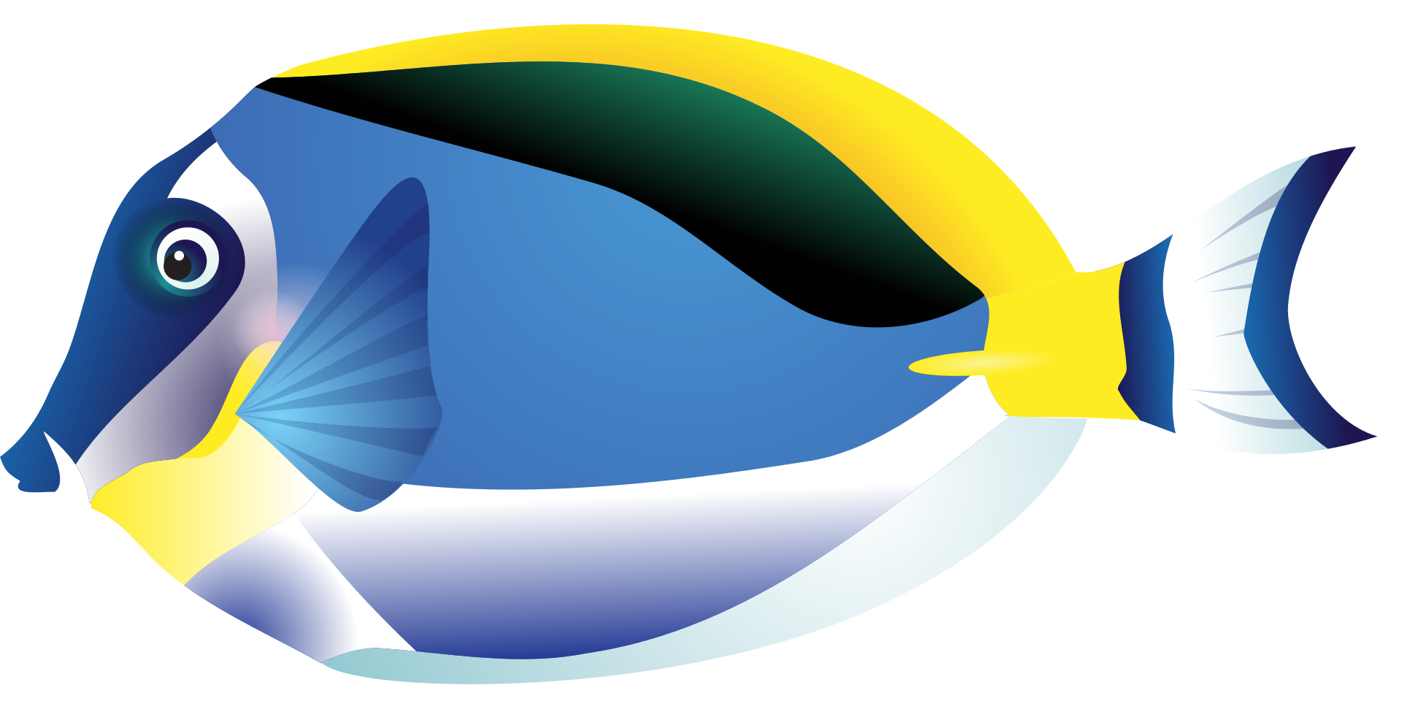

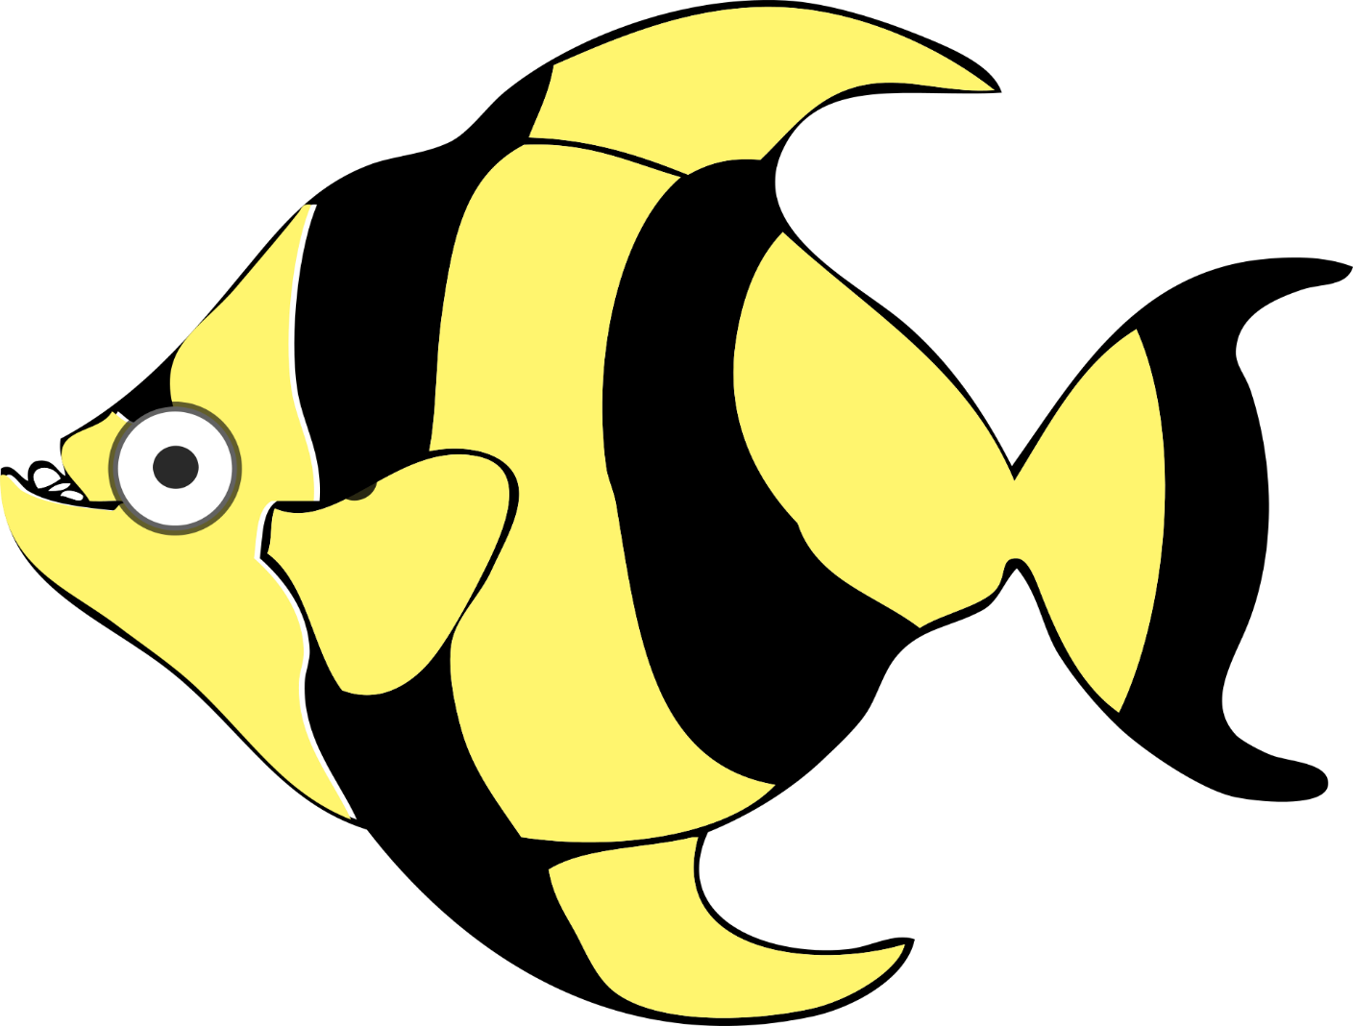

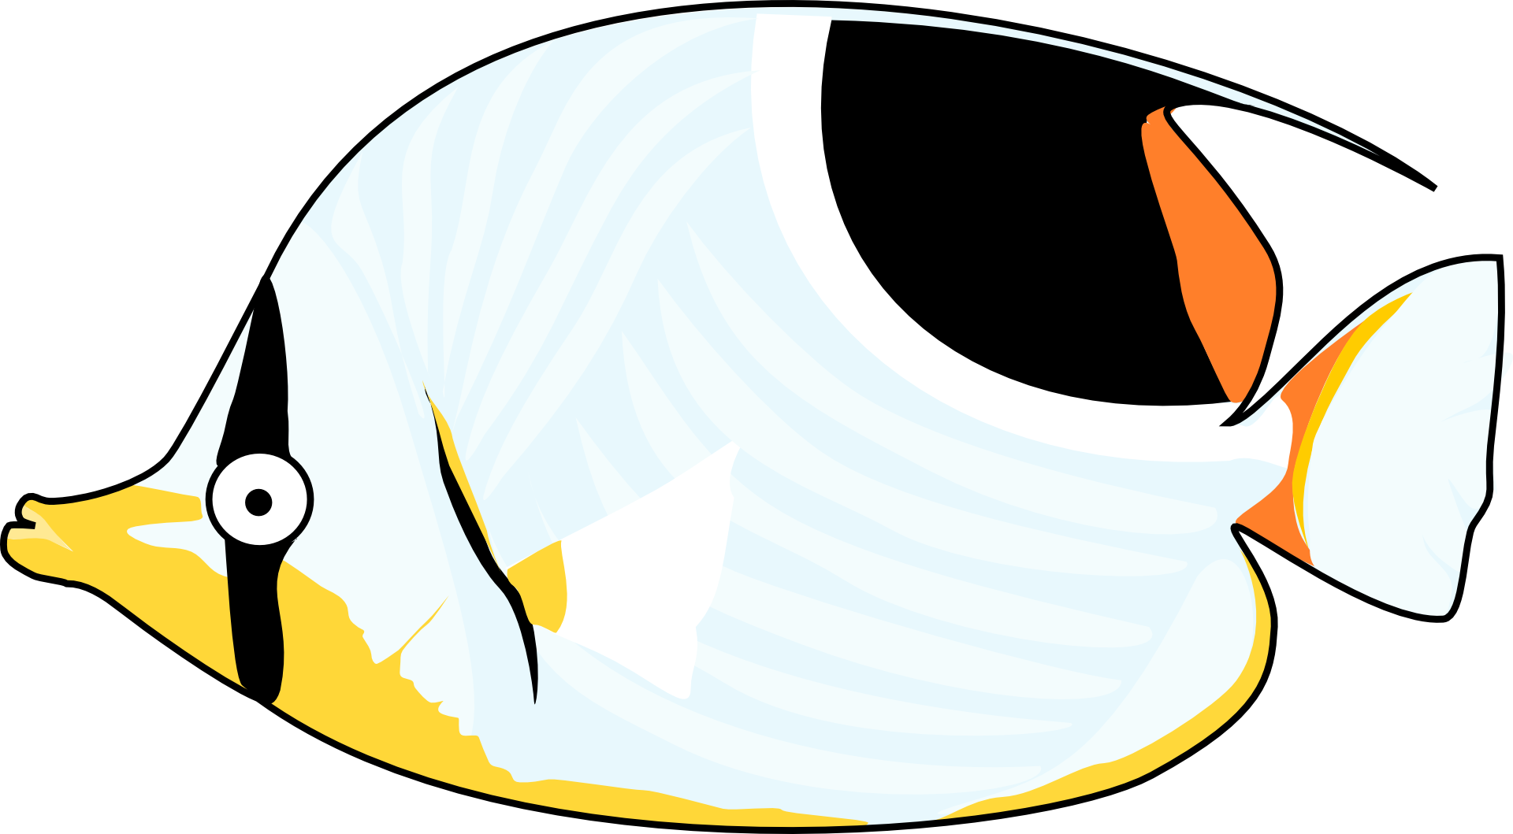

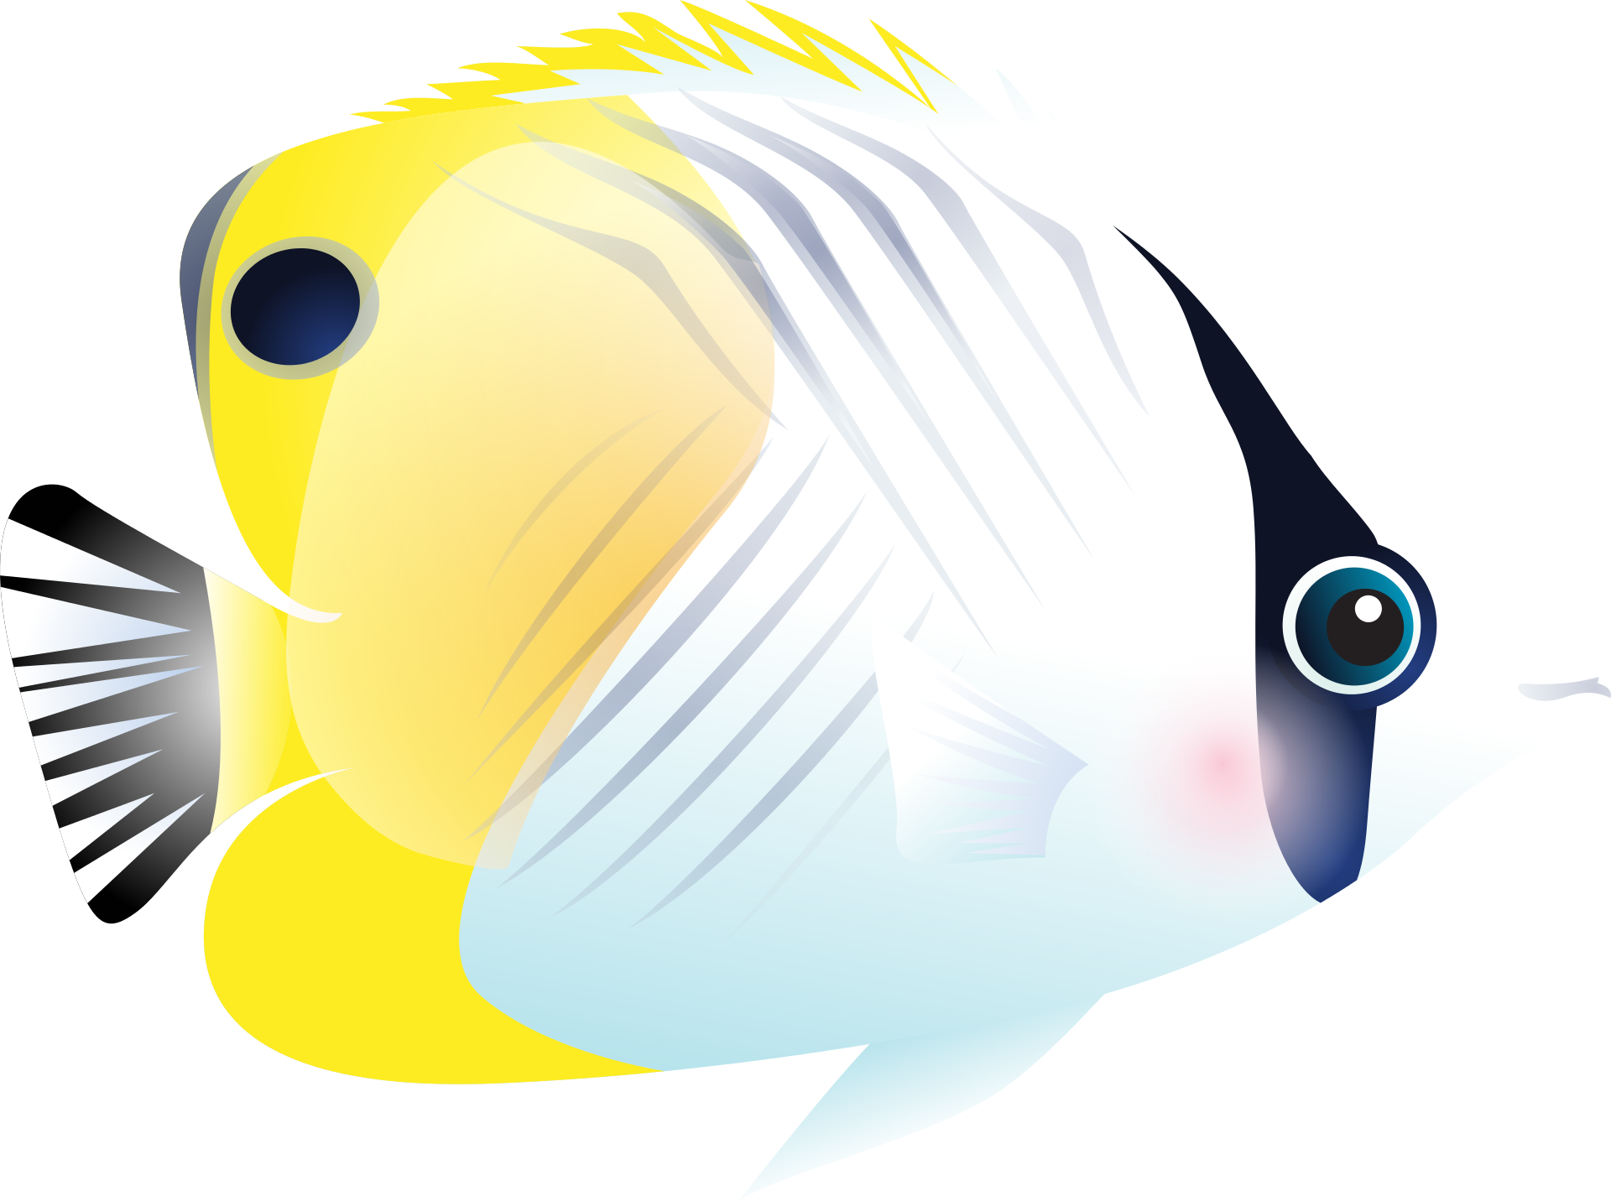

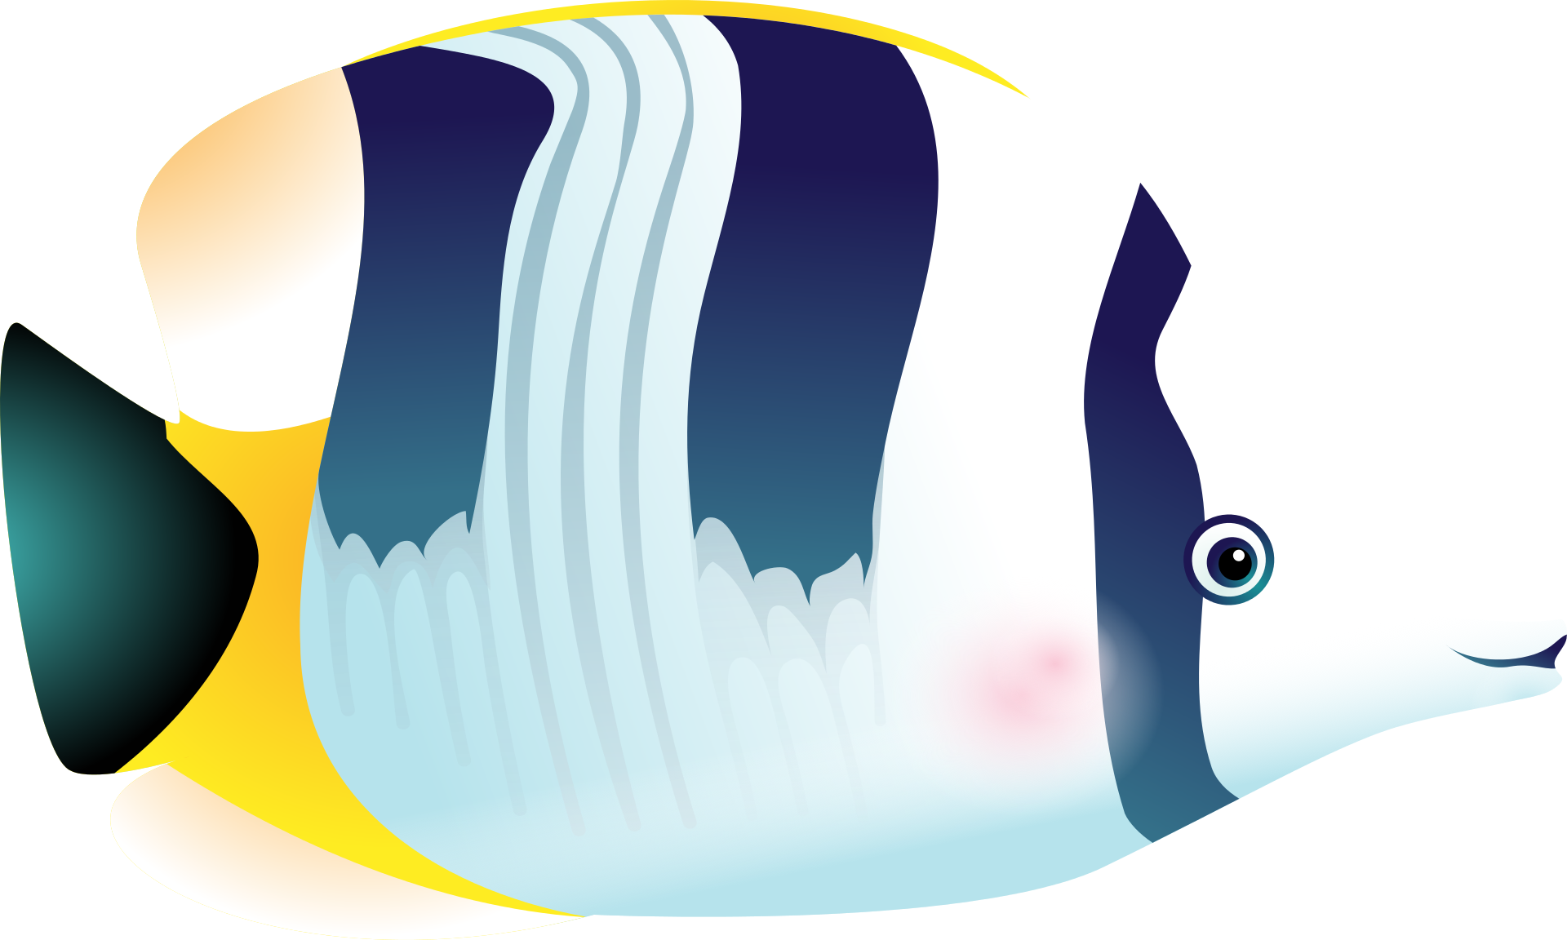

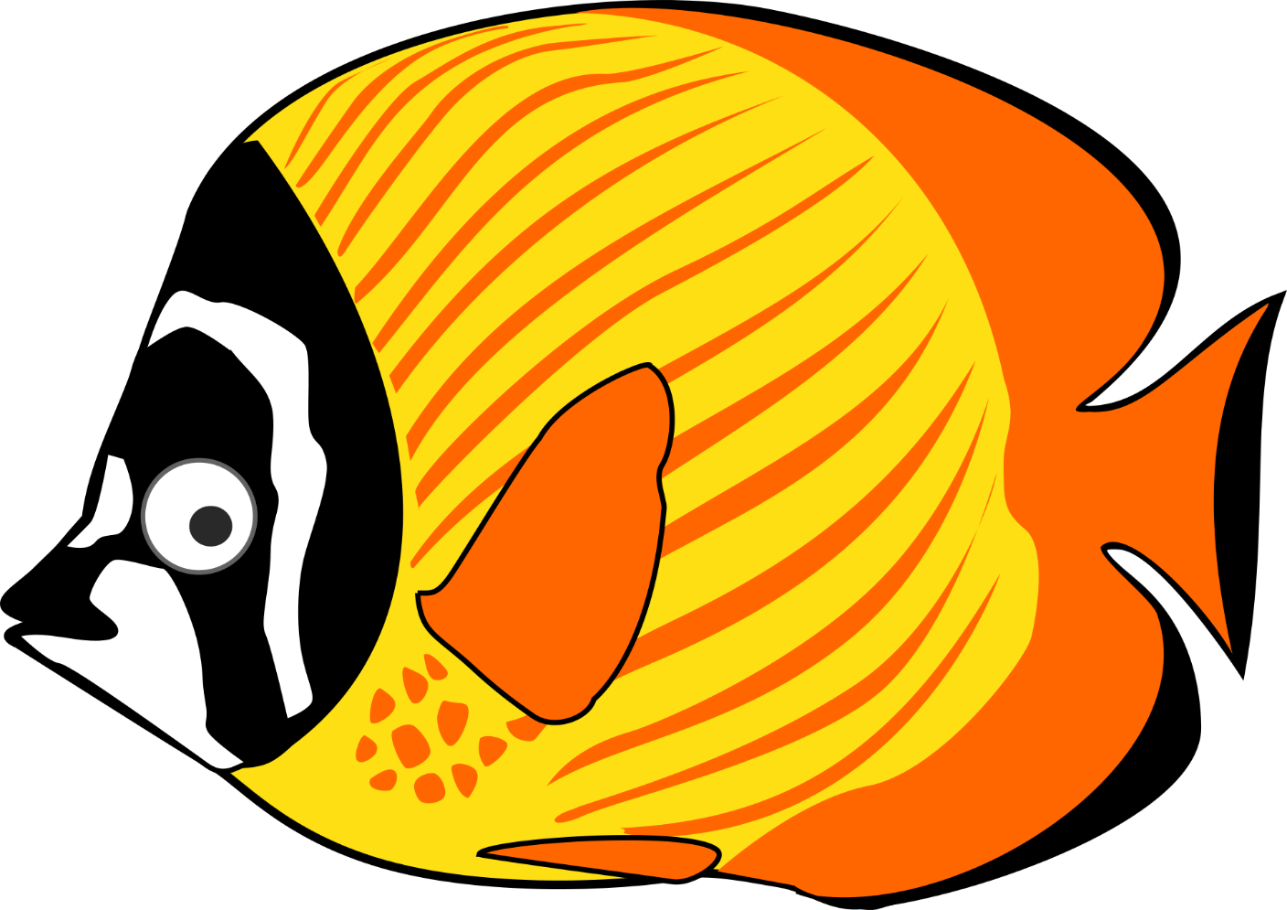

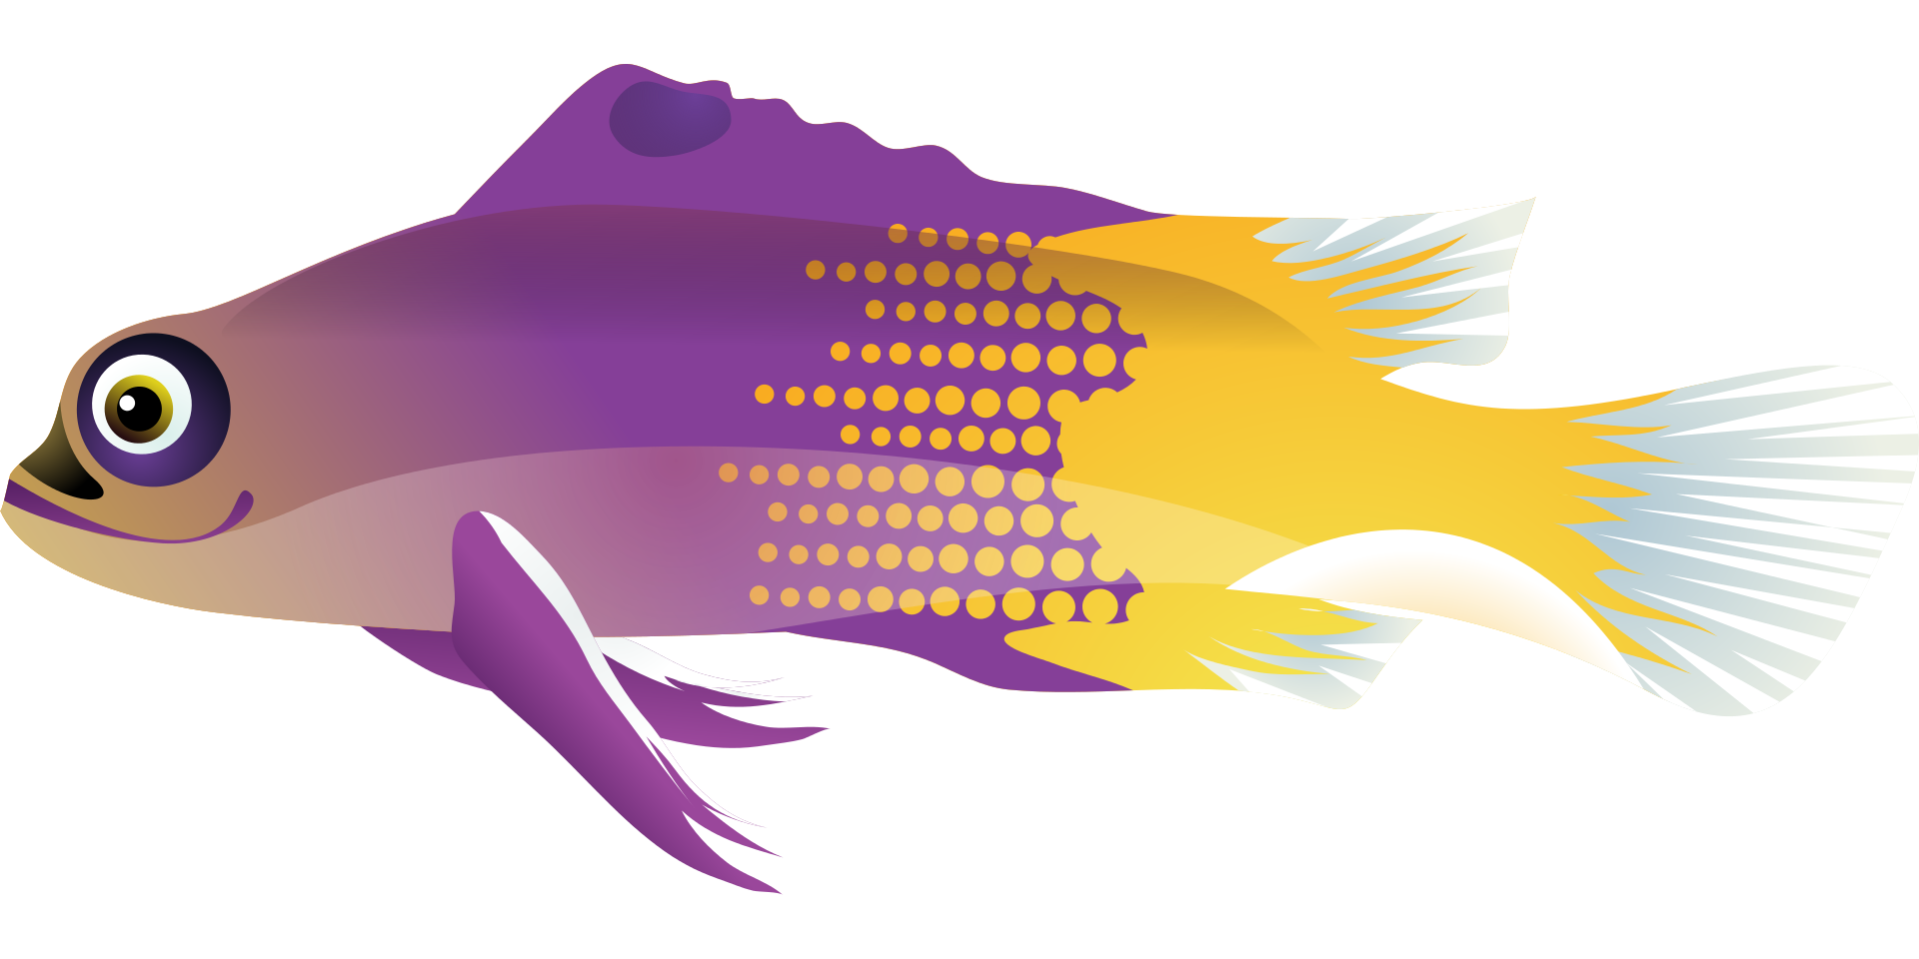

Image Credits:
OpenClipart-Vectors. (2013, October 11). Animal fish ocean tropic 159645. Pixabay. Retrieved April 9, 2017, from https://pixabay.com/en/animal-fish-ocean-tropic-159645/ Used under a CCO Public Domain License. Free for commercial use. No attribution required.
OpenClipart-Vectors. (2017, February). Black cartoon fish sea stripes 2027750. Pixabay. Retrieved April 9, 2017, from https://pixabay.com/en/black-cartoon-fish-sea-stripes-2027750/ Used under a CCO Public Domain License. Free for commercial use. No attribution required.
OpenClipart-Vectors. (2017, February). Cartoon fish sea tropical 2027751. Pixabay. Retrieved April 9, 2017, from https://pixabay.com/en/cartoon-fish-sea-tropical-2027757/ Used under a CCO Public Domain License. Free for commercial use. No attribution required.
OpenClipart-Vectors. (2017, February). Cartoon fish sea tropical yellow 2027751. Pixabay. Retrieved April 9, 2017, from https://pixabay.com/en/cartoon-fish-sea-tropical-yellow-2027751/ Used under a CCO Public Domain License. Free for commercial use. No attribution required.
Samyoung_pyun. (2016). Fish tropical fish sea 1331807. Pixabay. Retrieved April 9, 2017, from https://pixabay.com/en/fish-tropical-fish-sea-1331807/ Used under a CCO Public Domain License. Free for commercial use. No attribution required.
Samyoung_pyun. (2016). Fish tropical fish sea exotic fish 1332194. Pixabay. Retrieved April 9, 2017, from https://pixabay.com/en/fish-tropical-fish-sea-exotic-fish-1332194/ Used under a CCO Public Domain License. Free for commercial use. No attribution required.
Samyoung_pyun. (2016). Tropical fish sea aquarium 1332205. Pixabay. Retrieved April 9, 2017, from https://pixabay.com/en/fish-tropical-fish-sea-aquarium-1332205/ Used under a CCO Public Domain License. Free for commercial use. No attribution required.
Samyoung_pyun. (2016). Tropical fish sea exotic 1331812. Pixabay. Retrieved April 9, 2017, from https://pixabay.com/en/fish-tropical-fish-sea-exotic-fish-1331812/ Used under a CCO Public Domain License. Free for commercial use. No attribution required.

Samyoung_pyun. (2016). Tropical fish sea exotic fish. Pixabay. Retrieved April 9, 2017, from https://pixabay.com/en/fish-tropical-fish-sea-exotic-fish-1332198/ Used under a CCO Public Domain License. Free for commercial use. No attribution required.
Samyoung_pyun. (2016). Tropical fish sea nemo 1331816. Pixabay. Retrieved April 9, 2017, from https://pixabay.com/en/fish-tropical-fish-sea-nemo-1331816/ Used under a CCO Public Domain License. Free for commercial use. No attribution required.
Samyoung_pyun. (2016). Tropical fish sea surgeon 1331813. Pixabay. Retrieved April 9, 2017, from https://pixabay.com/en/fish-tropical-fish-sea-surgeon-1331813/ Used under a CCO Public Domain License. Free for commercial use. No attribution required.

