Hello, Friends!
By Wilma Boyle Bunker
p. 254a

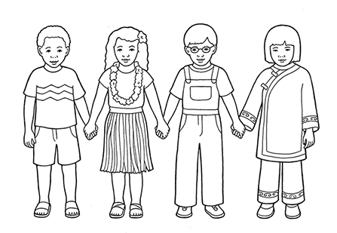

Flipchart compiled by Cherice Montgomery

Hello, friends!
It's nice to be

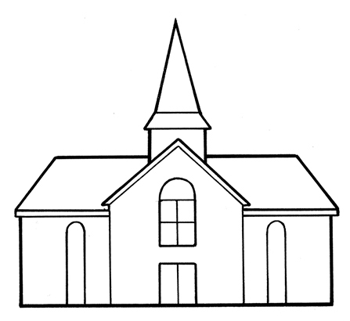
here with you in Primary.

I'll help you, and you'll help me.
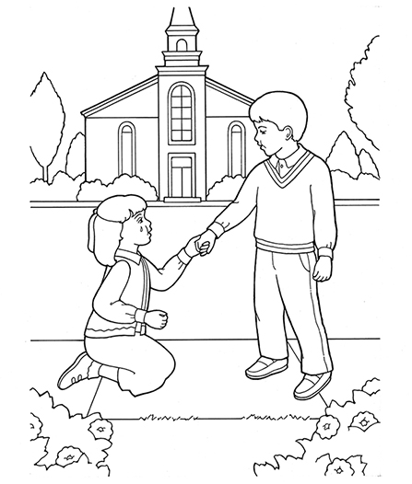

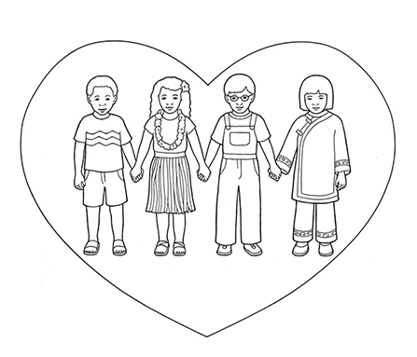
We'll be happy as can be.
Image Credits

Children Various Nationalities Holding Hands:
https://www.lds.org/media-library/images/children-various-nationalities-holding-hands-387252?lang=eng

Meetinghouse Whitaker: https://www.lds.org/media-library/images/meetinghouse-whitaker-368214?lang=eng

Boy Helping Girl: https://www.lds.org/media-library/images/boy-helping-girl-360532?lang=eng

Children Love: https://www.lds.org/media-library/images/children-love-1238924?lang=eng

