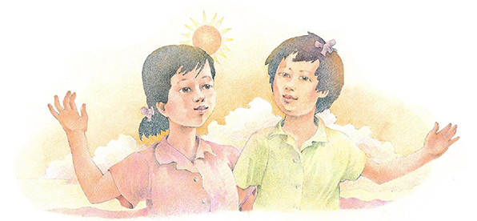
Hello, Friends!
By Wilma Boyle Bunker
p. 254a

Flipchart compiled by Cherice Montgomery
Hello, friends!
It's nice to be

here with you in Primary.

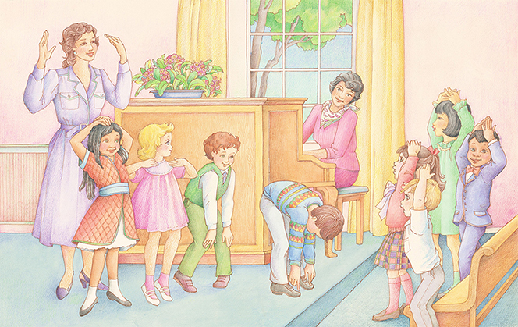

I'll help you, and you'll help me.

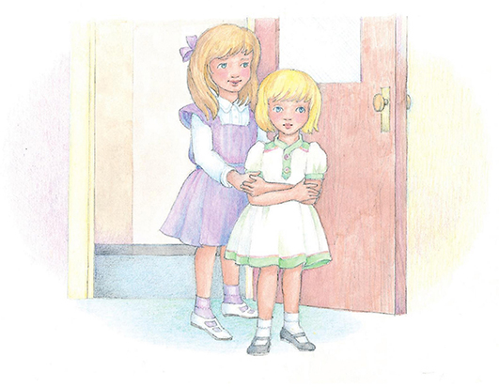

We'll be happy as can be.
Image Credits

Friends in Sunshine: https://www.lds.org/media-library/images/children-songbook-art-153062?lang=eng&_r=1

LDS Primary Children Singing Activity: https://www.lds.org/media-library/images/lds-primary-children-singing-activity-358193?lang=eng

Girls Walking into Primary: https://www.lds.org/media-library/images/children-songbook-art-153026?lang=eng

Clapping & Singing: https://www.lds.org/media-library/images/children-songbook-art-153066?lang=eng

