*I Lived in Heaven*

*The Children’s Songbook, p. 4*

Words & Music by

Janine Jacobs Brady

Picture flipchart for the 2nd verse created by

Cherice Montgomery

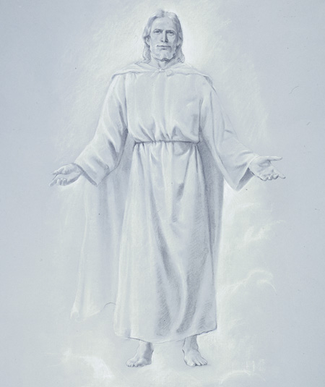



so we all could return there above

There was another who sought for the honor divine



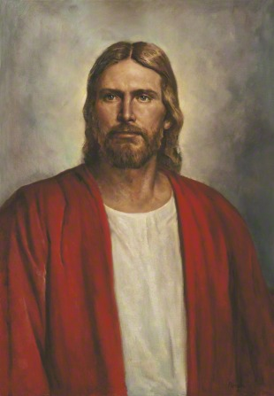

Father, send me and the glory be thine.