What’s Your Favorite Food?
Compiled by Cherice Montgomery

Instructions:

- Look at these pictures of food. [Pizza, Sloppy Joe, Soup, Tacos]

- Find the number of your favorite food.

- Hop the number of your favorite food.

- (Now spin if you chose pizza. Clap if you chose a sloppy joe. Slurp if you chose soup. Rub your tummy if you chose tacos.)
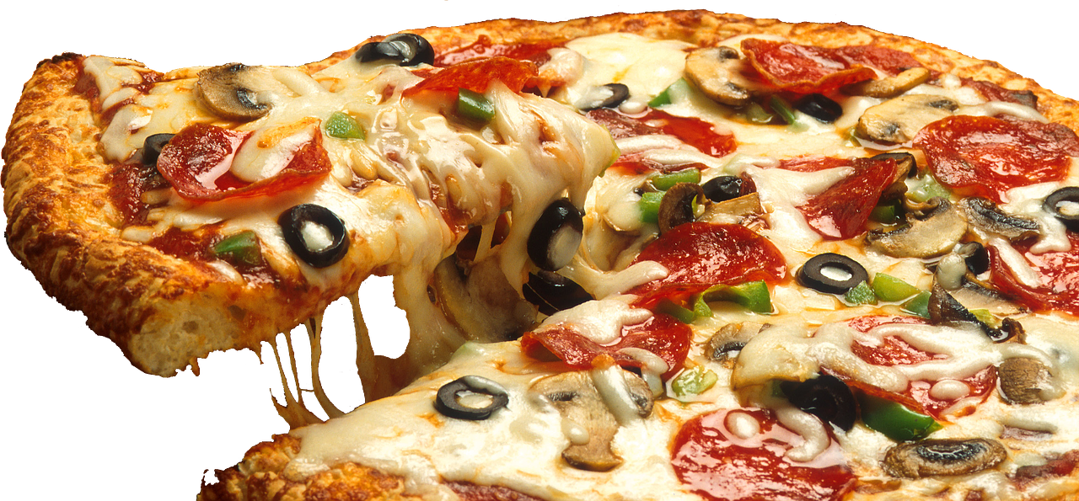
1
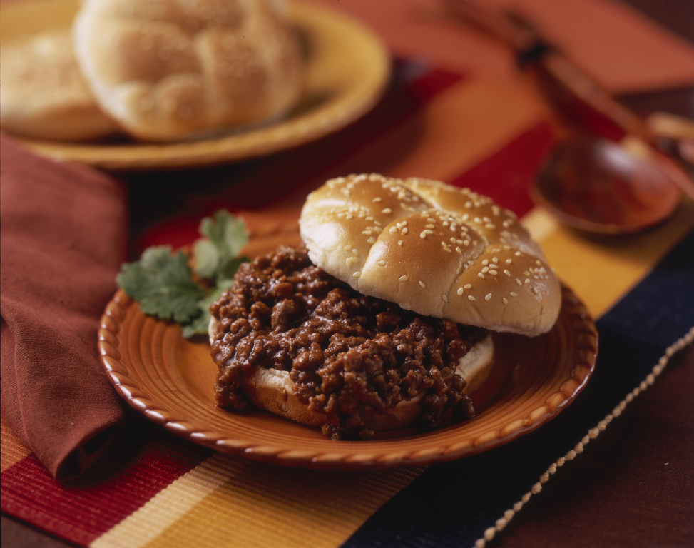
2
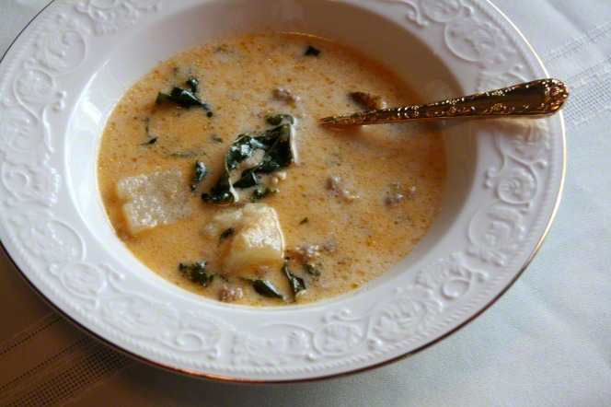
3
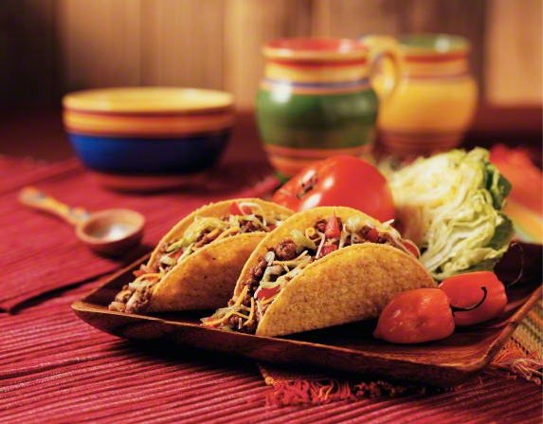
4
Credits

Sloppy Joe: LDS Media Library. (n.d.). Sloppy Joe. Retrieved March 31, 2019, from https://www.lds.org/media-library/images/food-sloopy-joe-plate-276256?lang=eng&_r=1

Soup: LDS Media Library. (n.d.). Soup. Retrieved March 31, 2019, from https://www.lds.org/media-library/images/soup-927753?lang=eng&_r=1

Supreme Pizza: Skeeze. (2015, Feb. 2). Supreme pizza sliced cheese italian 619133. Retrieved March 31, 2019, from https://pixabay.com/photos/supreme-pizza-sliced-cheese-italian-619133/ Used under a Pixabay License. Free for commercial use. No attribution required.

Tacos: LDS Media Library. (n.d.). Tacos. Retrieved March 31, 2019, from https://www.lds.org/media-library/images/tacos-tomato-lettuce-peppers-276253?lang=eng&_r=1

