Pictures for Retelling the Feeding of the Five Thousand

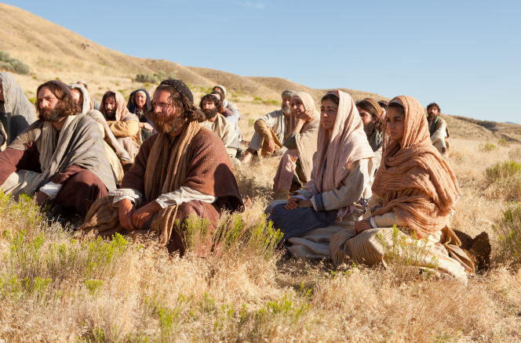
5,000
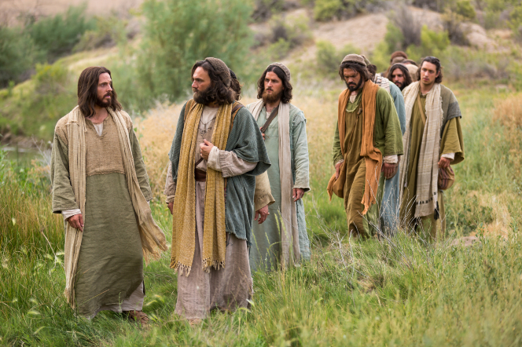
The people are hungry!
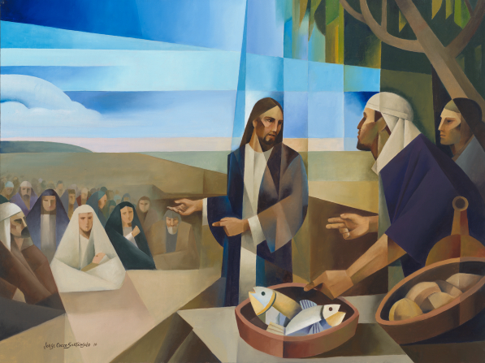
Feed the people!

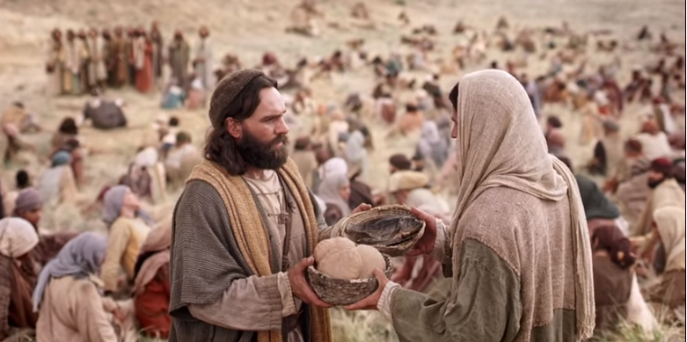

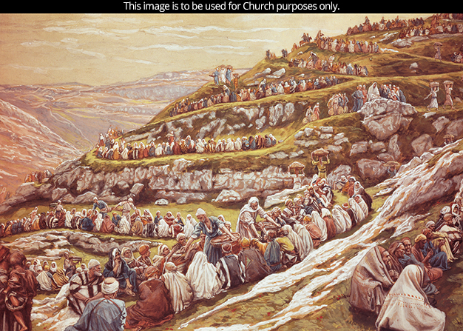
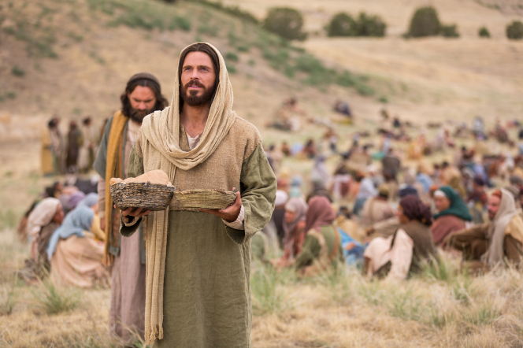
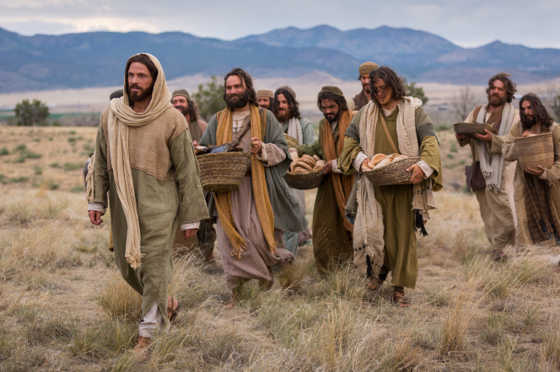
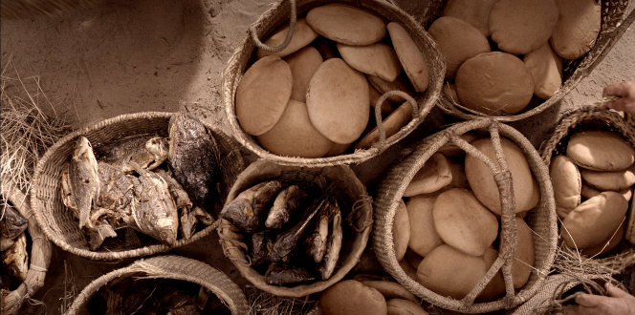

Credits
https://www.lds.org/media-library/images/disciples-serving-loaves-fishes-whitaker-338378?lang=eng
Listeners Learn of the Higher Law
Jesus Walks with His Disciples
Go and Feed Them
The Feeding of the 5,000 (Screenshot)
Feeding the 5,000 (The Miracle of the Loaves and Fishes)
Jesus Feeds the 5,000
Abundance of Bread and Fish
Bread & Fish

