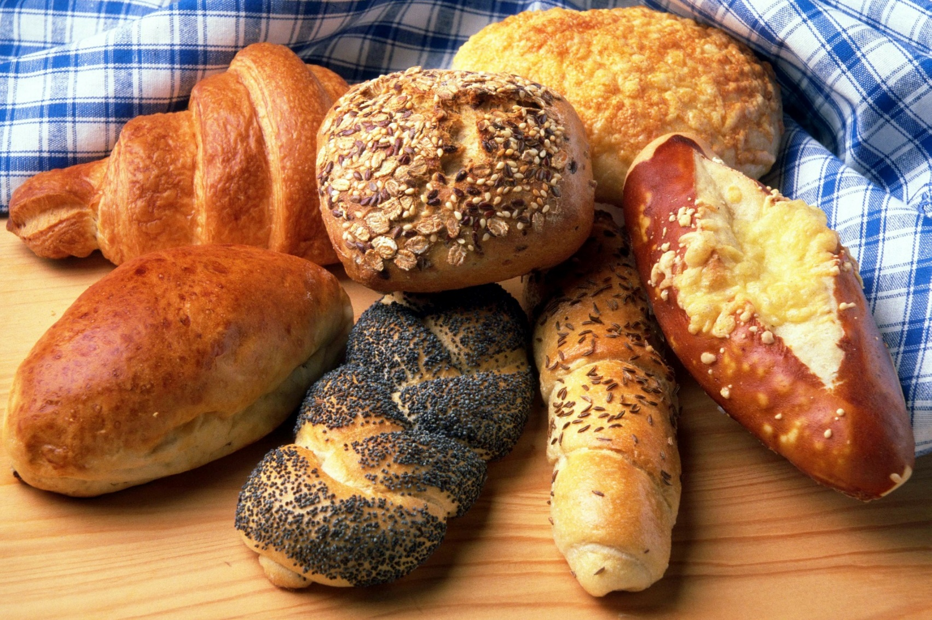

For use with Jesus Feeds the 5,000
Compiled by Cherice Montgomery
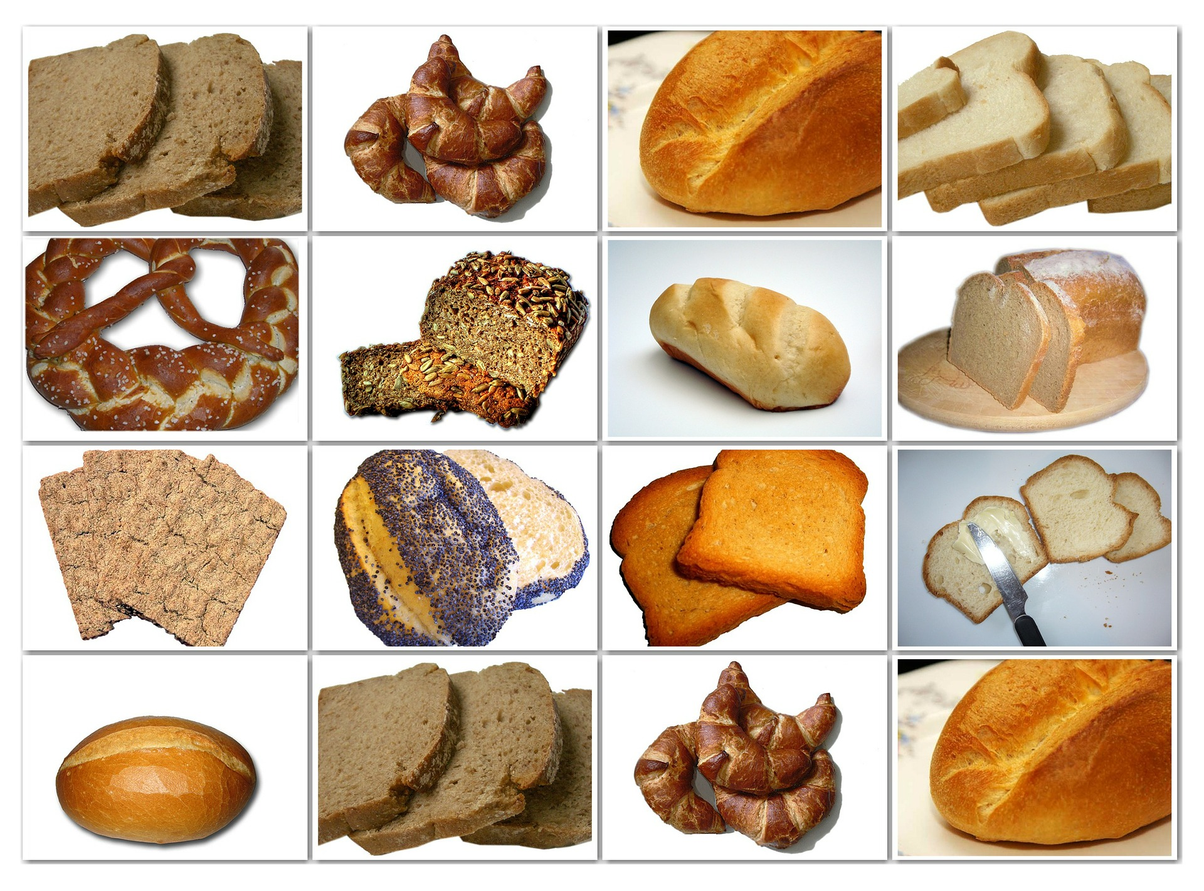
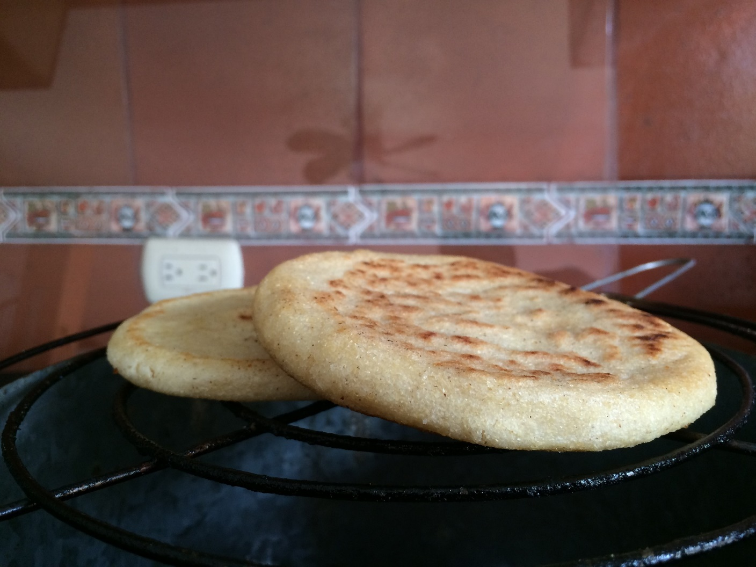
Arepas
(Venezuela)
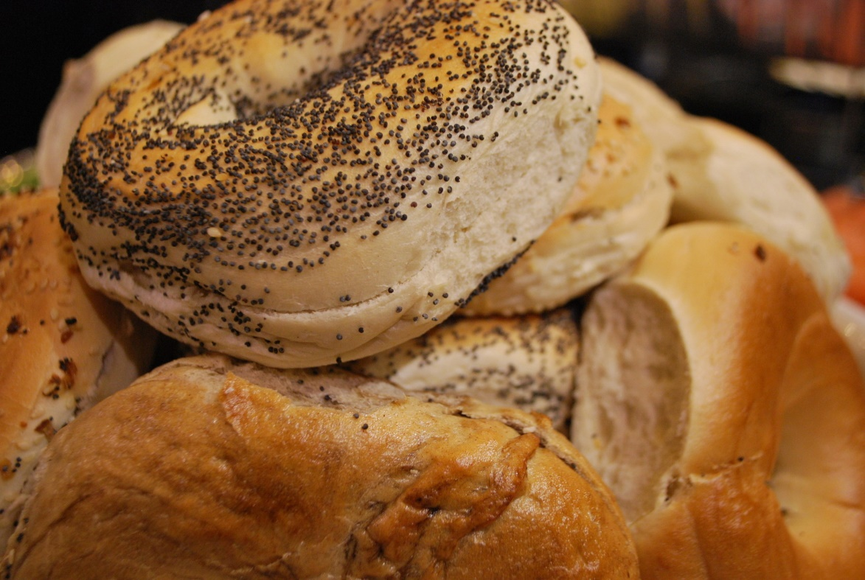
Bagels
(Poland)
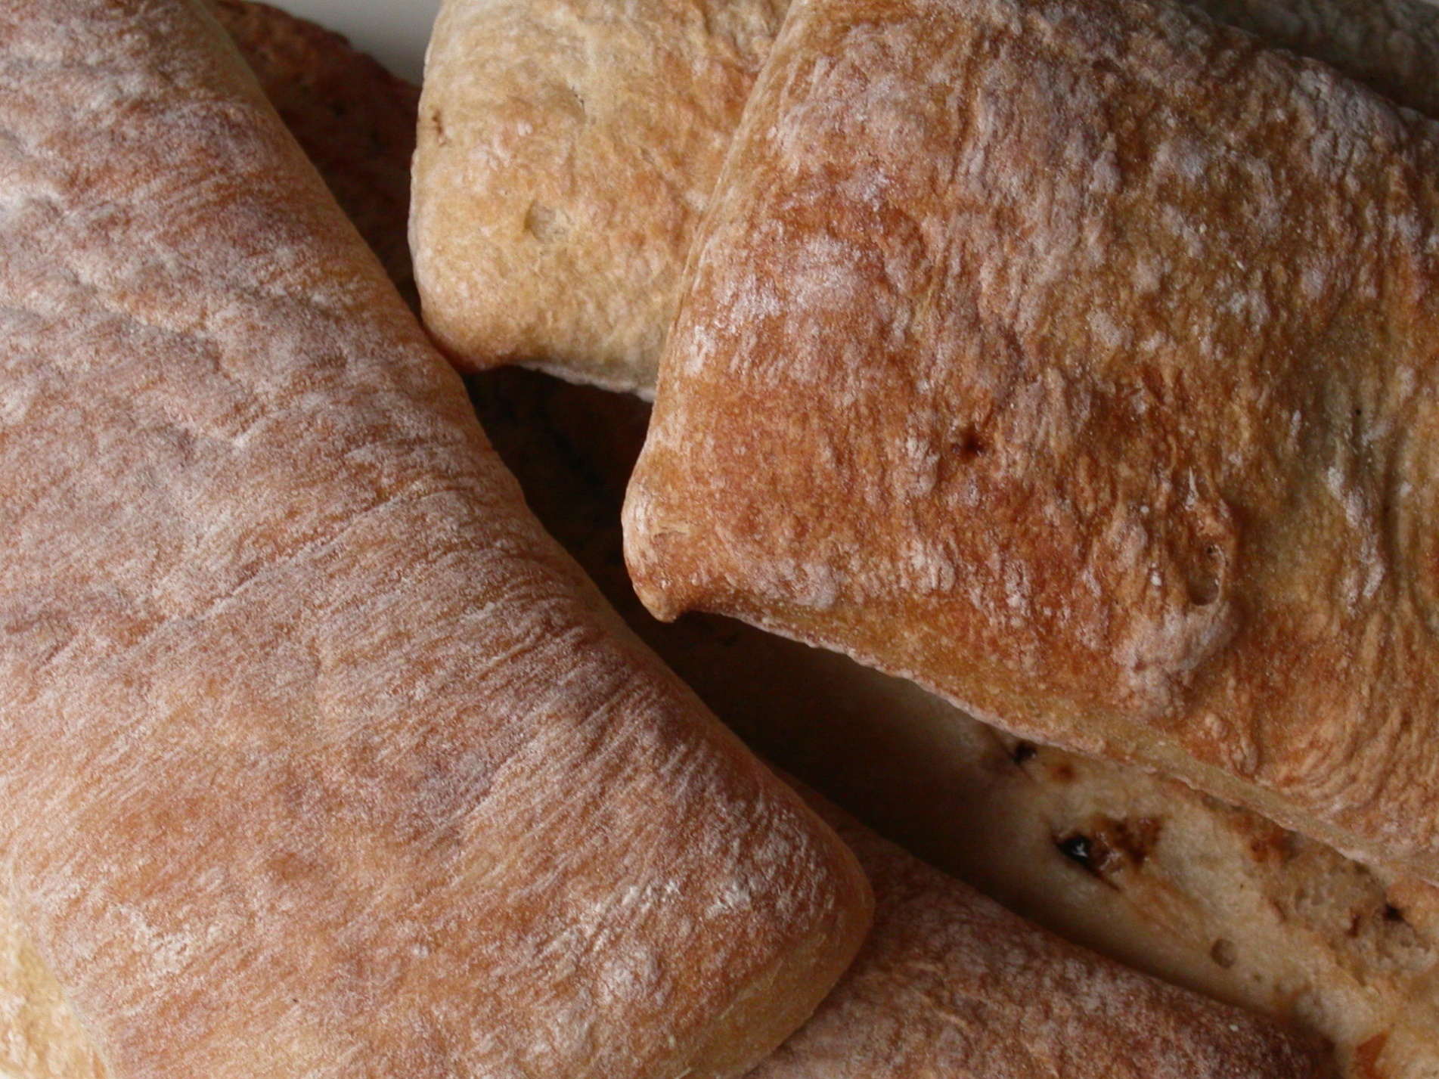
Ciabatta
(Italy)
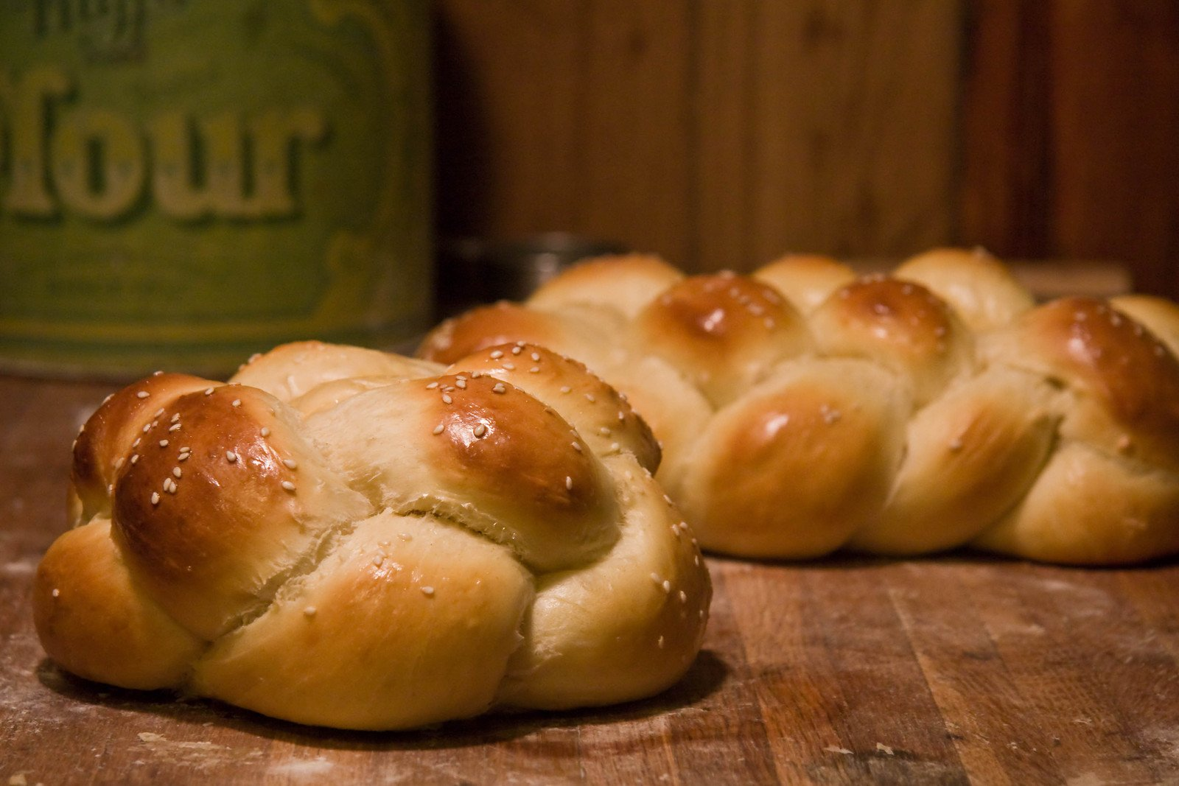
Challah Bread
(Israel)

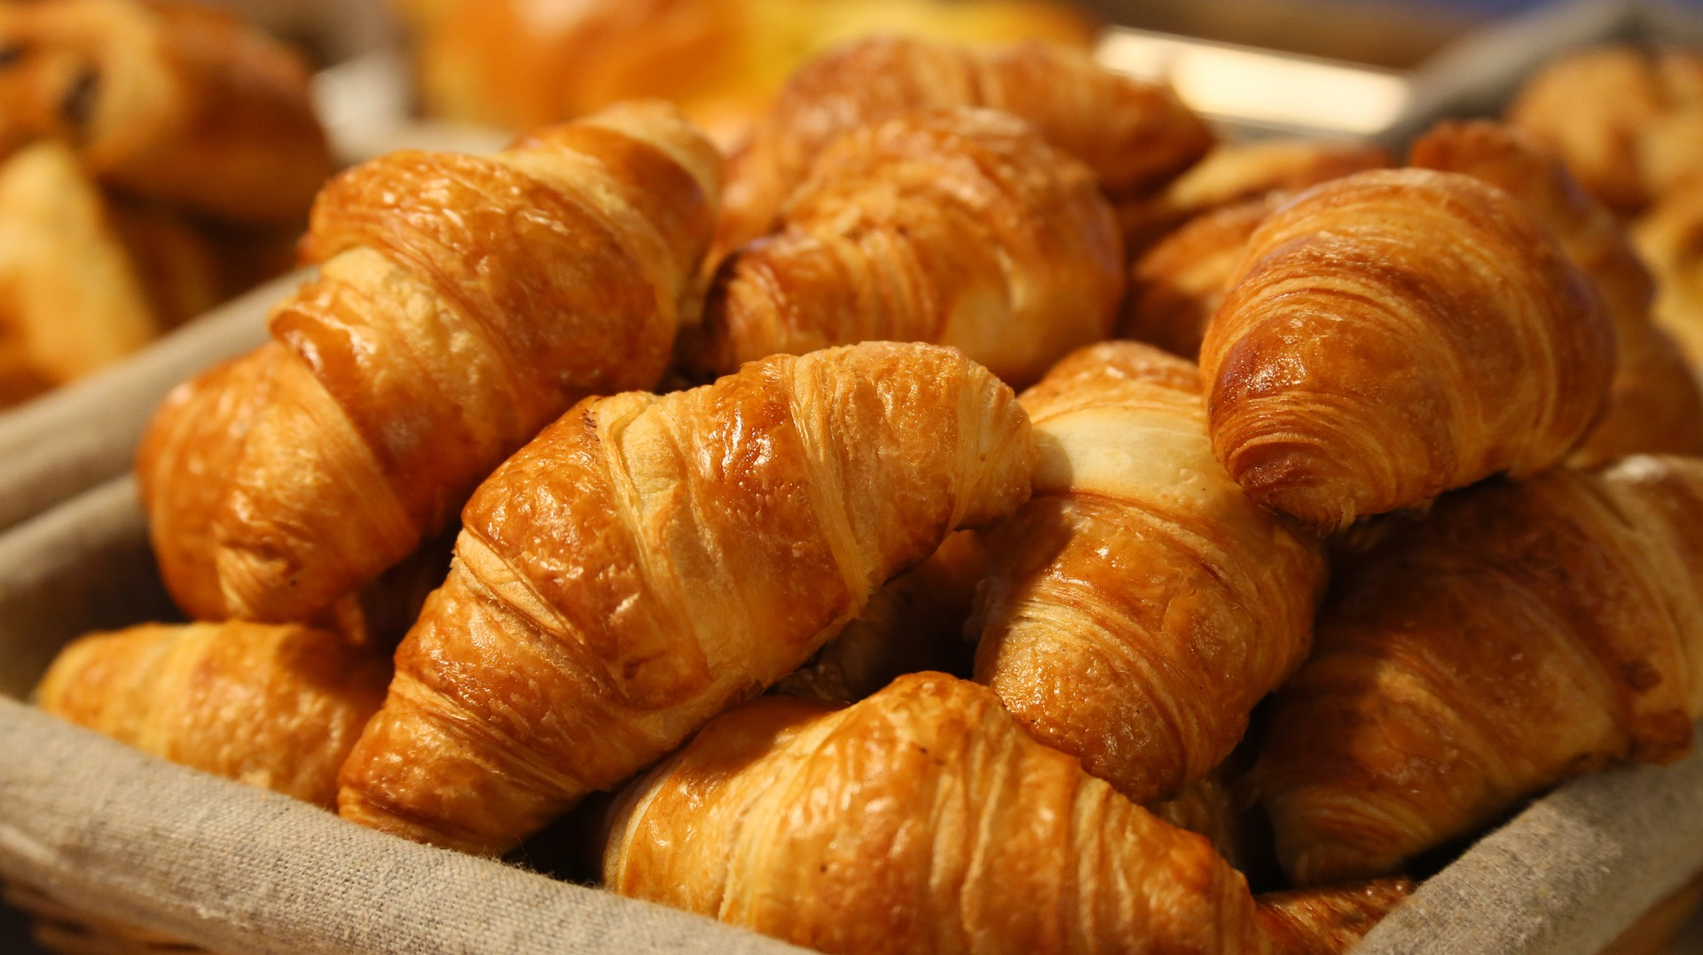
Croissants
(France)
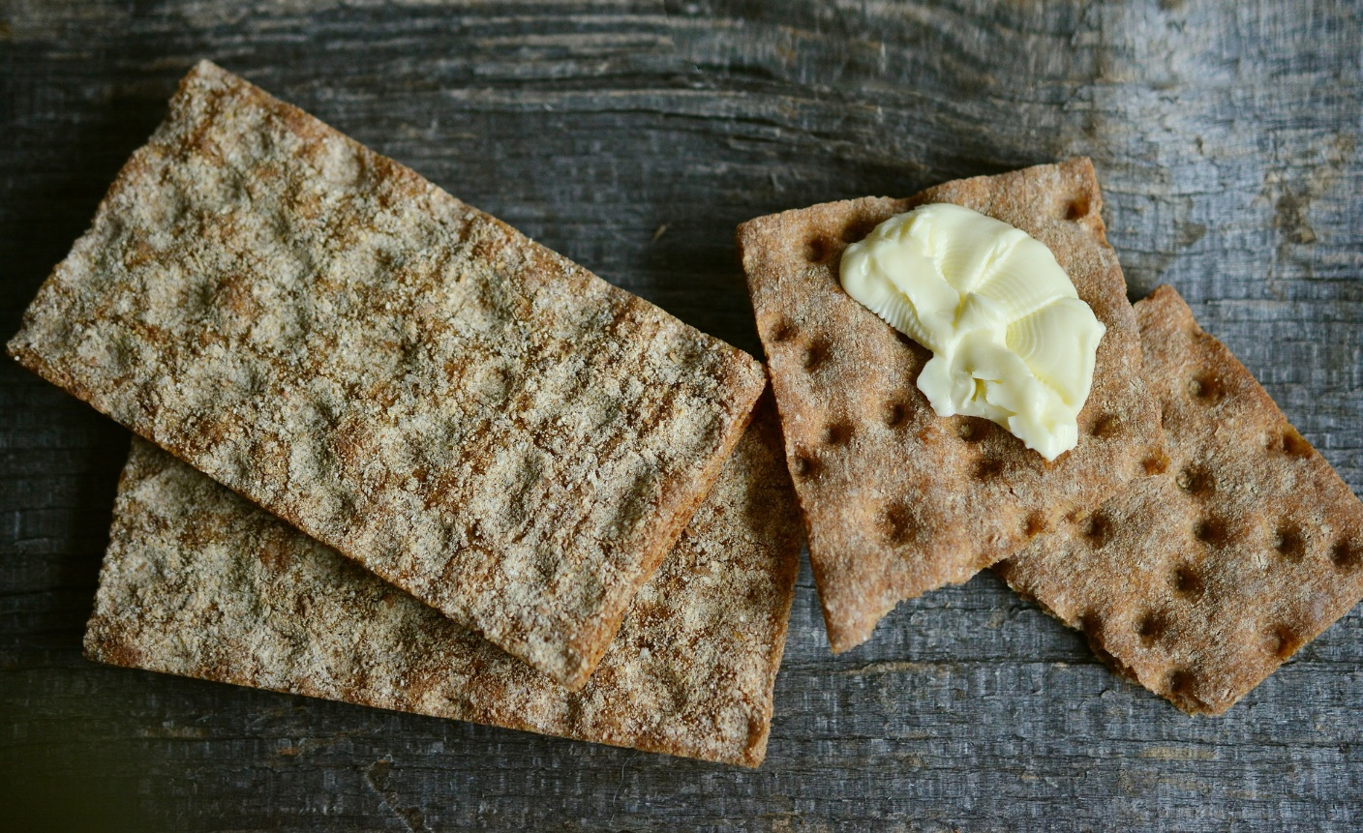
Knäckebröd
(Sweden)
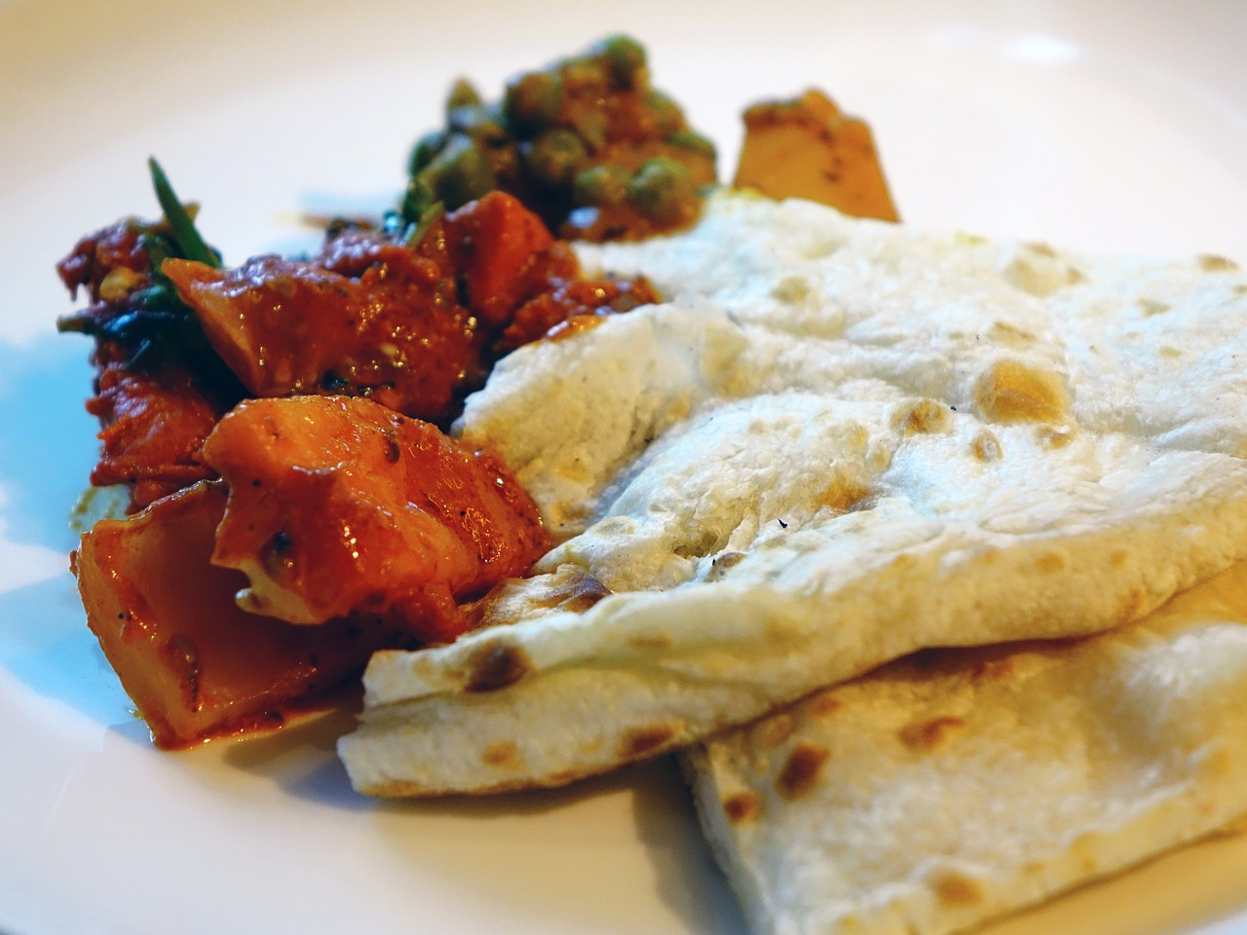
Naan
(India)
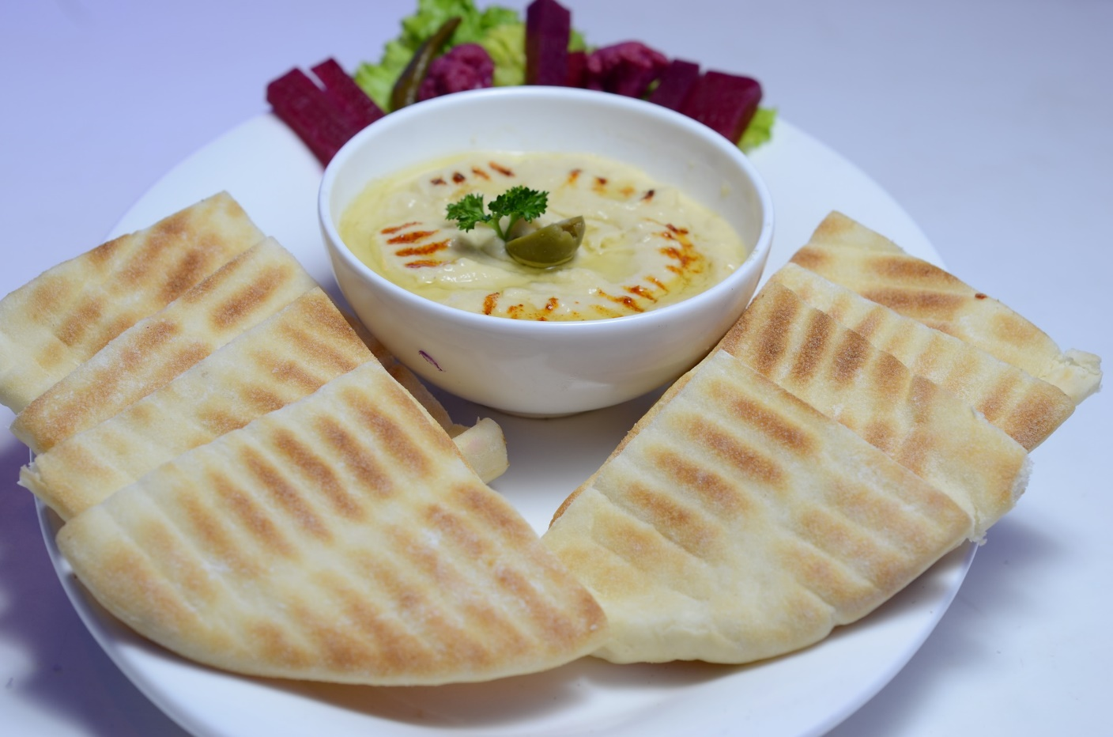
Pita
(Greece)
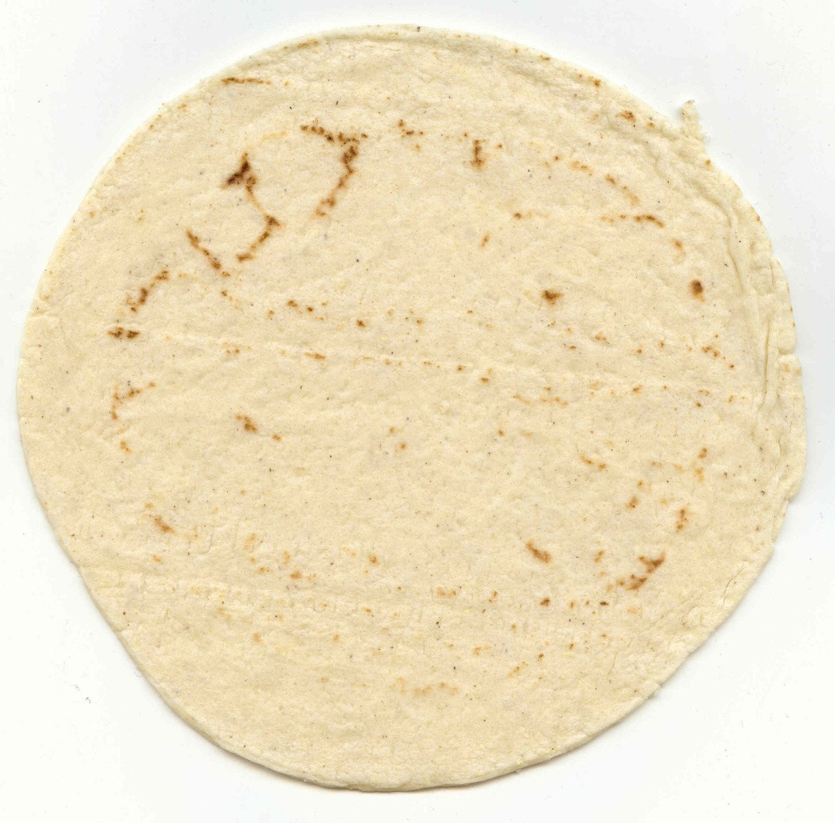
Tortilla
(Mexico)
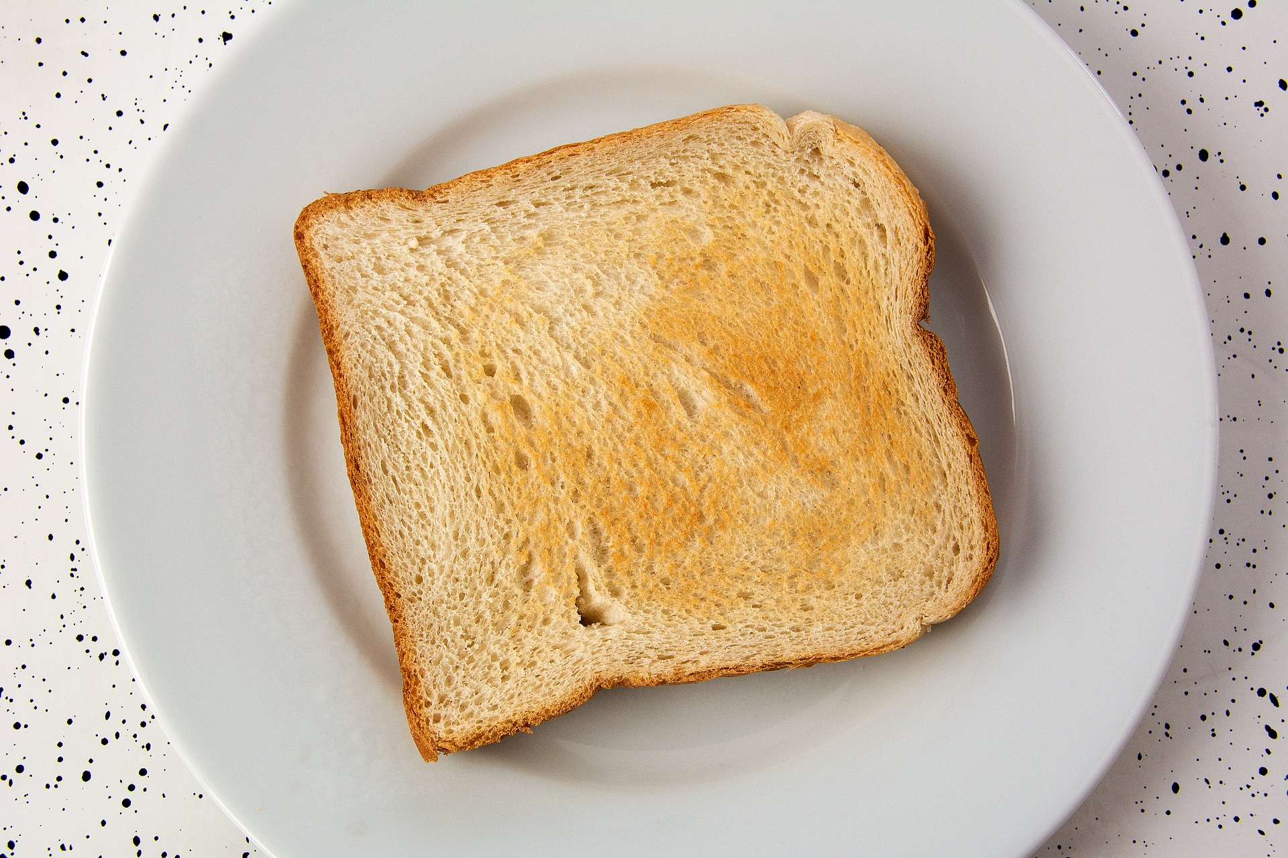
White Bread
(United States)

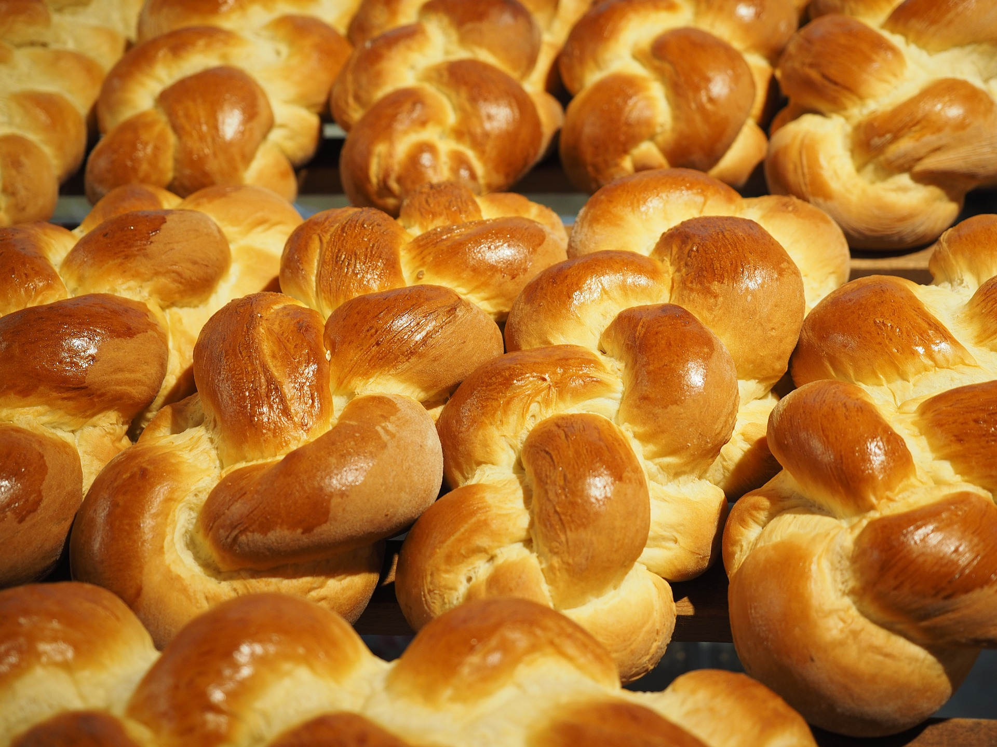
Zopf
(Switzerland)
Credits
Carter, Allison. (2013, May 18). https://www.freeimages.com/photo/bagels-1318288 Used under a Freeimages.com Content License.

Cegoh. (2015, May 11). https://pixabay.com/photos/naan-khamiri-bread-snack-indian-760528/ Used under a Pixabay License. Free for commercial use. No attribution required.

CongerDesign. (2018, Feb. 26). https://pixabay.com/photos/crispbread-bread-crispy-food-crack-3135132/ Used under a Pixabay License. Free for commercial use. No attribution required.

CordMediaStuttgart. (2015, Dec. 15). https://pixabay.com/photos/toast-eat-breakfast-white-bread-1077881/ Used under a Pixabay License. Free for commercial use. No attribution required.

Devkpandey. (2017, May 25). https://pixabay.com/photos/pita-bread-hamas-food-dishes-2337315/ Used under a Pixabay License. Free for commercial use. No attribution required.

Fong, Kristine. (2011, Nov. 11). https://www.freeimages.com/photo/challah-1318414 Used under a Freeimages.com Content License.

Geralt. (2013, Dec. 18). https://pixabay.com/photos/bread-roll-croissant-food-230134/ Used under a Pixabay License. Free for commercial use. No attribution required.

Hans. (2015, Jun. 2). https://pixabay.com/photos/butterzopf-hefekranz-easter-braid-779985/ Used under a Pixabay License. Free for commercial use. No attribution required.

HugoLondono. (2016, May 12). https://pixabay.com/photos/arepa-arepas-breakfast-venezuela-1379236/ Used under a Pixabay License. Free for commercial use. No attribution required.

K., Philipp. (2005, Sept. 11). https://www.freeimages.com/photo/bread-1-1558279 Used under a Freeimages.com Content License.

Noche. https://www.freeimages.com/photo/tortilla-1329303 Used under a Freeimages.com Content License.

Pexels. (2016, Mar. 27). https://pixabay.com/photos/bread-croissant-morning-puff-paste-1284438/ Used under a Pixabay License. Free for commercial use. No attribution required.

Romanov. (2013, Feb. 21). https://pixabay.com/photos/bread-roll-crispy-delicious-83242/ Used under a Pixabay License. Free for commercial use. No attribution required.

StockSnap. (2015, Sept. 5). https://pixabay.com/photos/rice-cakes-snack-food-925903/ Used under a Pixabay License. Free for commercial use. No attribution required.

