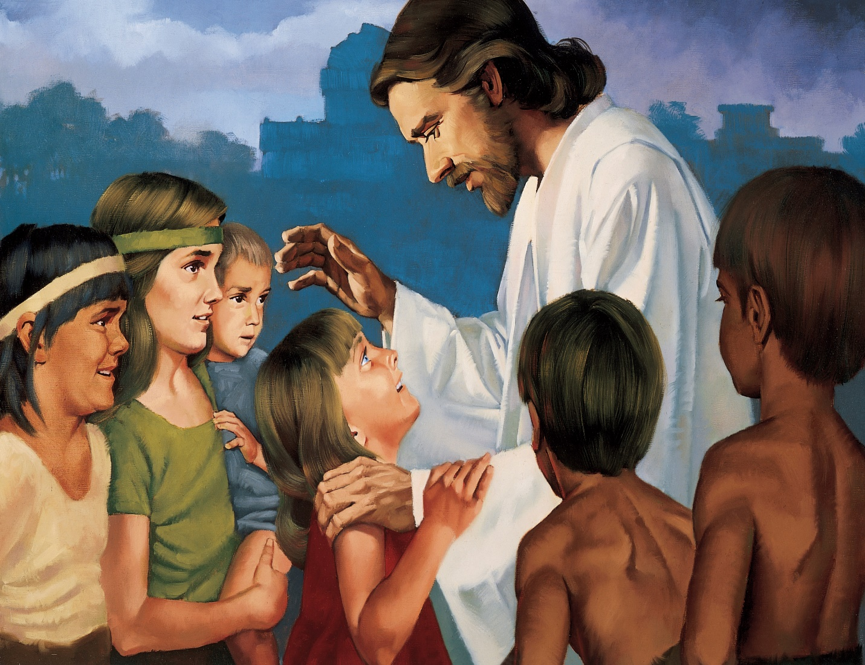
Flipchart for
Jesus Said
Love Everyone, p. 61
Compiled by
Cherice Montgomery
Jesus said,
“Love ev’ryone;”
Treat them
kindly too.
When your heart
is filled with love,
Others will
love you.
Image Credits:

The Church of Jesus Christ of Latter-day Saints. Children’s drawings. The Church of Jesus Christ Media Library. Retrieved Jun. 11, 2023 from https://www.churchofjesuschrist.org/media/image/art-childrens-illustration-faces-c298de1?lang=eng&collectionId=408040e2e846420e8df818f3169c9543

The Church of Jesus Christ of Latter-day Saints. School’s out. The Church of Jesus Christ Media Library. Retrieved Jun. 11, 2023 from https://www.churchofjesuschrist.org/media/image/children-school-5b39554?lang=eng&collectionId=408040e2e846420e8df818f3169c9543

The Church of Jesus Christ of Latter-day Saints. Thanksgiving service project. The Church of Jesus Christ Media Library. Retrieved Jun. 11, 2023 from https://www.churchofjesuschrist.org/media/image/family-finding-christmas-on-doorstep-e867b2f?lang=eng&collectionId=408040e2e846420e8df818f3169c9543

The Church of Jesus Christ of Latter-day Saints. Tree house. The Church of Jesus Christ Media Library. Retrieved Jun. 11, 2023 from https://www.churchofjesuschrist.org/media/image/boys-planning-tree-house-0a752f4?lang=eng&collectionId=408040e2e846420e8df818f3169c9543

The Church of Jesus Christ of Latter-day Saints. Christ blessing the Nephite children. The Church of Jesus Christ Media Library. Retrieved Jun. 11, 2023 from
https://www.churchofjesuschrist.org/media/image/jesus-christ-blessing-children-nephite-ea821a9?lang=eng&collectionId=3cbf78e787498a07417814a31656063f9227b4c6

