Keep the Commandments,
p. 146
Compiled by
Cherice Montgomery
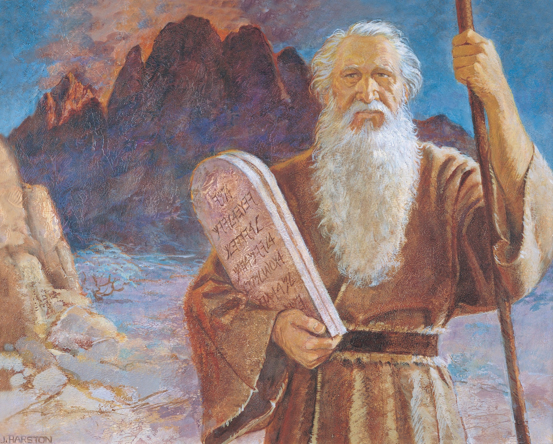
Keep the commandments
Keep the commandments

In this there is safety

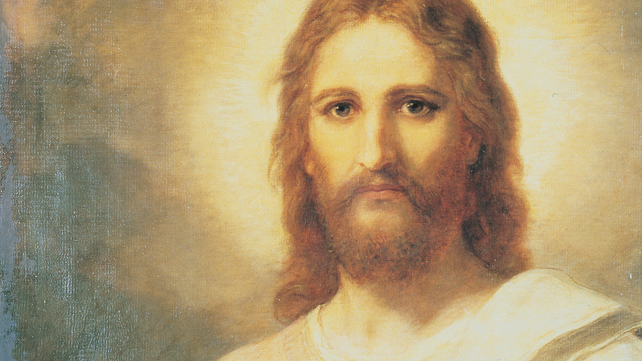
In this there is peace

He will send
blessings

He will send
blessings
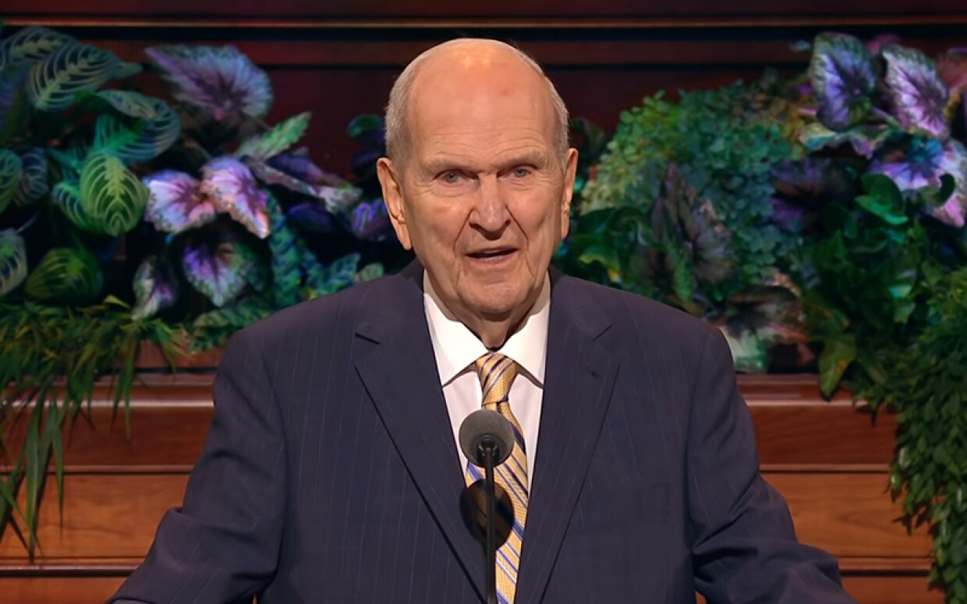
Words of a prophet
Keep the commandments

In this there is safety

and peace.

Image credits:

Altmann, Gerd (Geralt). (2019, Apr. 23). Hands receive light appreciation. Pixabay. Retrieved Jun. 10, 2023 from https://pixabay.com/photos/hands-receive-light-appreciation-4153292/

Harston, Jerry. Moses and the tablets. The Church of Jesus Christ Media Library. Retrieved Jun. 11, 2023 from https://www.churchofjesuschrist.org/media/image/moses-ten-commandments-1717b4a?lang=eng

Jeanneret, Raphael. (2023, May 4). Police officer. Pixabay. Retrieved Jun. 11, 2023 from https://pixabay.com/illustrations/police-officer-authority-justice-7968581/

The prince of peace: Find lasting peace through Jesus Christ. The Church of Jesus Christ Media Library. Retrieved Jun. 11, 2023 from https://www.churchofjesuschrist.org/media/video/2017-02-1000-the-prince-of-peace-find-lasting-peace-through-jesus-christ?lang=eng

Hunt, Kevin V. (2022, Aug. 20). President Nelson speaking. Quotes from conference: 17 new temples, wow! Family Search Blog. Retrieved Jun. 11, 2023 from https://www.familysearch.org/en/blog/general-conference-2022/quote-7 Direct link: https://cms-b-assets.familysearch.org/dims4/default/ed02af4/2147483647/strip/true/crop/800x500+0+0/resize/1240x775!/format/webp/quality/90/?url=https%3A%2F%2Ffamilysearch-brightspot.s3.amazonaws.com%2F74%2Fca%2Fba72e97b45aaa729c5535f225ca3%2Fpresident-nelson.jpg

