Heart Jump Activity

Hearts for
Kindness Begins with Me, p. 145
Heart Jump Activity
Compiled by Cherice Montgomery

kind

everyone

everyone

right
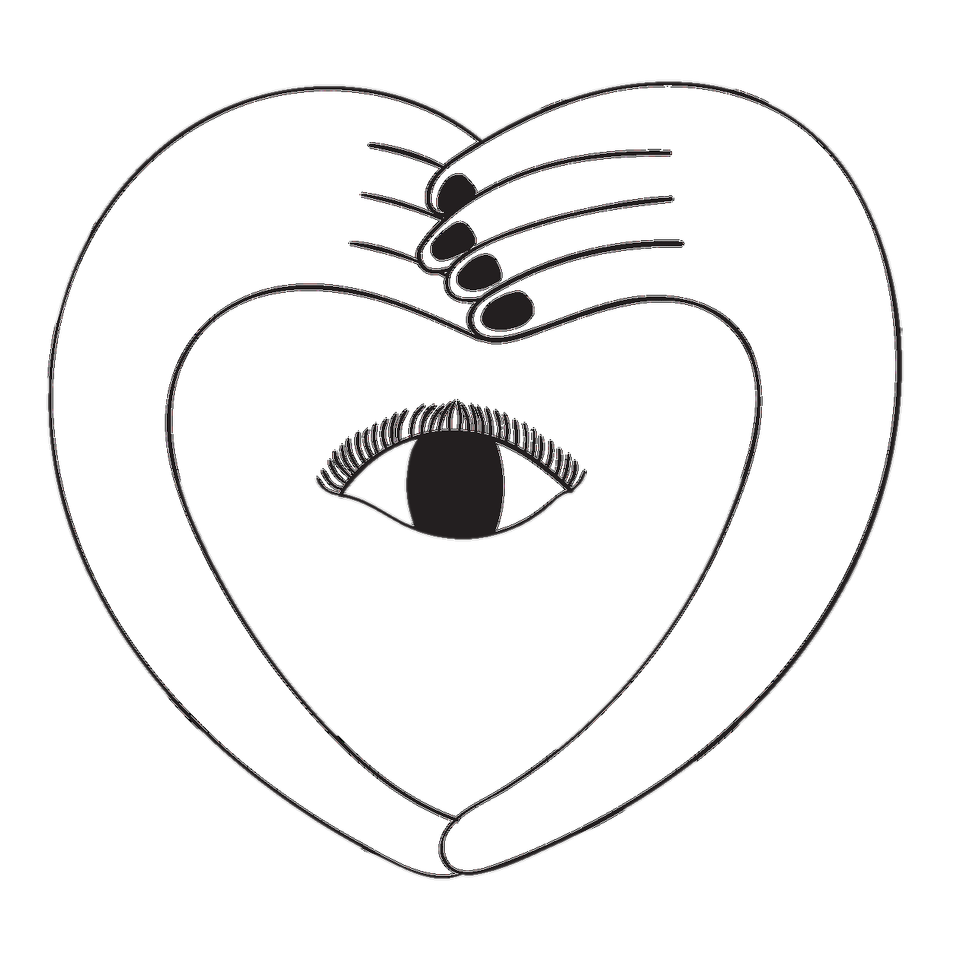

see
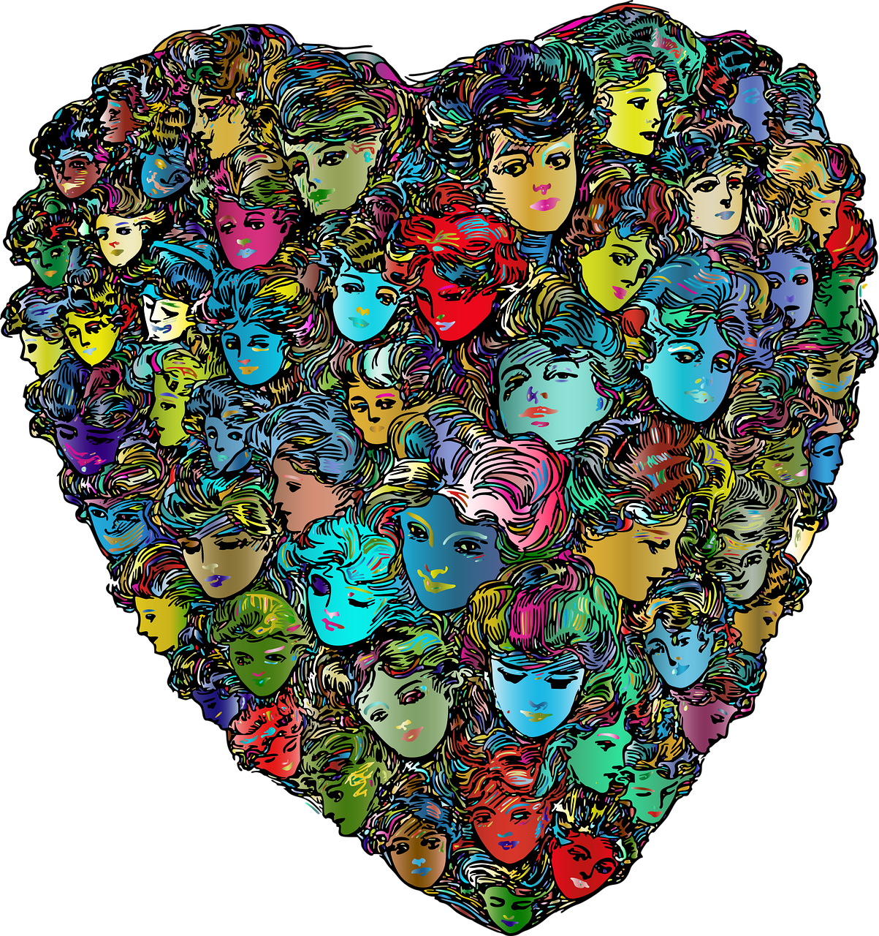

say

remember
kindness begins

me
Instructions for “Kindness Heart Jump” Activity
(Summarized from LDS Primary Printables):
Lay eight hearts in two separate lines of four, 2 feet apart (or in a circle or heart shape).
Invite four children to come to the front.
- Primary: Sing the song.
- Primary: Clap the beat while you sing.
- Helper Children: Jump to a new heart on each beat.
- If you end on a black heart, tell something mean kids often do, then sit down.
- If you end on a gold heart, read the scripture on the back and/or tell something kind you could do.

I want to be kind to everyone,
Jump jump

for that is right you see! (Sit on last beat.)
jump jump
So I say to myself remember this...
Jump jump
Kindness begins with me! (Sit on last beat.)
jump jump
Gold Heart Scripture: “34 A new commandment I give unto you, That ye ªlove one another; as I have loved you, that ye also ^{b}love one another. 35 By this shall all men know that ye are my disciples, if ye have ªlove one to another” (John 13:34-35).

Black Heart Scripture: "But I say unto you, Love your enemies, bless them that curse you, do good to them that hate you, and pray for them which despitefully use you, and persecute you." (Matthew 5:44).

Image Credits:

Clker-Free-Vector-Images. (2014, Jun. 4). Pixabay. Retrieved Jun. 13, 2023 from https://pixabay.com/vectors/red-heart-health-love-shape-304570/ Used under a Pixabay License. Free for commercial use. No attribution required.
GDJ. (2020, Apr. 17). Pixabay. Retrieved Jun. 13, 2023 from https://pixabay.com/vectors/kids-children-heart-boys-girls-5056458/ Used under a Pixabay License. Free for commercial use. No attribution required.
GDJ. (2018, Mar. 19). Pixabay. Retrieved Jun. 13, 2023 from https://pixabay.com/vectors/cranium-head-abstract-art-thought-3244100/ Used under a Pixabay License. Free for commercial use. No attribution required.
GDJ. (2017, Feb. 15). Pixabay. Retrieved Jun. 13, 2023 from https://pixabay.com/vectors/ekg-electrocardiogram-heart-art-2069872/ Used under a Pixabay License. Free for commercial use. No attribution required.
GDJ. (2018, Mar. 5). Pixabay. Retrieved Jun. 13, 2023 from https://pixabay.com/vectors/heart-flags-countries-united-unity-3204671/ Used under a Pixabay License. Free for commercial use. No attribution required.
GDJ. (2022, Oct. 12). Pixabay. Retrieved Jun. 13, 2023 from https://pixabay.com/vectors/women-heart-love-girls-romantic-7517986/ Used under a Pixabay License. Free for commercial use. No attribution required.
RosZie. (2022, Jul. 19). Pixabay. Retrieved Jun. 13, 2023 from https://pixabay.com/illustrations/self-love-self-confidence-psychology-7331547/ Used under a Pixabay License. Free for commercial use. No attribution required.
RosZie. (2022, May 18). Pixabay. Retrieved Jun. 13, 2023 from https://pixabay.com/illustrations/self-love-self-confidence-psychology-7206573/ Used under a Pixabay License. Free for commercial use. No attribution required.
RosZie. (2022, Sept. 15). Woman hugging self in front of a fingerprint. Pixabay. Retrieved Jun. 13, 2023 from https://pixabay.com/illustrations/woman-heart-self-love-7454662/ Used under a Pixabay License. Free for commercial use. No attribution required.
Saydung89. (2020, Oct. 29). Pixabay. Retrieved Jun. 13, 2023 from https://pixabay.com/illustrations/hands-heart-eye-tear-cartoon-love-5695072/ Used under a Pixabay License. Free for commercial use. No attribution required.
The Church of Jesus Christ Media Library. CTR logo. The Church of Jesus Christ Media Library. Retrieved Jun. 13, 2023, from https://www.churchofjesuschrist.org/media/image/ctr-logo-62da351?lang=eng

