Listen to the
Still Small Voice,
p. 107

Compiled by
Cherice Montgomery
Listen!

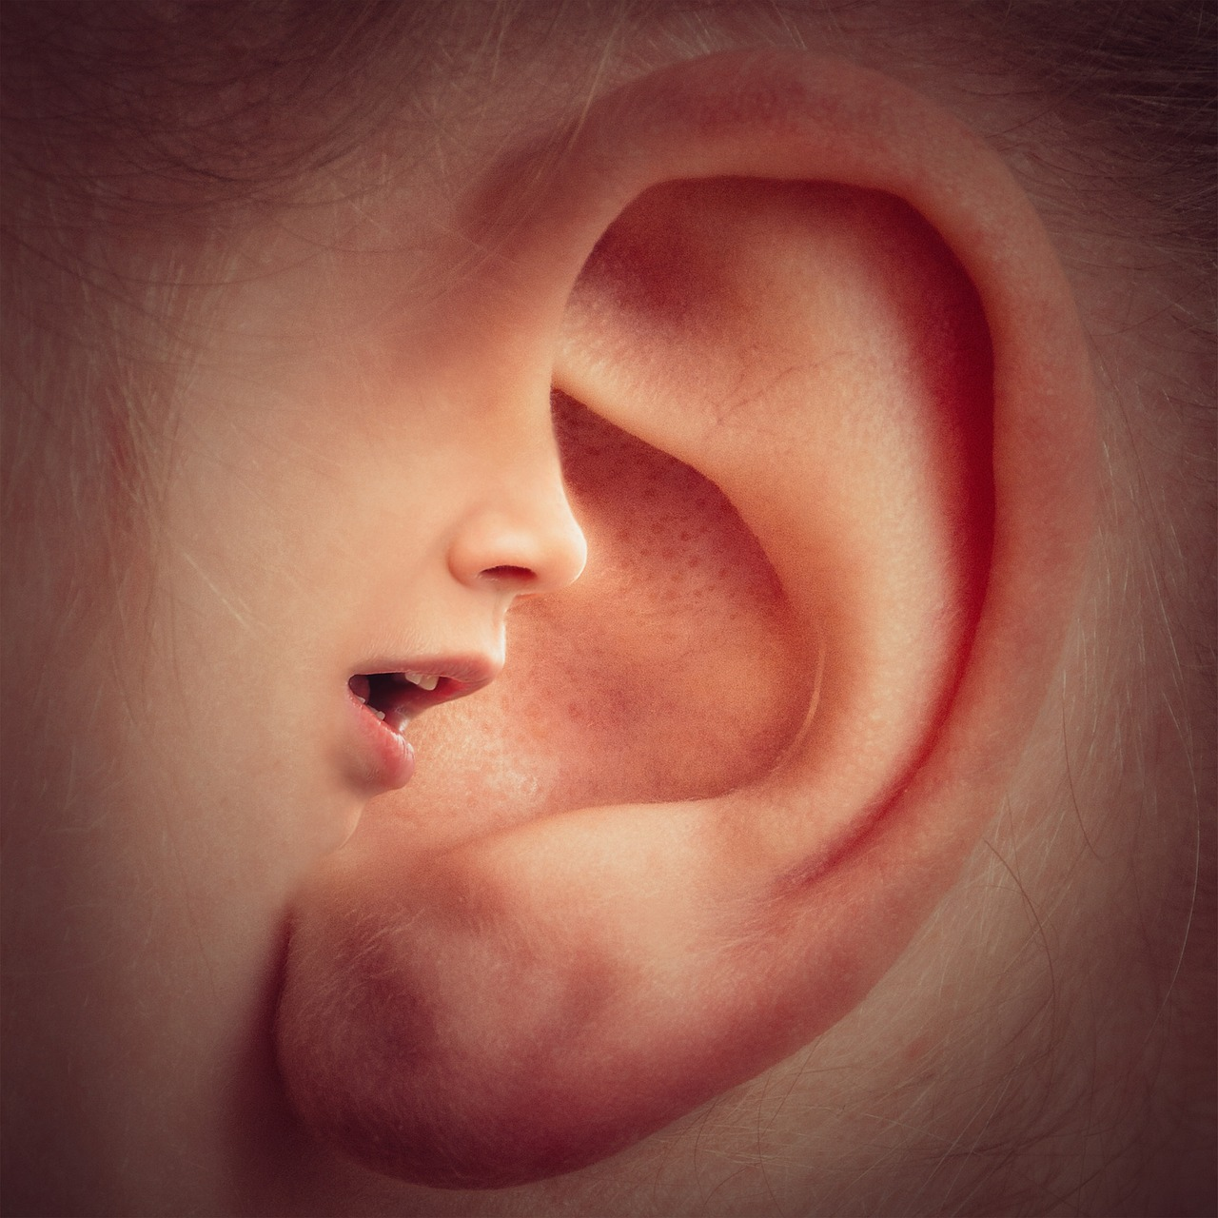
to the
still small voice.
Listen!
Listen!
When you have to make a choice
He will
guide you
always.
Image credits:
Kvrkchowdari. (2016, Jul. 24). Choose the right direction. Pixabay. Retrieved Jun. 10, 2023 from https://pixabay.com/photos/choose-the-right-direction-1536336/ Used under a Pixabay License. Free for commercial use. No attribution required.
The Church of Jesus Christ. (2003, Jun.). Boy cupping ear. Come follow me activities for little ones. Friend. Retrieved Jun. 10, 2023 from https://www.churchofjesuschrist.org/study/friend/2023/06/34-come-follow-me-activities-for-little-ones?lang=eng Direct image link: https://assets.churchof jesuschrist.org/e778858ce2a75be330c497a6b08e13f49eb758b8.jpeg
Truthseeker08. (2016, Dec. 20). Hand finger pointing. Pixabay. Retrieved Jun. 10, 2023 from https://pixabay.com/photos/hand-finger-pointing-pointing-1923005/ Used under a Pixabay License. Free for commercial use. No attribution required.
Wolter, Thomas. (2019, Feb. 1). Ear mouth nose face head voices. Pixabay. Retrieved Jun. 10, 2023 from https://pixabay.com/photos/ear-mouth-nose-face-head-voices-3971050/ Used under a Pixabay License. Free for commercial use. No attribution required.

