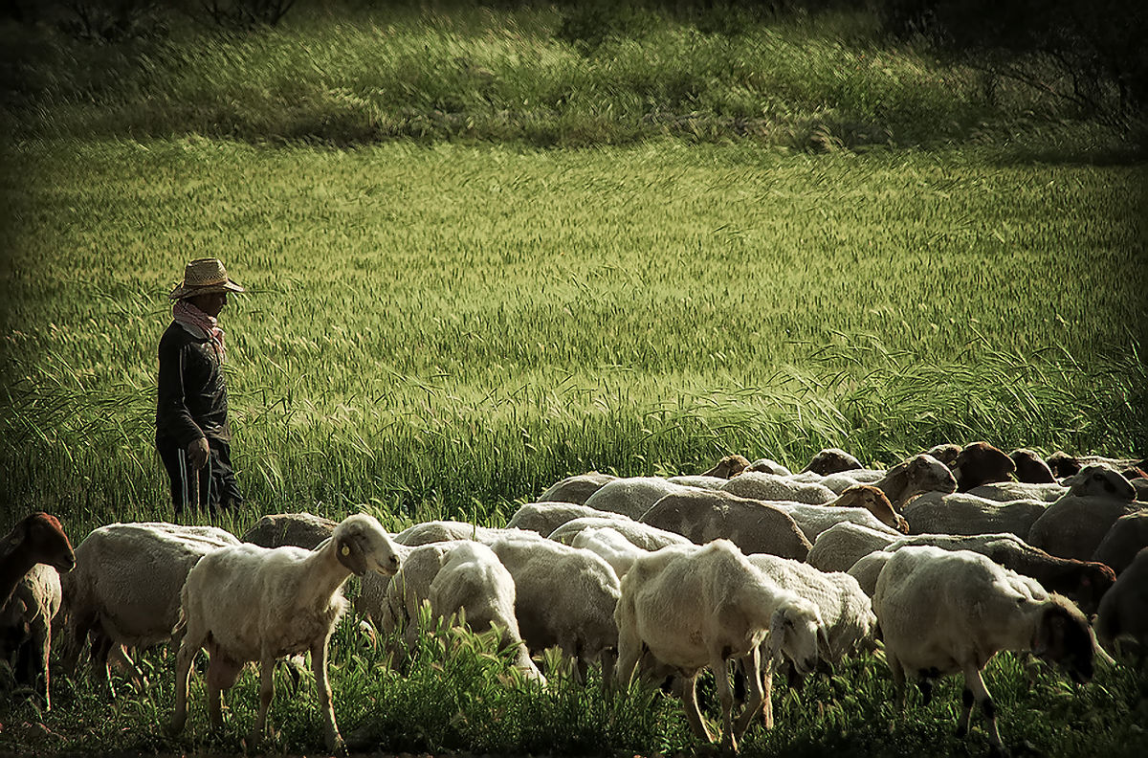
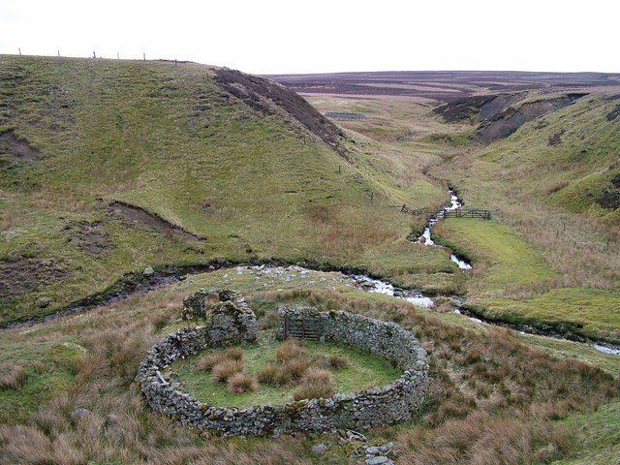
Image: David Brown
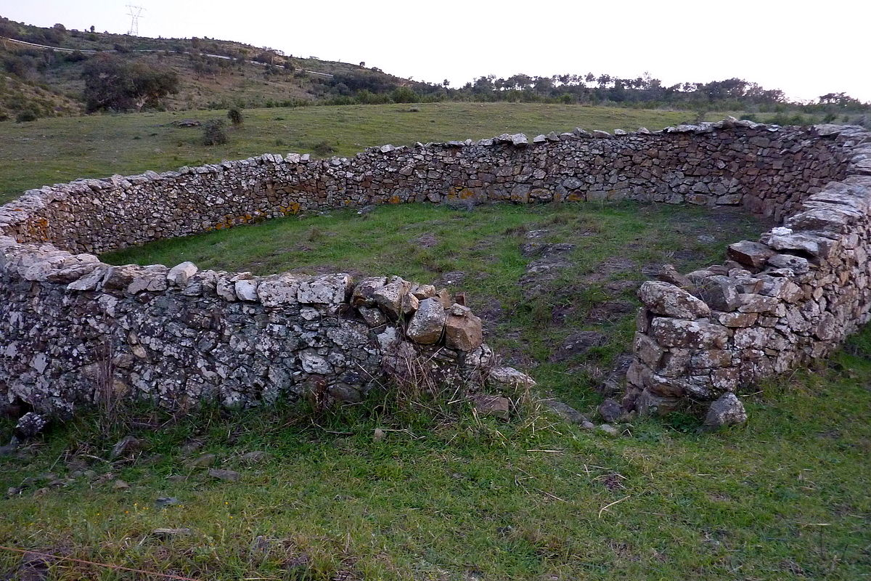
Image: Amiexial
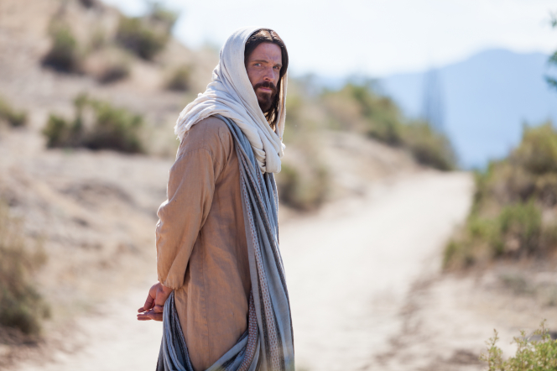
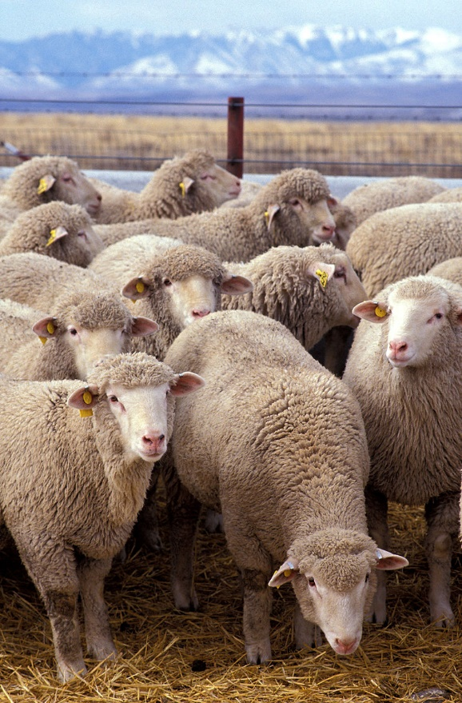
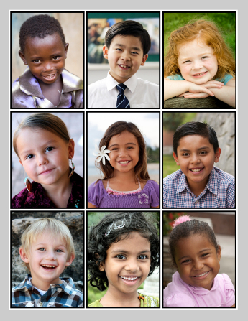
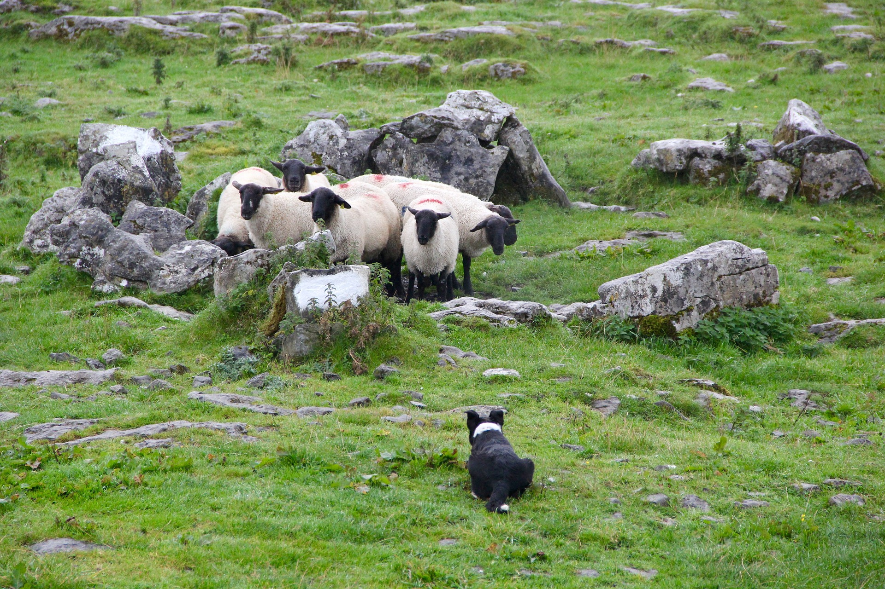
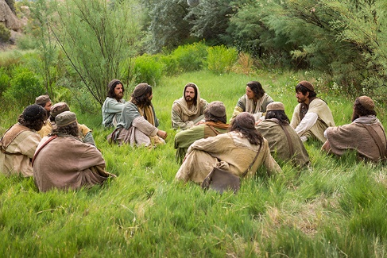
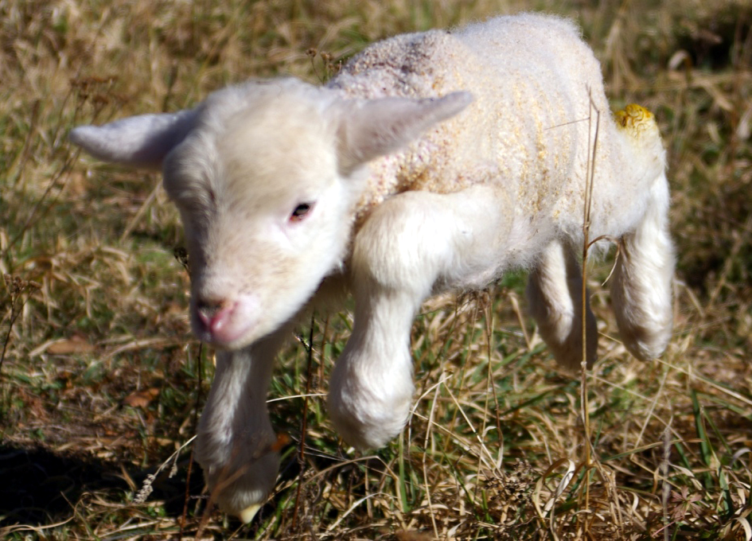
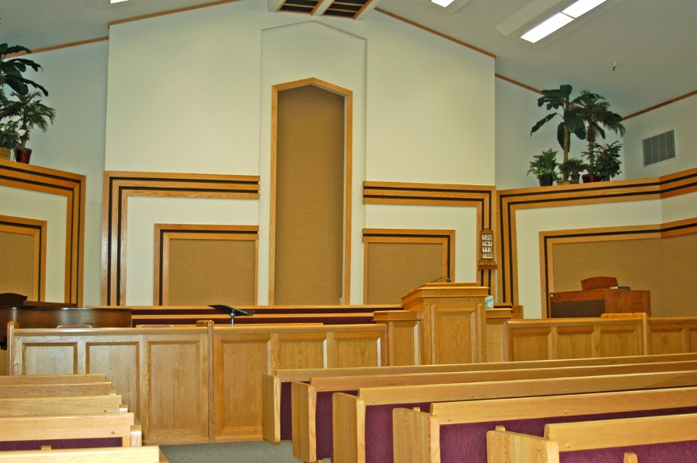
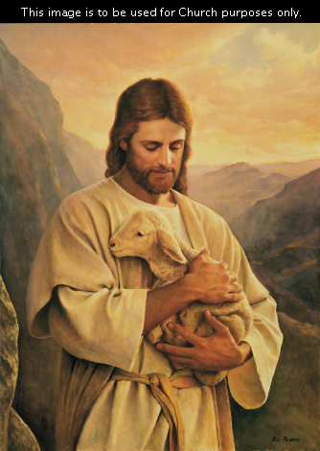
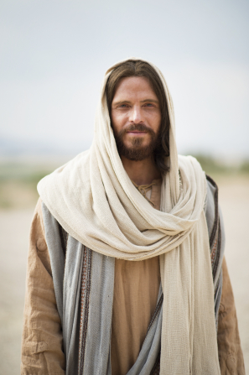
CREDITS
Army Amber. (2012, Oct. 22). Pixabay. https://pixabay.com/photos/shepherd-man-sheep-flock-winter-60657/ Used under a
Pixabay License. Free for commercial use. No attribution required.
Amiexial. (2014, Mar. 14). Wikimedia Commons. https://commons.wikimedia.org/wiki/File:Ameixial_-_sheep_fold_(13532252844).jpg Used under a Creative Commons Attribution License.
Brown, David. (2007, Apr. 10). Wikimedia Commons. https://commons.wikimedia.org/wiki/File:Sheepfolds_-_geograph.org.uk_-_397095.jpg Used under a Creative Commons Attribution, Share Alike License.
Ddxc. (2007, Dec. 4). Wikipedia. https://en.wikipedia.org/wiki/File:Flock_of_sheep.jpg
Marliese. (2013, Oct. 5). Pixabay. https://pixabay.com/photos/goat-animals-flock-of-sheep-nature-189734/ Used under a
Pixabay License. Free for commercial use. No attribution required.
Mary Bettini Blank. (2015, Oct. 13). Pixabay. https://pixabay.com/photos/sheepdog-lambs-sheep-livestock-981878/ Used
under a Pixabay License. Free for commercial use. No attribution required.
Shanks, Peter. (2007, Jul. 15). Lamb, first steps. Wikipedia. https://en.wikipedia.org/wiki/File:Lamb_first_steps_(edited).jpg
Taybe, Lehava. (2011). The shepherd: Geography of Israel. Wikimedia.
https://commons.wikimedia.org/wiki/File:PikiWiki_Israel_16624_The_Shepherd.jpg
Flock of sheep. Wikipedia. https://en.wikipedia.org/wiki/File:Flock_of_sheep.jpg

