The Still Small Voice, p. 106

Words & Music by

Merrill Bradshaw

Flipchart compiled by

Cherice Montgomery



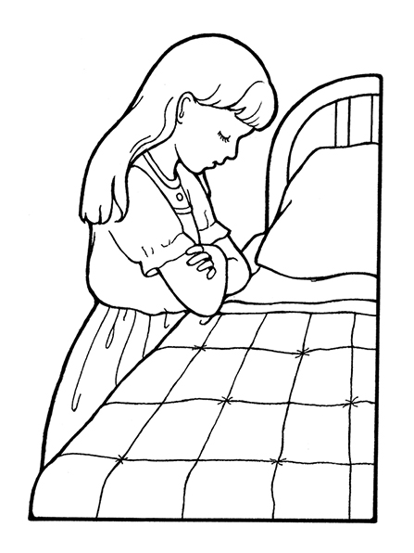

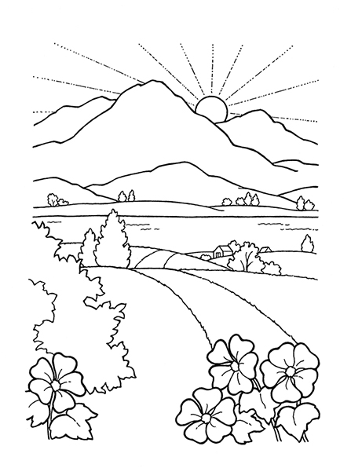

Guide

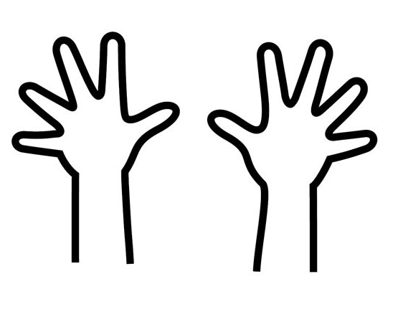

Save





Lead



Direct





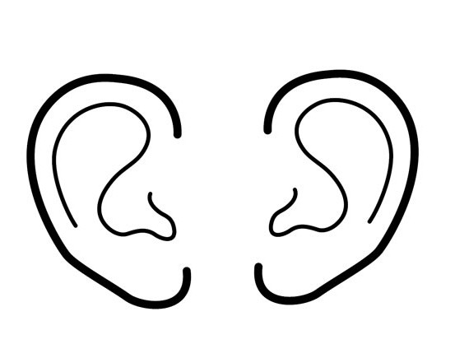













Credits: All images are from the LDS Media Library except the following:

Clker-Free-Vector-Images. (2012, May 7). Forefinger pointing gesture human 48955. Pixabay. Retrieved February 3, 2019, from <https://pixabay.com/en/forefinger-pointing-gesture-human-48955/> Used under a Pixabay License. Free for commercial use. No attribution required.