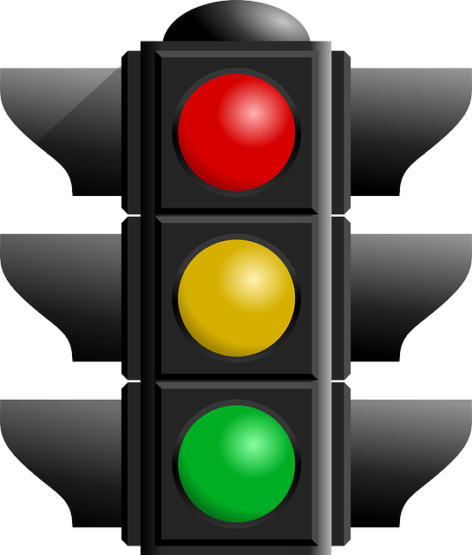

Traffic Lights for Singing Time
Compiled by Cherice Montgomery
Red: Hum
Yellow: Sing slowly
Green: Move and sing

Image Credits:
Clker-Free-Vector-Images. (2012, Apr. 1). Traffic light red black green. Pixabay. Retrieved Jun. 11, 2023 from https://pixabay.com/vectors/traffic-light-red-black-green-24177/ Used under a Pixabay License. Free for commercial use. No attribution required.

Open Clipart Vectors. (2013, Oct. 8). Green traffic light. Pixabay. Retrieved Jun. 11, 2023 from https://pixabay.com/vectors/traffic-light-green-go-149580/ Used under a Pixabay License. Free for commercial use. No attribution required.

Open Clipart Vectors. (2013, Oct. 8). Yellow traffic light. Pixabay. Retrieved Jun. 11, 2023 from https://pixabay.com/vectors/traffic-light-yellow-traffic-lights-149582/ Used under a Pixabay License. Free for commercial use. No attribution required.

Open Clipart Vectors. (2013, Oct. 8). Red traffic light. Pixabay. Retrieved Jun. 11, 2023 from https://pixabay.com/vectors/traffic-light-red-stop-149581/ Used under a Pixabay License. Free for commercial use. No attribution required.

