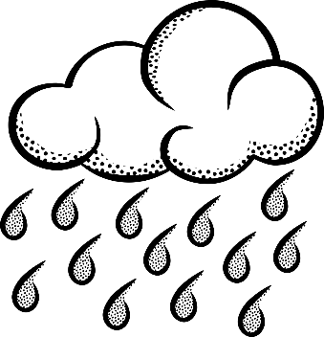
I

I

2

B

I

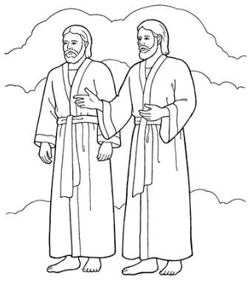
2

B

I

Image sources:
https://pixabay.com/en/eye-mascara-makeup-iris-black-149604/
https://pixabay.com/en/cloud-clouds-sky-blue-white-346706/
https://pixabay.com/en/rain-clouds-weather-rainy-sky-1295101/
https://pixabay.com/en/thought-bubble-think-comic-blank-305053/
https://pixabay.com/en/child-flower-tree-girl-boy-dress-990369/
https://pixabay.com/en/globe-world-earth-black-white-308065/
https://pixabay.com/en/washing-machine-clothes-washer-99241/
https://pixabay.com/en/thug-life-thug-life-young-suburbs-944620/
https://pixabay.com/en/star-favorite-shine-bookmark-153971/
https://www.lds.org/media-library/images/primary-men-1264764?lang=eng
https://www.lds.org/media-library/images/boy-being-baptized-398319?lang=eng&_r=1

