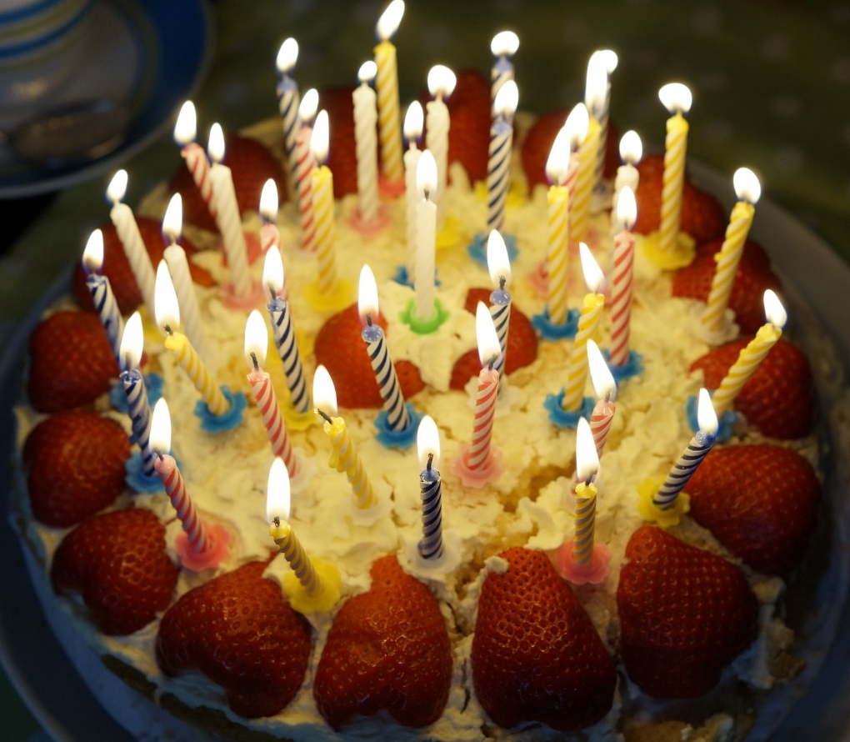

You’ve Had a Birthday

Text and Music by Barbara A. McConchie
Flipchart by Cherice Montgomery
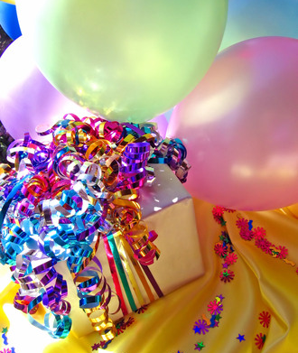

You’ve had a birthday, shout
hooray!
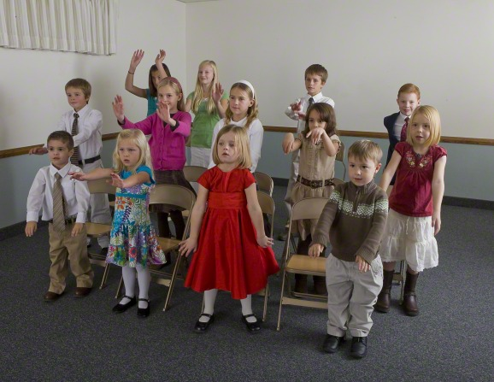
We want to sing to you today!
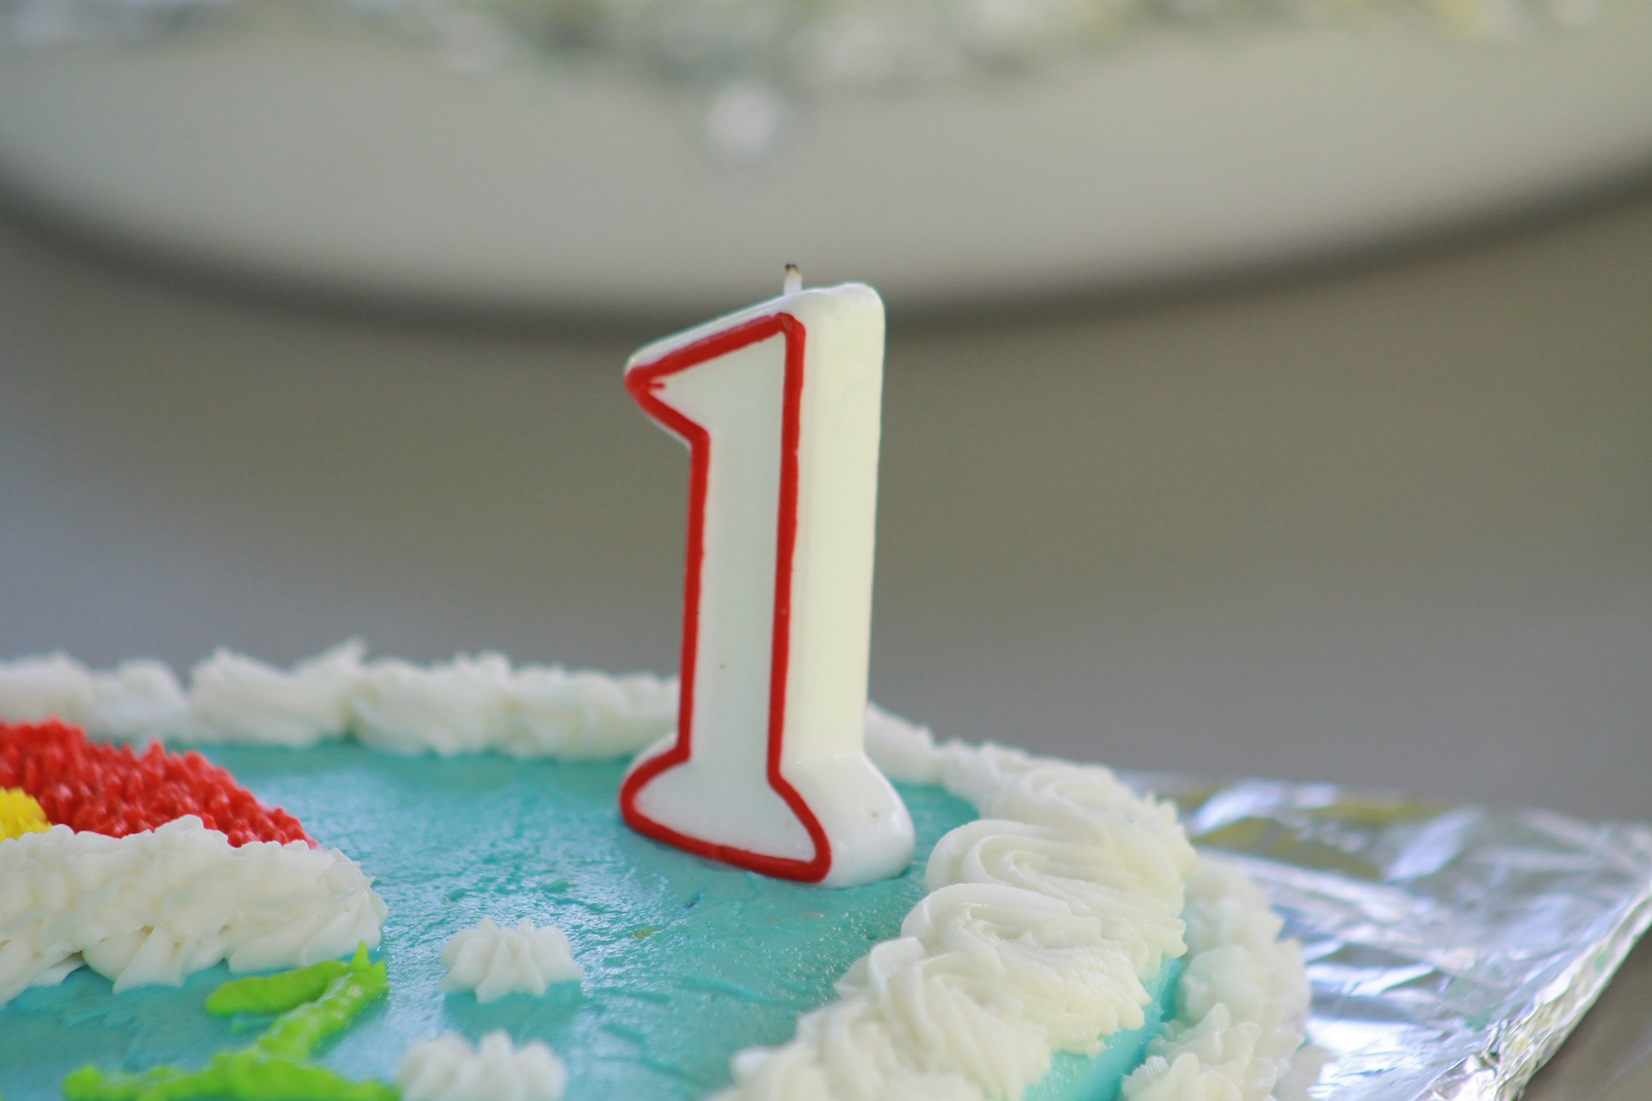
One year older and wiser too!
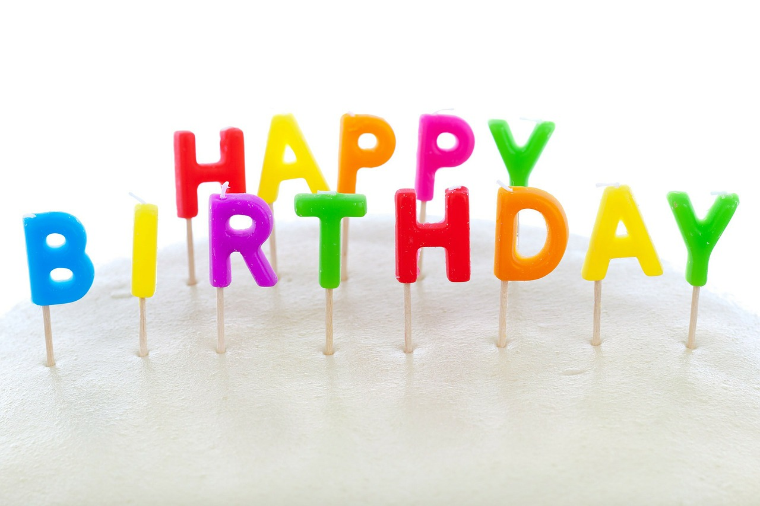
to you!
Image credits:
Efraimstochter. (2015, April 28). Birthday cake burn candles. Pixabay. Retrieved April 9, 2017 from https://pixabay.com/en/birthday-cake-burn-candles-757103/ Used under a CCO Public Domain License. Free for commercial use. No attribution required.
Barefoot, Karen. (n.d.). Happy birthday 1423422. FreeImages.com. Retrieved April 9, 2017 from http://www.freeimages.com/photo/happy-birthday-1423422 Used under a FreeImages.com Content License.
LDS.org. (n.d.). Singing time. LDS.org: Retrieved April 9, 2017 from https://www.lds.org/media-library/images/singing-time-598909?lang=eng
Godsgirl_Madi. (2015, May 30). Birthday cake first birthday one. Pixabay. Retrieved April 9, 2017 from https://pixabay.com/en/birthday-cake-first-birthday-one-843921/ Used under a CCO Public Domain License. Free for commercial use. No attribution required.
Public Domain Pictures. (2012, December 24). Happy birthday cake candle. Pixabay. Retrieved April 9, 2017 from https://pixabay.com/en/happy-birthday-cake-candle-72159/ Used under a CCO Public Domain License. Free for commercial use. No attribution required.

